MINISTRY OF EDUCATION AND SCIENCE OF KYRGYZ REPUBLIC

KYRGYZ-GERMAN INSTITUTE OF APPLIED INFORMATICS

**COURSEWORK**

Programming Languages

on the subject: «**SAB-Real Estate Agency** »

Supervisor A. Kibekbaev(Senior Lecturer )_____________________

English Language Adviser M. Karagulova (Ass.Prof.) _______

Monitoring Adviser K.B. Turganov (Senior Lecturer)_____________

Completed by WIN-1-21 S. Nogorbekov ____________________

1. Rapilbekova ____________________
2. Zulfibaeva ____________________

**Content**

Introduction 3

Charter laws and rights 5

Team Roles: 6

Software requirements specification 7

Used tools 8

Architectural Representation 9

Main Part (Marketer) 13

Main Part (Manager) 15

Main Part (Worker) 18

Main Part (Director’s account) 20

Main Part (Sales agent) 24

Conclusion 30

References 33

# Introduction

**Real estate agency is a company that sells, leases or manages houses, land and buildings for their owners.**

We have been researching some Kyrgyz real estate agency programs for workers and I have found: ‘Avangard. Real estate’ is basically a site, which gives an opportunity to advertise one’s premises. What you get by buying their service:

* + High-quality advertisement of your place (ads on 80 sites in 24 hours, paid advertising in social media, the company carry out professional photography of the apartment)
  + Realtor training (realtors take a sales course using the technology of ZARA, NIKE, FORD. Also it is possible to choose realtor, that will be 24/7 in touch)
  + Open price and fixed commission.

The problem is that ‘Avangard. Real estate’ is more client-oriented and directed to sell their assistance rather than making a platform for people who work in this kind of companies. Internet is full of this kind of web-services mainly for people, who are looking for some premise. For instant: ‘House.kg’, ‘an.kg’ and so on.

**Automated system “Real Estate Agency.”-(“SAB") is intended to make life easier for those who work for companies and real estate agencies by doing various tasks.**

**Abstract:** The program has its users: CEO, marketer, manager, employees, sales agents. Each of the users has their own access to the program by login and password. The corresponding menu opens, depending on the category of person’s account. Consequently, all workers have their own menu, which provide dissimilar information and functions.

**Subject:** Real estate agency is a brokerage, its main duty is to “unite buyers with sellers”, when renting, exchanging, managing or buying real estate. Our program is worker-oriented, it’s main aim is to help workmen and make their job uncomplicated.

**Goals:** Make sure that we fully understood the material on the Python programming language to create a complete program in this language, in our case- automated system “Real estate agency (SAB)”.

**Objectives:** The main task is to create a program that would benefit employees in real estate agent companies by making their daily doings easier. These functions should be performed:

**1.** Create login to one’s account

**2.** Develop an ability to choose from the menu based on the type of worker’s account

**3.** Develop an ability to search

**4.** Develop an ability to delete or change some data

**5.** Develop an ability to see some types of reports

**Relevance:** There is an enormous quantity of foreign brokerage management platforms. And the first on the list is **‘Brokermint’**. It allows to “automatically calculate commissions”, and pay off with newest ACH payments. “‘Brokermint’ helps drive your efficiency and profitability with: • Transaction Management

• Commission Automation

• Accounting

• Agent Management

• Reporting and Analytics Integrates”

Overall, the users are delighted with this platform: it has 4.3 points out of 5 on G2(site). Based on the reviews, users praise tool for transaction and broker management, ACH payout. In addition, they have been mentioning that this site “is often looking for ways to improve their processes and offer more features”, ‘Brokermint’ removes various obstacles that were getting in the way while working in previous versions.

**‘Crexi’** is the platform, which has the highest rank on the above site (4.8 out of 5). It’s fastest-growing marketplace in real estate agency. ‘Crexi’ is advanced technological data platform that was made to support CRE industry (Commercial Real Estate). It has helped thousands of brokers, tenants and buyers to transact deals quicker. For instance, CRE professionals can rapidly and firmly streamline, manage and grow their business. Users like almost everything about ‘Crexi’, except too many “annoying” and “irrelevant” notifications, that cause “missing potentially important ones”.

**Target group:** Project is done for almost all kinds of workers, who toil in companies, related to real estate.

# Charter laws and rights

* To receive, on request, limited medical leave for health reasons or for another valid reason.
* The right to privacy and the non-disclosure of private information, provided that it is not prejudicial to the work.
* Voluntarily physically attend our meetings in University.
* Political, religious agitation within our team is prohibited.
* It is prohibited to leave the team without raising the issue for general discussion.

# Team Roles:

Salim/Nogorbekov:

* Documentation
* Main menu (entrance)
* Director’s account
* Presentation

Akylai/Rapilbekova:

* Documentation
* Marketer account
* Employee (worker’s) account
* Presentation

Bermet/Zulfibaeva:

* Documentation
* Manager account
* Sales agent account
* Presentation

# Software requirements specification

The normative and reference information of our automated system is presented in the form of a reference book for all types of accounts in the form of one of the menu items, when clicked, the expanded text is displayed in the form of instructions.

The program must be written using Python, and all write and delete operations must be performed by writing to, reading from, and manipulating a file.

Following functions should be performed:

* + 1. Create login to one’s account
    2. Develop an ability to choose from the menu based on the type of worker’s account
    3. Develop an ability to search
    4. Develop an ability to delete or change some data
    5. Develop an ability to see some types of reports

# Used tools

*Program language:* Python

*IDE:* PyCharm

*Database:* JSON, CSV files

# Architectural Representation

Automated system “Real Estate Agency.” - (“SAB”) is intended to summarize information about the agency, about client coverage areas, information about the number of clients from each region, information for future purchases of apartments in a construction company, the number of rented objects, both apartments and business premises, the number of sold objects, both apartment and business premises or other objects.

Depending on the category of the person's account, the corresponding menu opens.

General information about all objects, employees, the state of the organization, customers and all other information such as the number of customer coverage areas with their full name is visible and available to the general director, manager.

It is possible for the marketer to see the customer coverage area, the low customer coverage area where attention is required, the budget for advertising, advertising categories and categories for promotion.

The employee, on the other hand, has the ability to see the schedule of the place of work and hours of work, his current salary, the number of years of service.

The real estate agent can see information about the objects that are for sale, rent or construction projects in different construction companies.

It is possible for an HR specialist to see the number of employees, update the list of candidates for a position, see all information on employees, including their work experience.

The director is able to delete from his list, namely from the file with the lists of the surnames of this or that employee, similarly add this or that employee. See complete information on clients, objects both building, and on those objects that are either leased or sold.

In the file where the director applies, there is an account and an account type. For example:

“Marat Nikiforov – Manager”

“Andrey Gavrilov – Employee”

“Aisuluu Boronbaeva – Marketer”

“Sergey Ivanov - HR Specialist”

“Maksat Tashtanov - Real Estate Agent”

“Arsen Bekbolotov - General Director”

**Login:**

The users of the program: CEO, marketer, manager, employees, sales agents. Everyone should have their own access to the system by login and password.

* For a marketer, for example, account type is “marketing” and the keyword
* For a CEO: “director” and the keyword
* For a manager: “manager” and the keyword
* For an employee: “worker” and the keyword
* For sales agency: “sales manager” and the keyword

**Account**

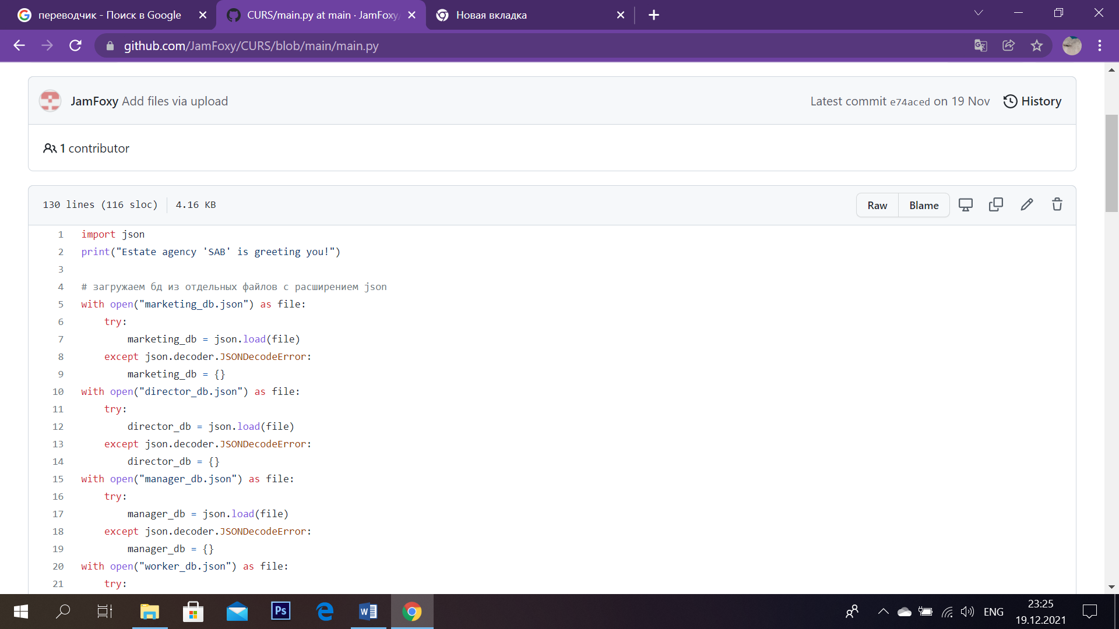

*Sc.1*

Our group decided to work with the JSON database. On the start of the program we display the main.py greeting: “Estate agency ‘SAB’ is greeting you!” (Sc.1)

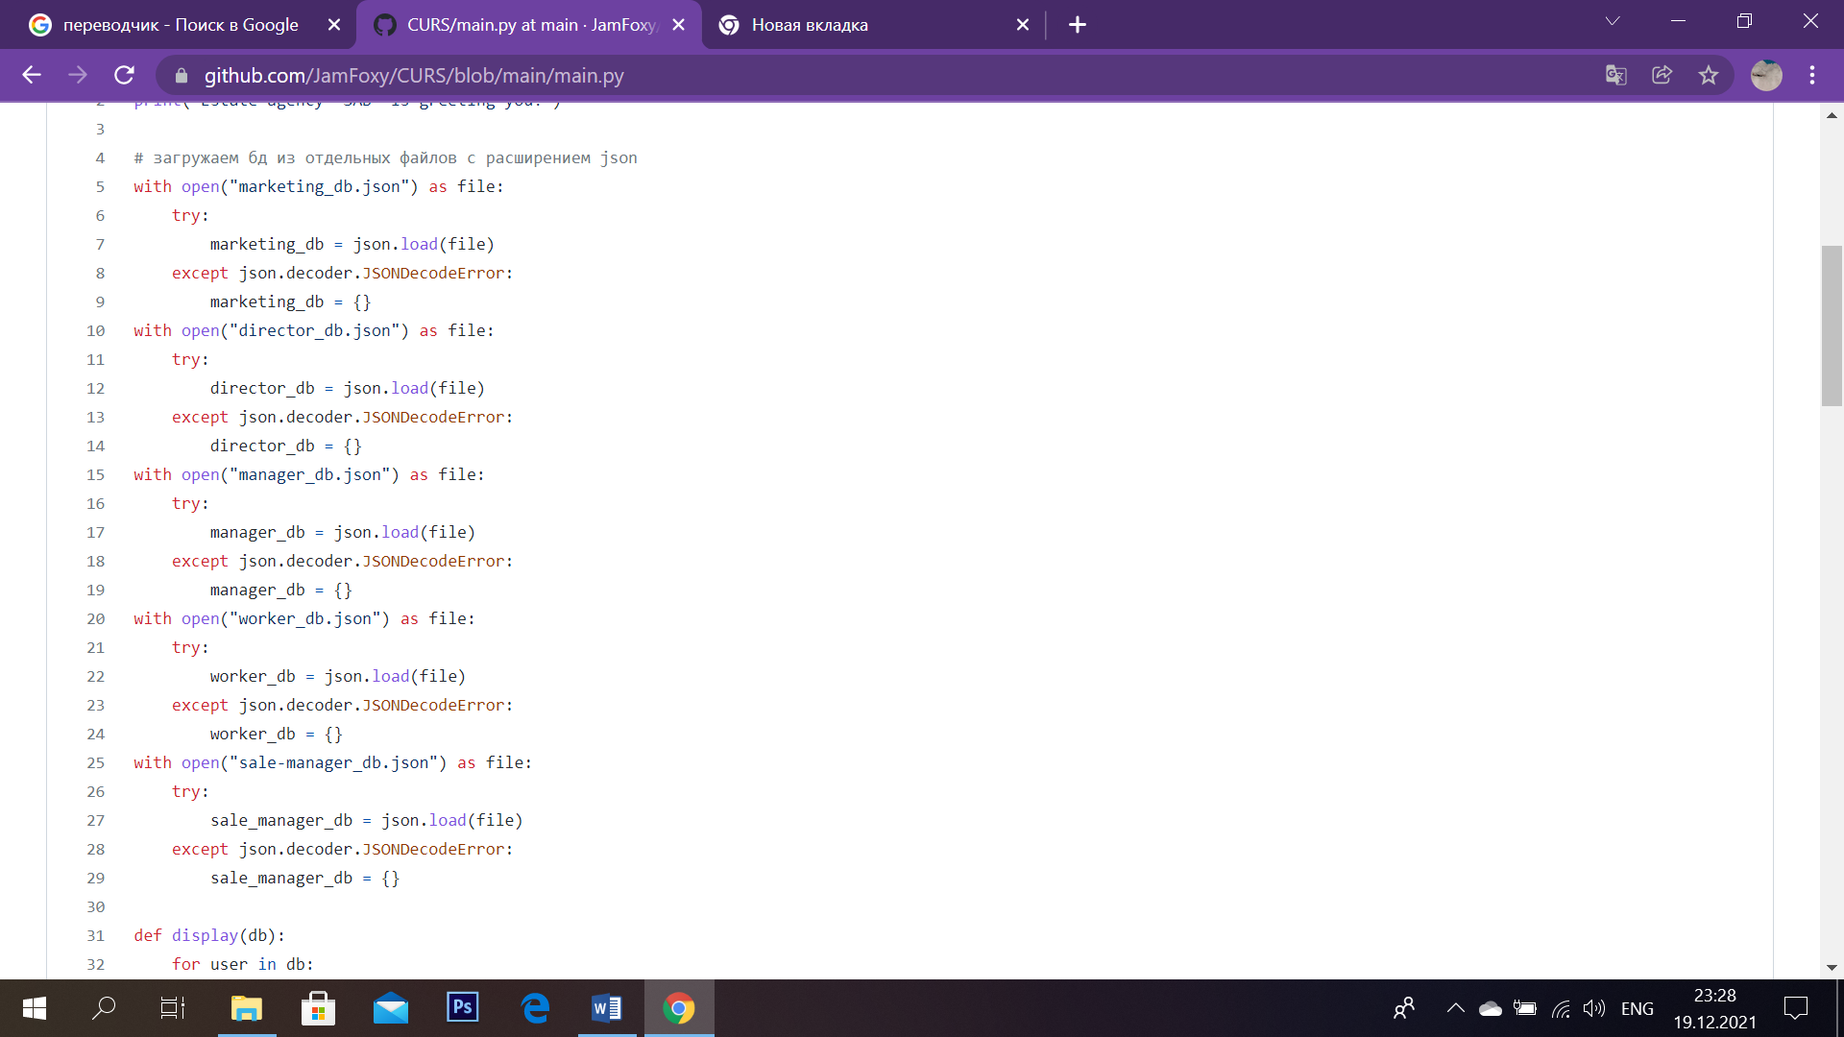

*Sc.2*

Then we load the database from separate files with the JSON extension (marketer_db, director_db, manager_db, worker_db, sale_manager_db). To avoid errors, we take the ‘try except’ construction, then the data is checked, to wit: account type, account, login, password. (Sc.2)

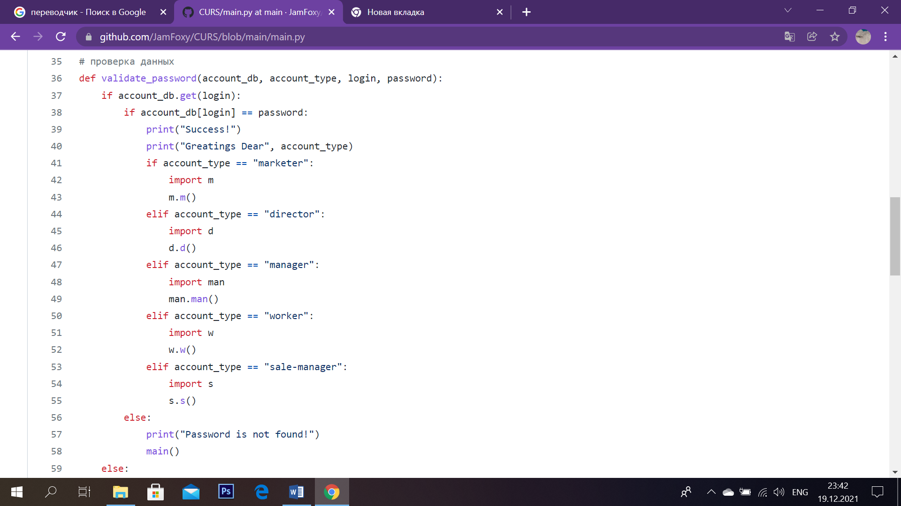

*Sc.3*

In the ‘validate_password’ function, we compare the account type that a user intends to write with the previously built-in the program type of the account by using ‘if-else’ statements. If everything matches a welcome message is displayed and the library created for the specific account type is imported. The ‘else’ statement works, when password is different from a built-in code, therefore we return to the main menu. (Sc.3)

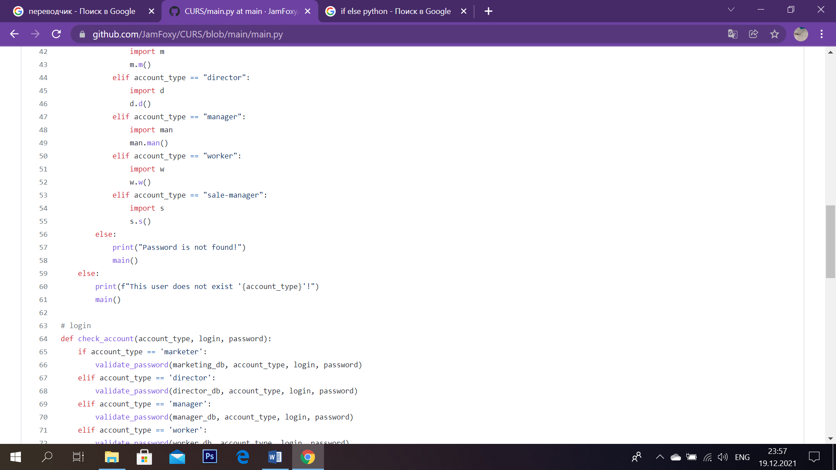

*Sc.4*

If a user types non-matching account type, an error message is displayed. (Sc.4)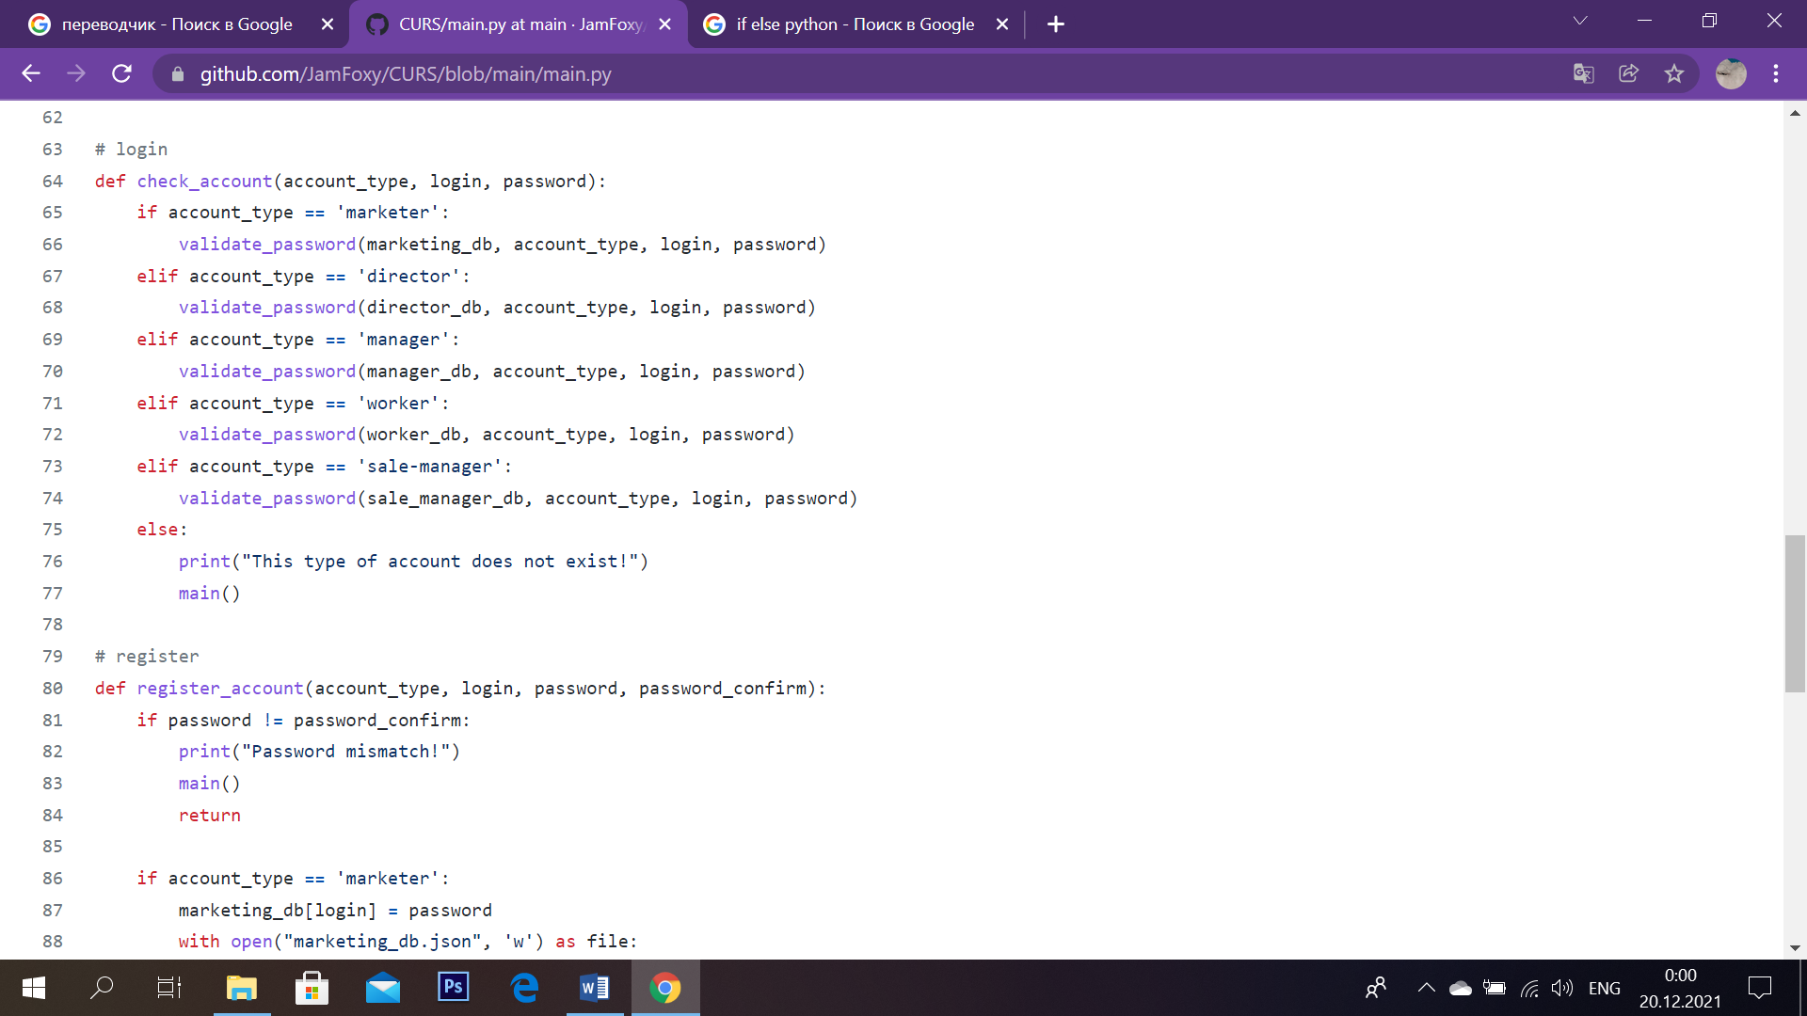

*Sc. 5*

Then, the login is being checked, through the ‘check­_acc’ function. We check the login with the password using the ‘validate password’ function, in case of a mismatch, a message is displayed about this, and the program goes back to the main menu. (Sc.5)

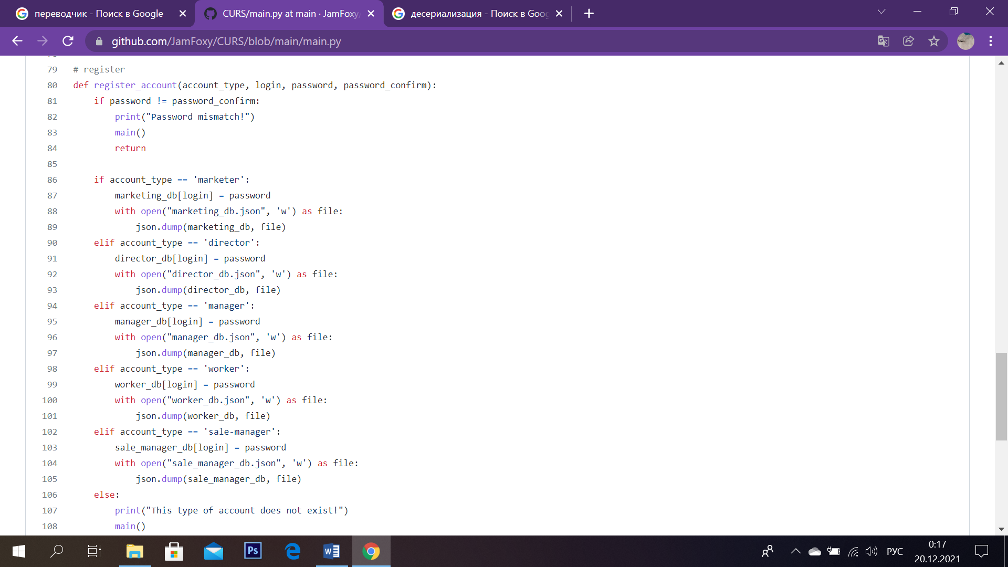

*Sc. 6*

Next comes the registration check function (‘register_acc’), where the program asks for: account type, login, password and password confirmation, in case of an incorrect input, a corresponding message is displayed. What the system does here is checks the passwords for correctness and write the data by DE serializing JSON files, and in case of incorrect input, an error message is shown on the screen. (Sc.6)

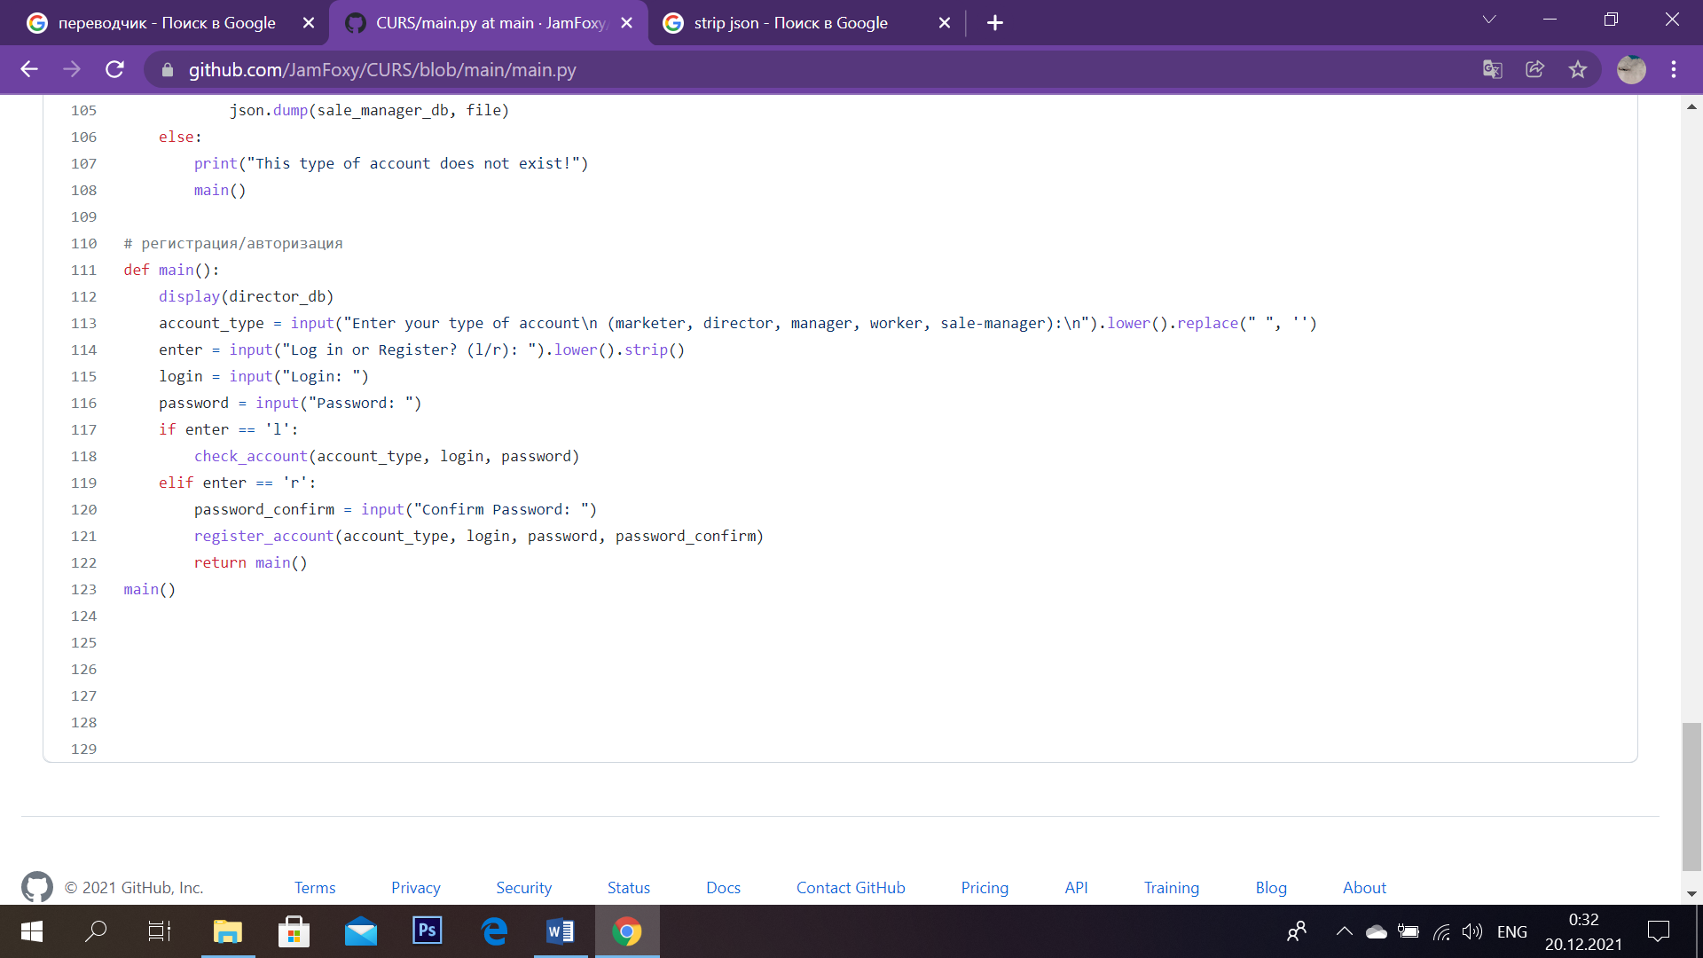

*Sc. 7*

At the very beginning, a function ‘def main()’ is printed that calls for the user to enter a certain number for the further operations of the program. It is that main menu, which is showed, when something doesn’t go with fitted in the program statements.

The registration function works as follows: the user is required to enter the account type, account and password, after which, in accordance with login or registration selection, certain functions are displayed above. (Sc.7)

# Main Part (Marketer)

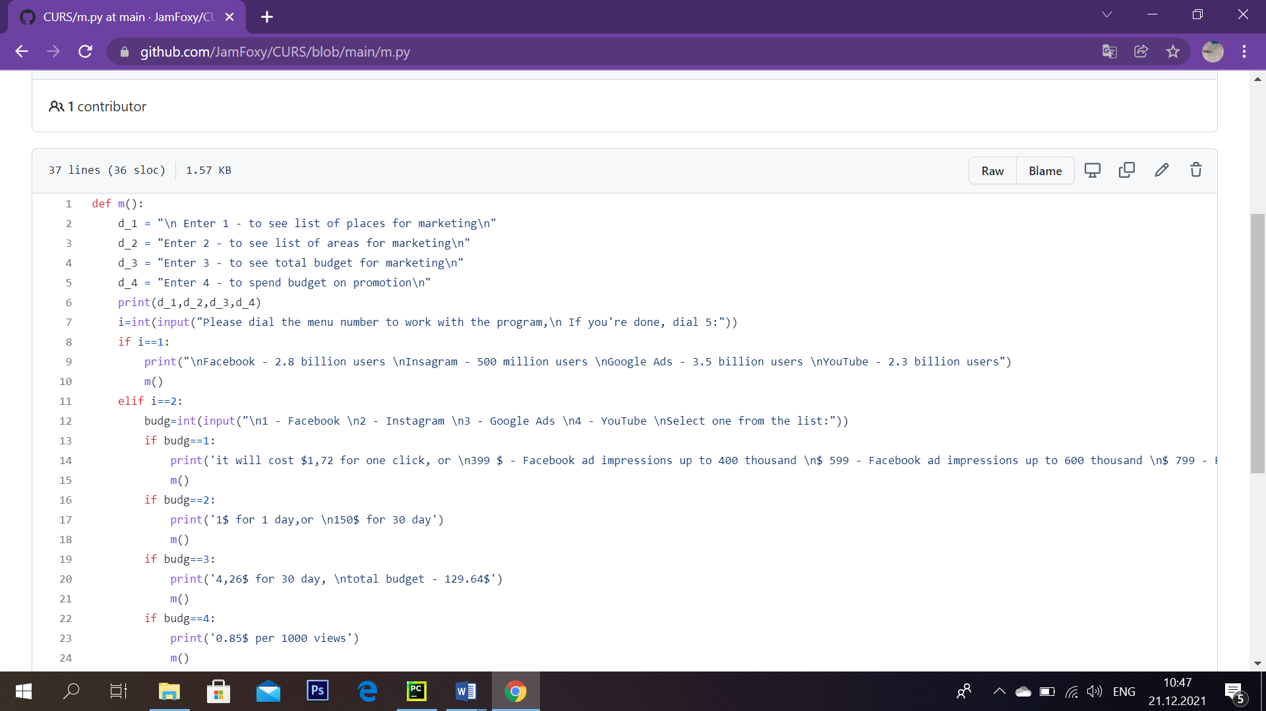

*Sc. 8*

When a user chooses marketer’s account our function, named ‘m’ works. As you see our variable, ‘i’, asks a person to enter the number to work with the program on a chosen task. (Sc.8)

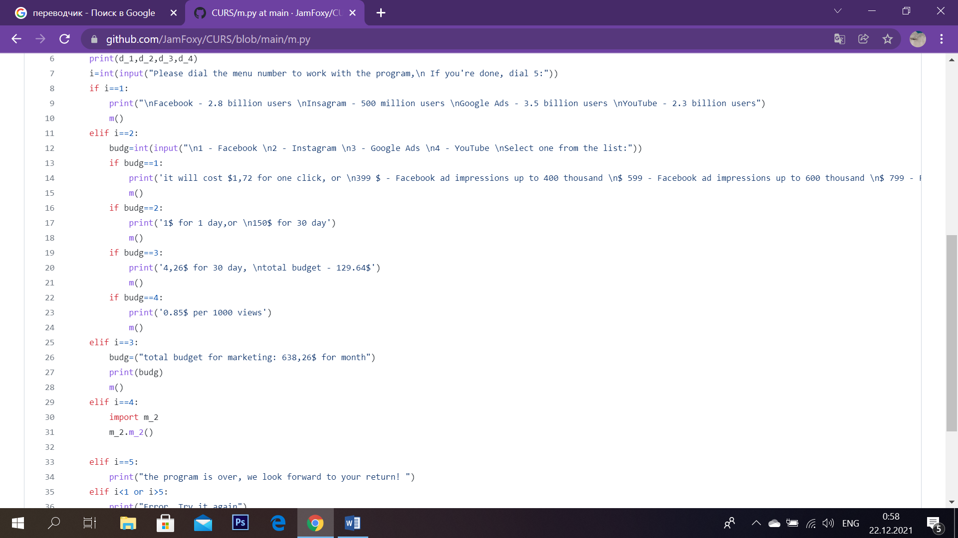

*Sc.9*

By using if-else constructions, corresponding information is displayed on the screen. As you see, if a worker chooses ‘1’, list of places for marketing opens. When they go with ‘2’, it is required for them to choose additionally what areas for marketing would they want to see, it might be: Facebook, Instagram, Google advirtisements or YouTube. To see data on a selected platform, it is needed to enter a number. Thus, when the ‘1’ is typed, details about commercial is seen; ‘2’ means that the user wants to see information about promotion on Instagram. Respectively, ‘3’ and ‘4’ are in charge for advertisements on Google and YouTube. After displaying data program returns to the function in the beginning (menu). (Sc.9)

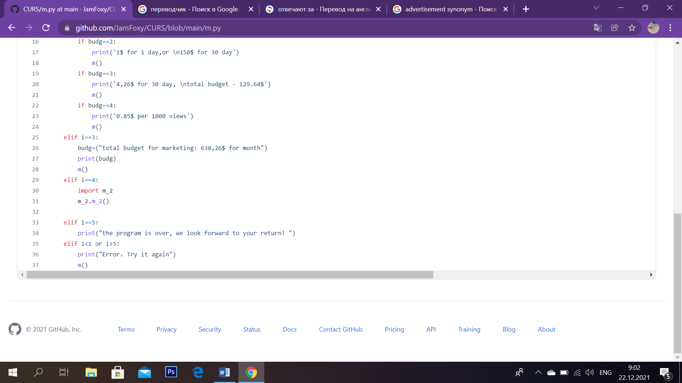

*Sc. 10*

Coming back to main menu choices: if you type ‘3’, the total budget for marketing is shown. When ‘4’ is chosen, we import another library (‘m_2’). (Sc.10)

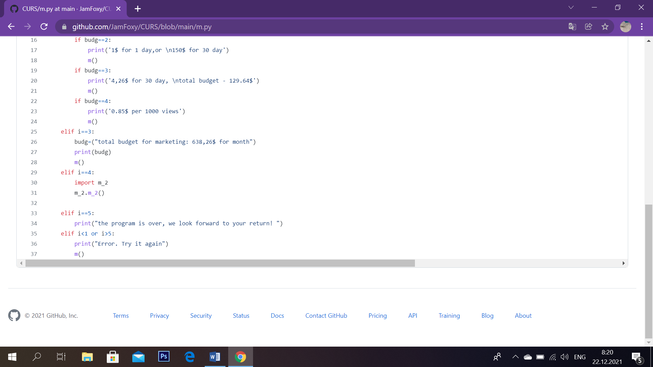

*Sc. 11*

In case when user enters ‘5’, program closes, that means that a person intends to leave it. On the screen following parting is showed: ‘the program is over, we look forward for your return’.

Whereas when someone enters number which is not on the menu list, then an error is displayed, and the program goes back to the menu in the beginning. Not only in this case the system displays marketer’s main course of actions: returns to the function ‘def m()’, but every time when it has shown needed material. (Sc.11)

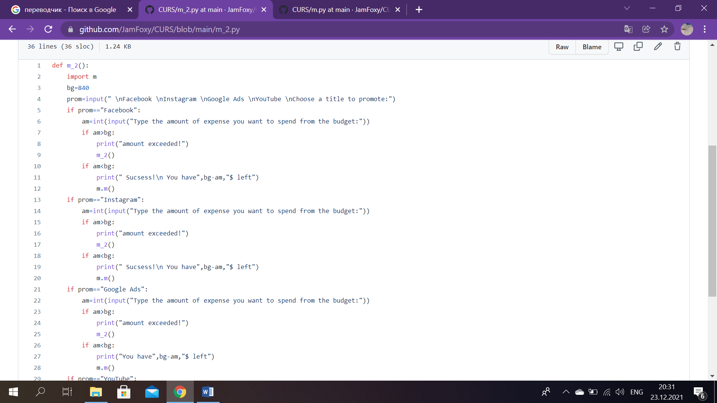

*Sc. 12*

This is our new function (library)- ‘m_2’, which is used for giving further information about finances in promotion. First of all, it is required from a user to select a title to promote. Then worker should select a social network and type the amount they want to spend from the budget. (Sc.12)

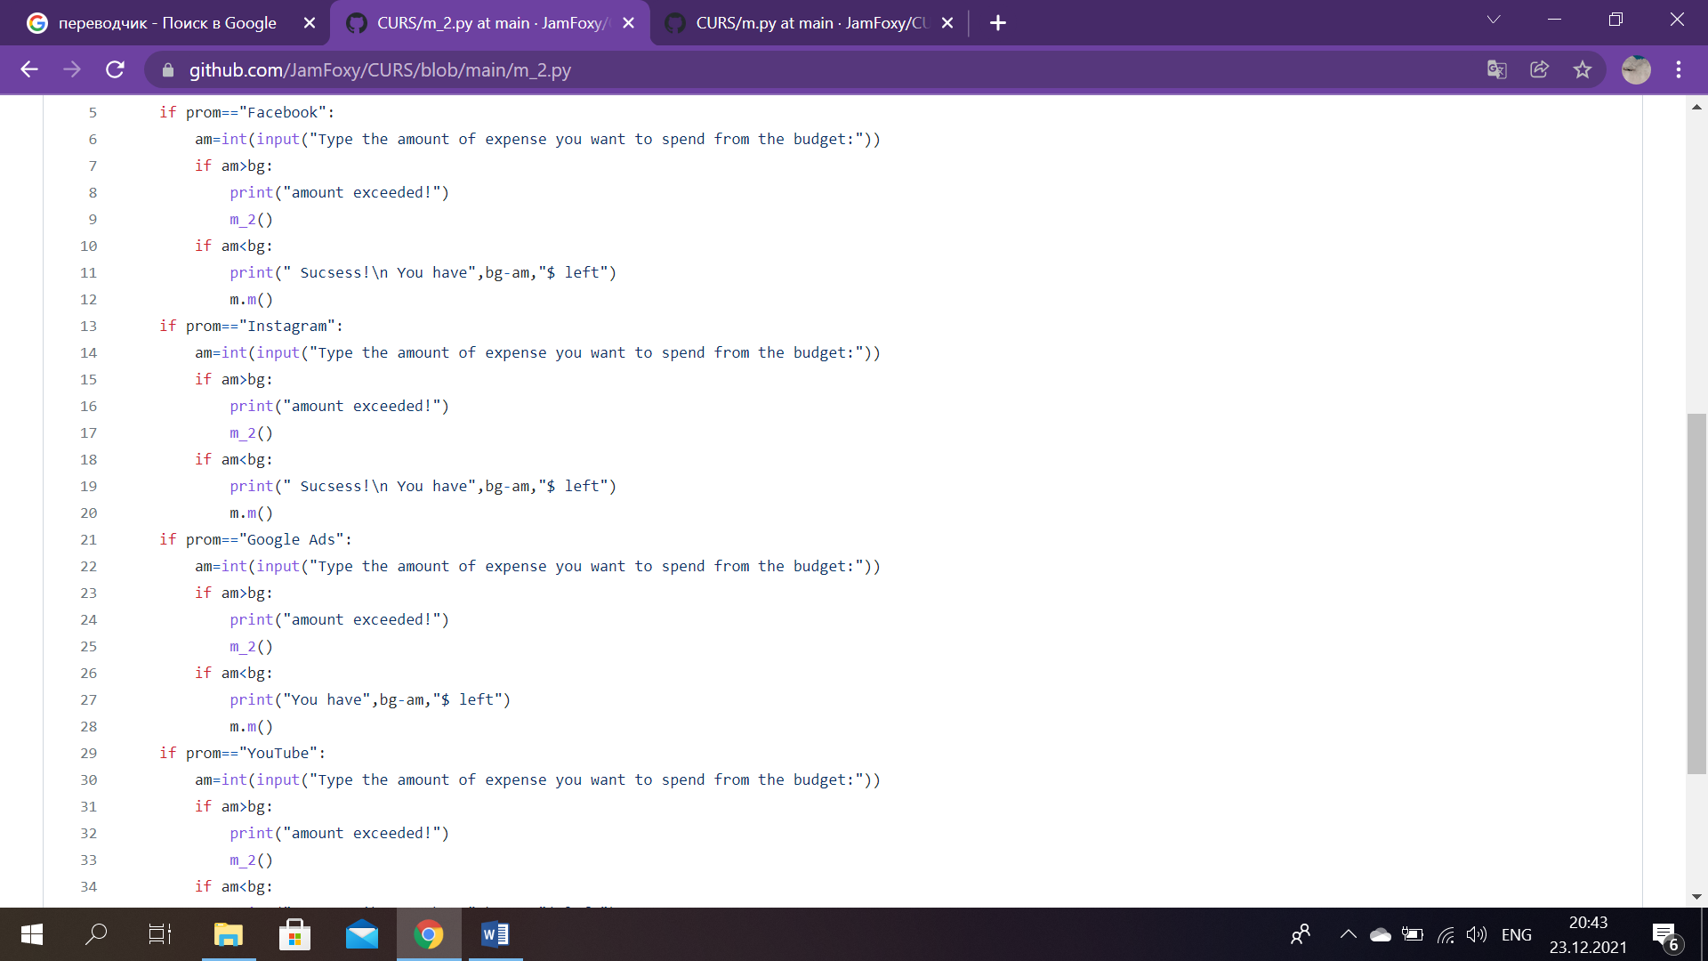

*Sc. 13*

For example, if ‘Facebook’ and number of money for promotion are entered, then a program compares selected quantity with total budget, which is built-in the program, it has been performed by creating a variable ‘bg’, which in its turn makes up 840 currency. On condition that entered amount is more than 840, a message of the amount being exceeded shows up. A message about successful promotion is displayed, when the number of money typed is less than built-in quantity. Withal, calculation of the amount of finances left is accomplished. And again we return to the main library of marketer’s account (m.py). (Sc.13)

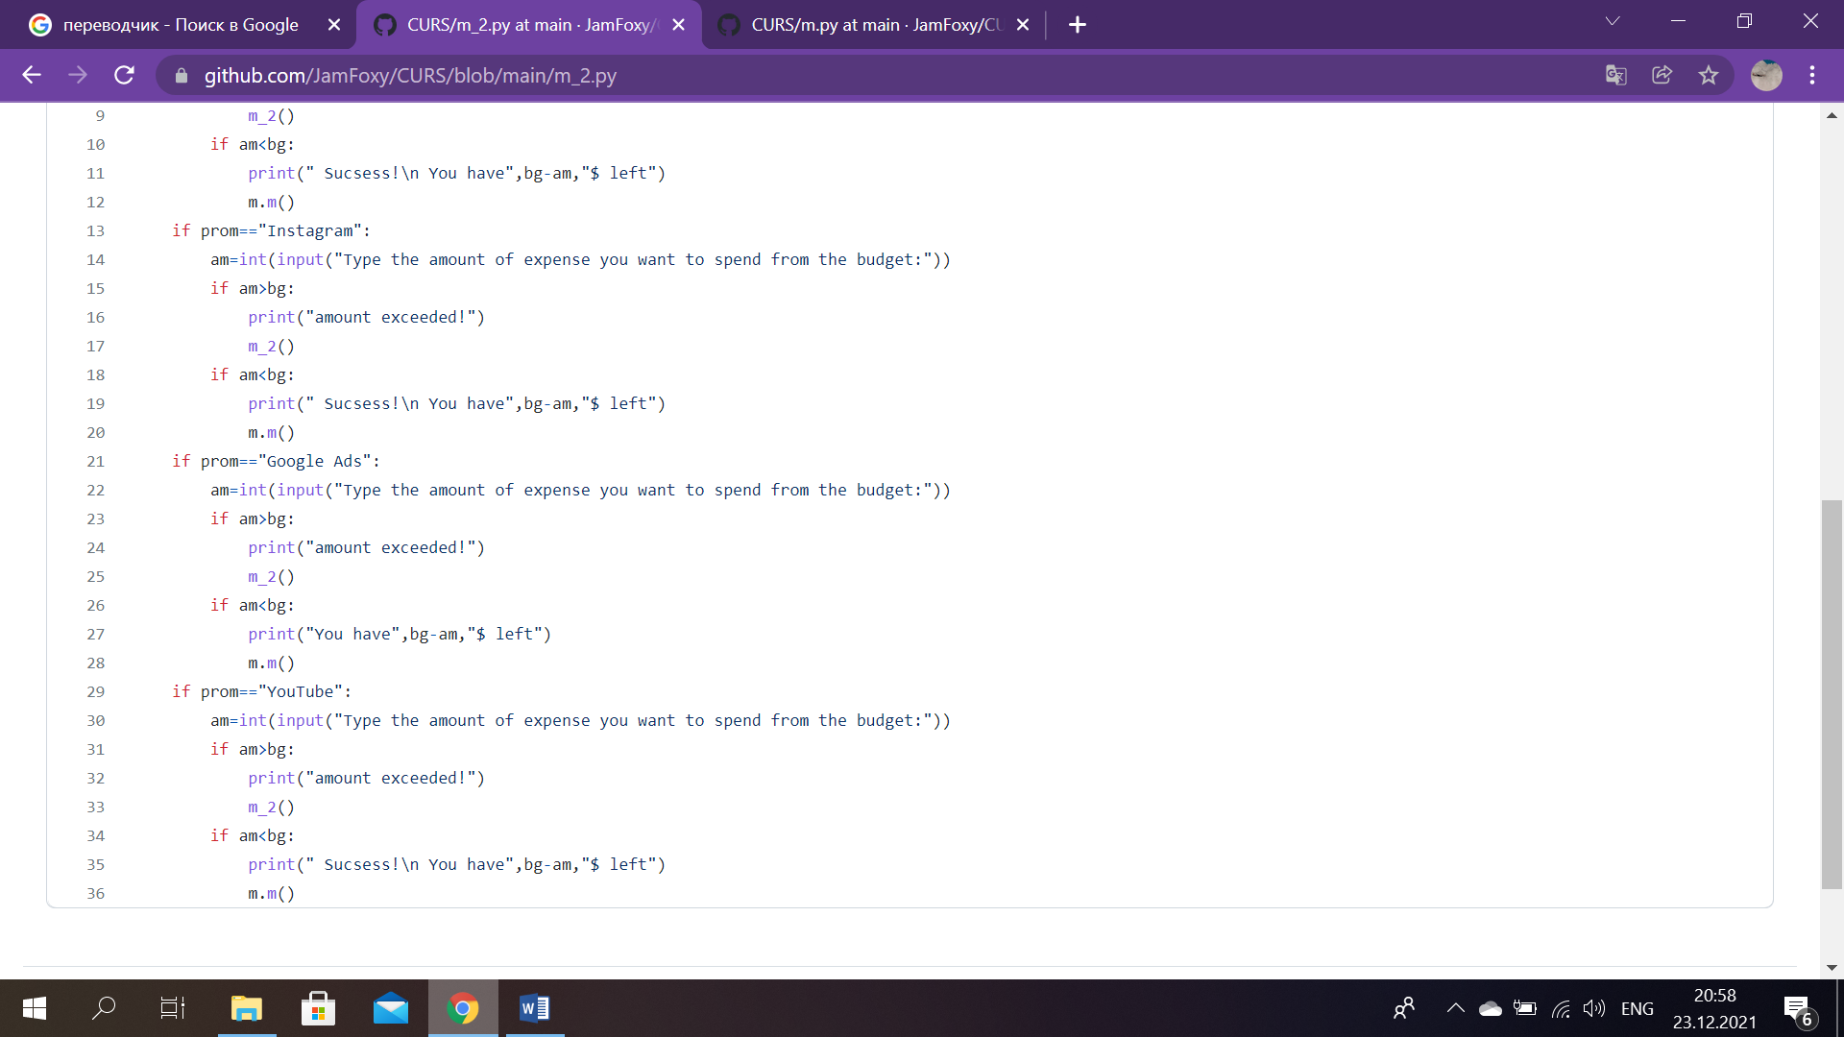

*Sc. 14*

Therefore, we do the same thing for other platforms, such as: Instagram, Google Ads and YouTube. (Sc.14)

# Main Part (Manager)

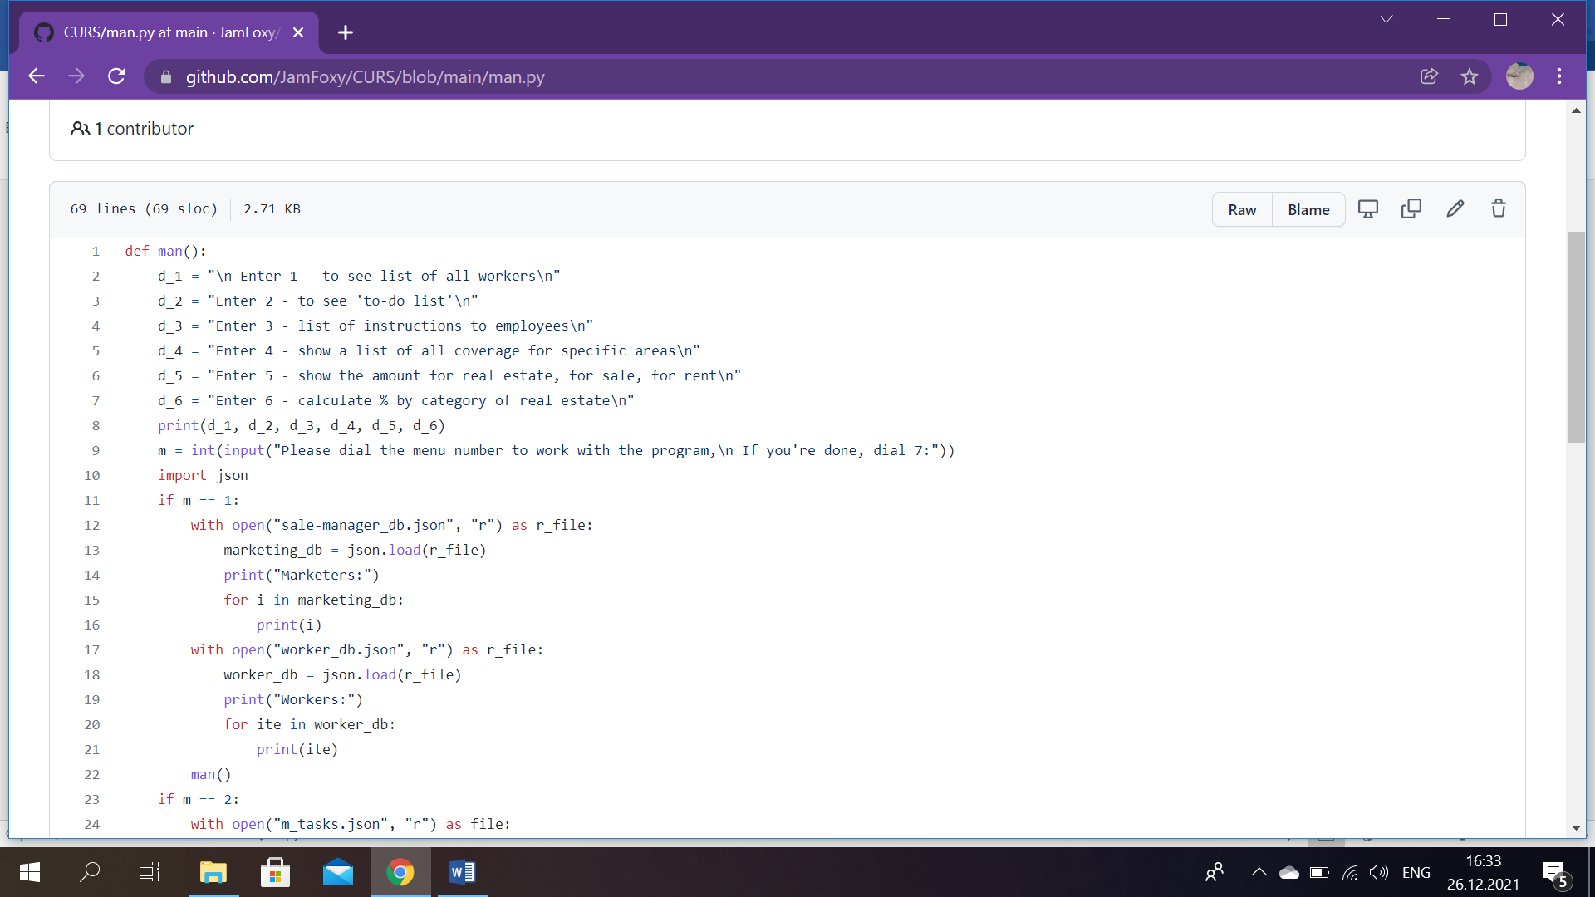

*Sc. 15*

The menu for the manager looks like this: first of all, the program suggests to dial the menu number to work with it, if finished, a worker should dial 7. If a manager types 1, it means, that he wants to see list of all workers, 2- ‘to-do’ list, 3- list of instructions to employees, 4- a list of all coverege for specific areas, 5- the amount for real estate, for sale and for rent, 6- calculated percentage by category of real estate. In the start we print all six options, so that a user could choose. By using escape sequence: ‘\n’, we mark the end of a line of text. Basically, it indicates that the current line ends here and a new one starts immediately after it. (Sc.15)

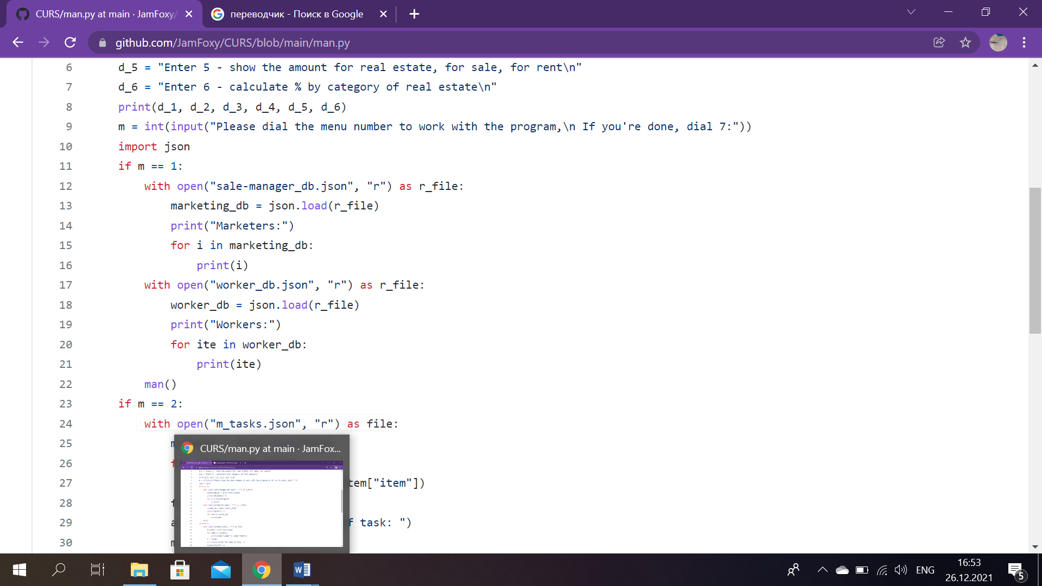

*Sc. 16*

Before anything else, JSON is imported, since we chose to work with this database. Hence, if a user wants to see the list of all company workers, we print initially marketes, by opening our JSON file ‘sale-manager_db’, then we use ‘r’ function to read it. And json. load() takes a file object and returns the JSON object. The same is done for list of workers, except, ‘worker.db’ file is loaded . In the end, we print workers and the program goes back to the main menu of manager’s account. (Sc.16)

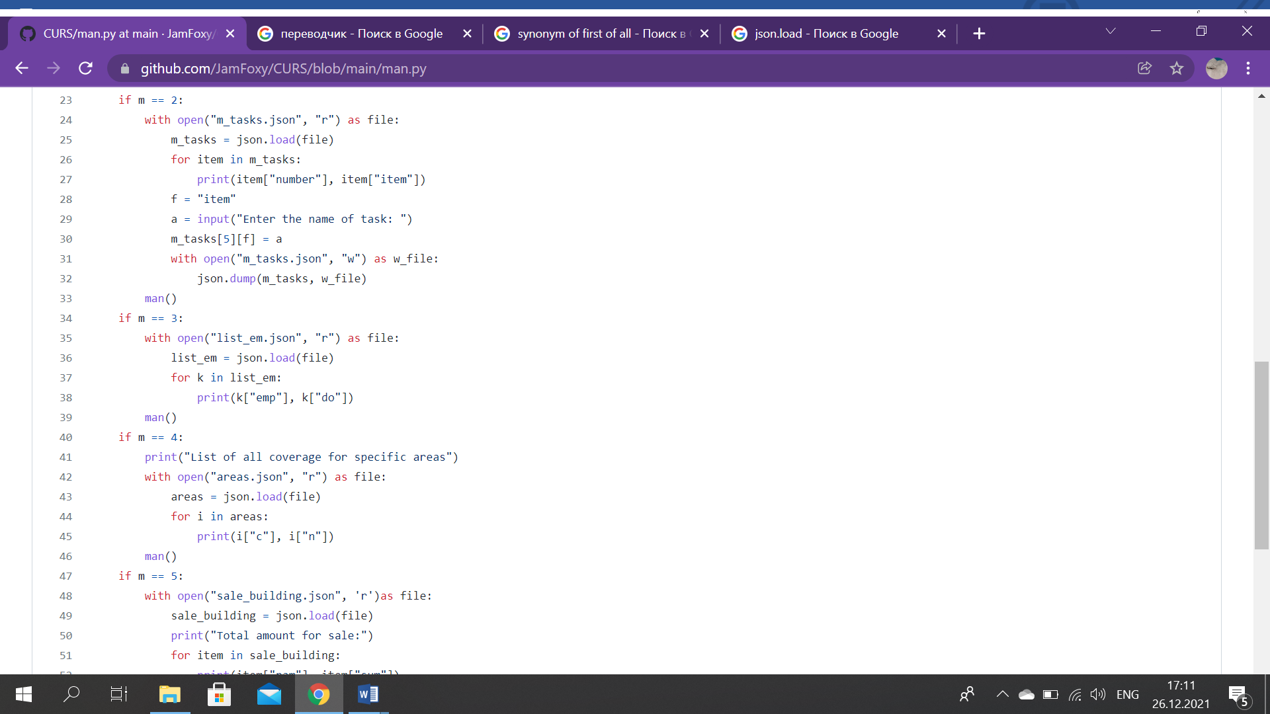

*Sc. 17*

This code is responsible for showing a ‘to-do’ list. In the beginning we open our file ‘m_tasks’ with JSON extension. By using Python for loop we print all numbered tasks. After that progam asks a manager to enter a new task and it is added via ‘w’ function, which is used to write in files, in our case, in ‘m_tasks’. (Sc.17)

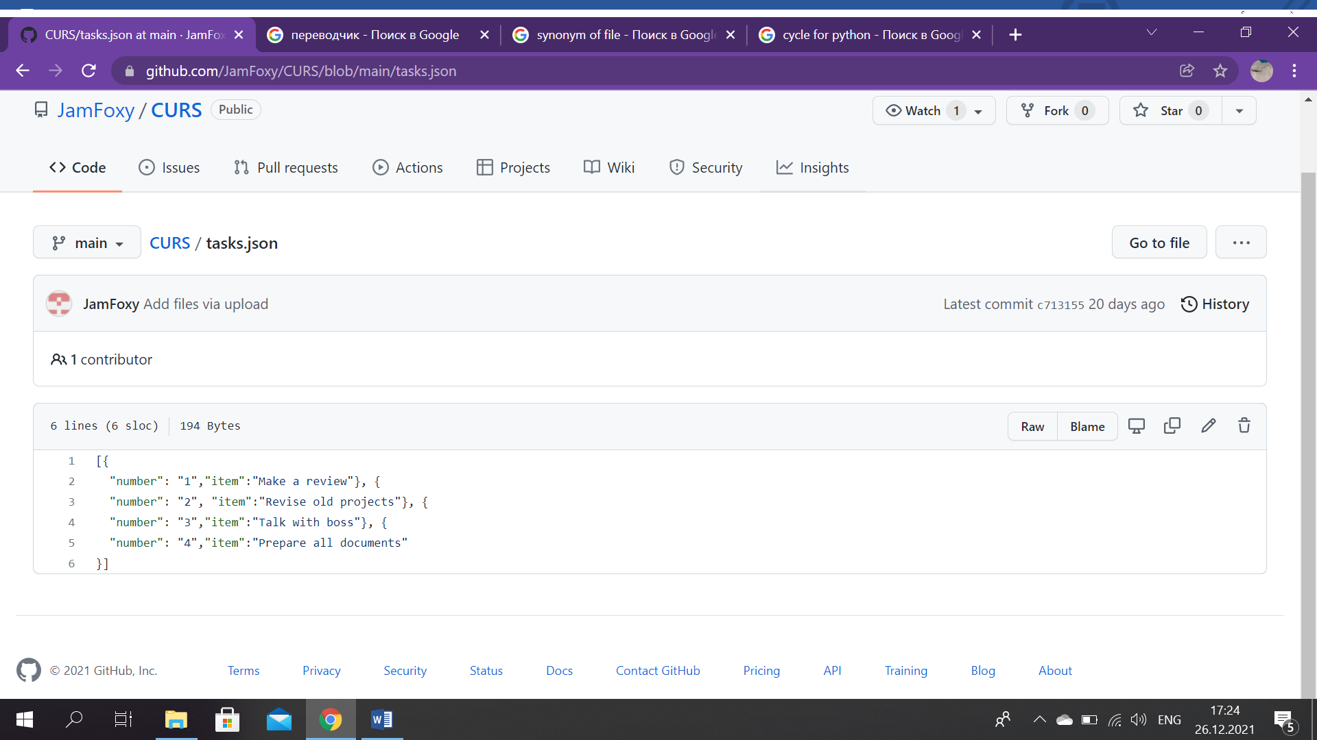

*Sc.18*

This is ‘m_tasks’ file, where as we see is only 4 items. For this reason in previous screenshot, this code was typed: m_tasks[5][f]. It means that a new task will be added and be numbered at the same time, as fifth task. (Sc.18)

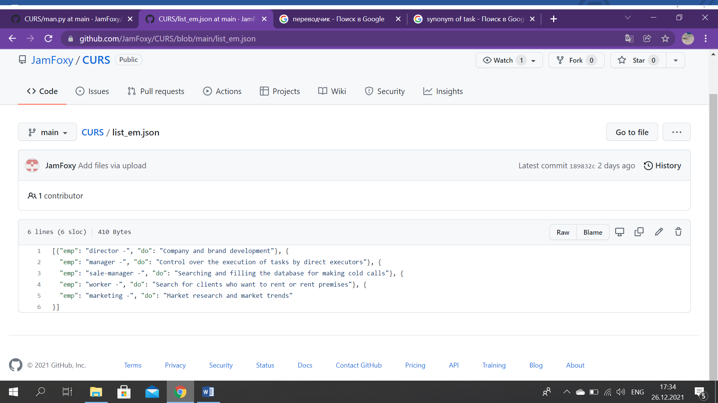

‘list_em’ file

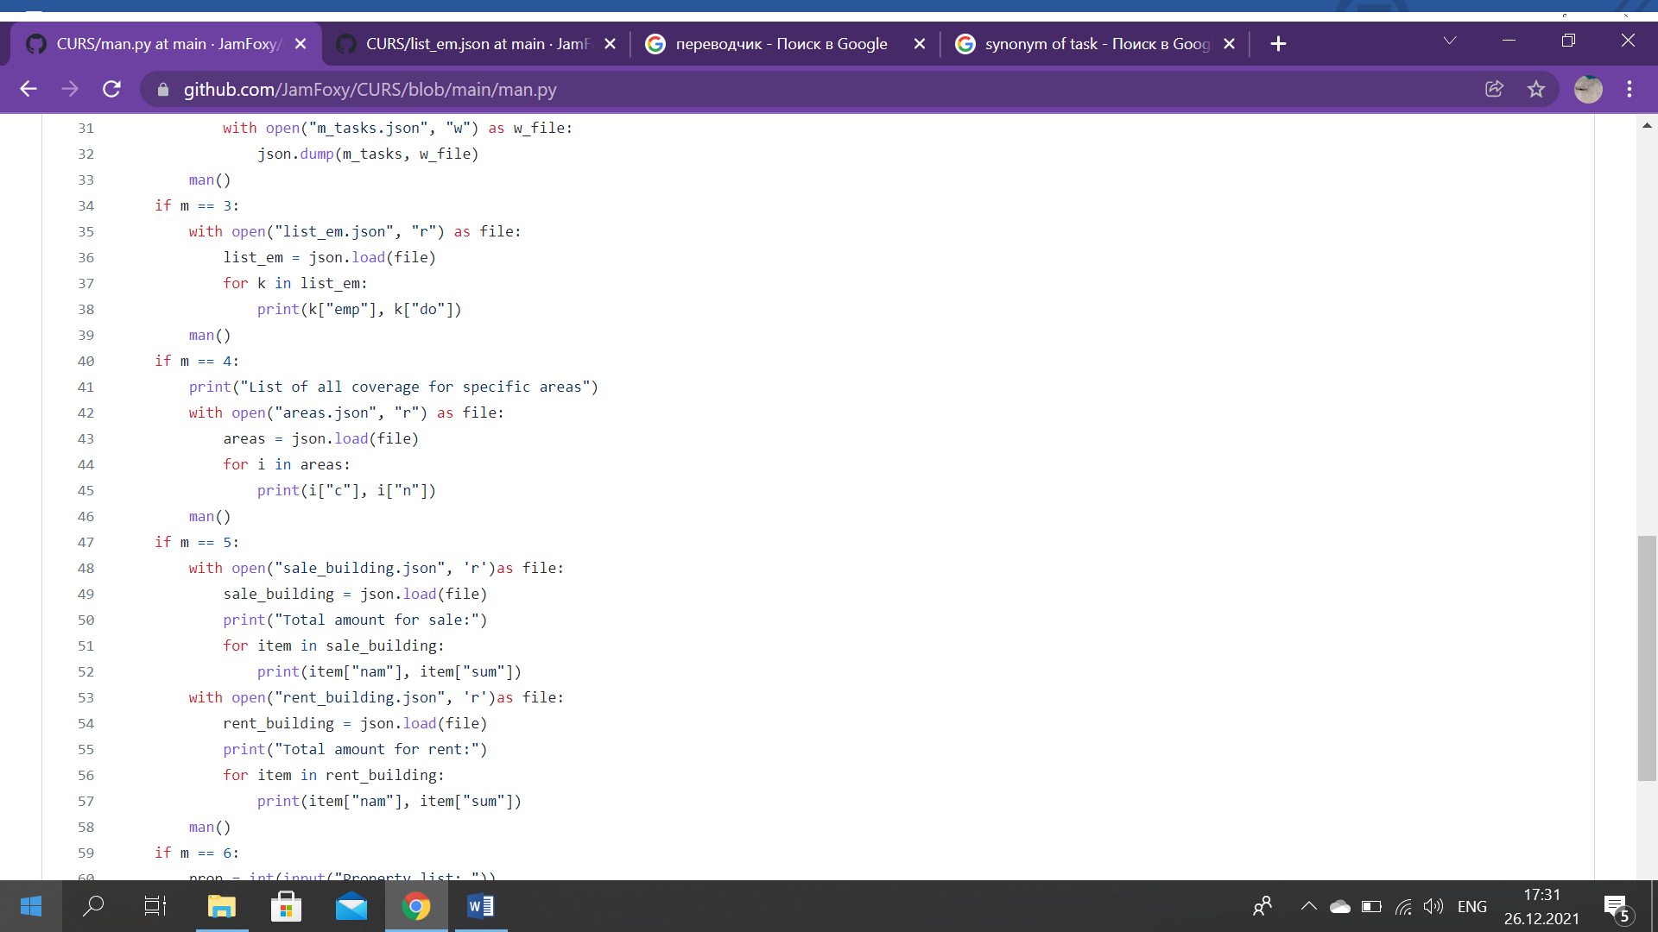

*Sc. 19*

We import ‘list_em’ file and print list of instructions to employees, where ‘emp’ means employee’s position and ‘do’- his duties. (Sc.19)

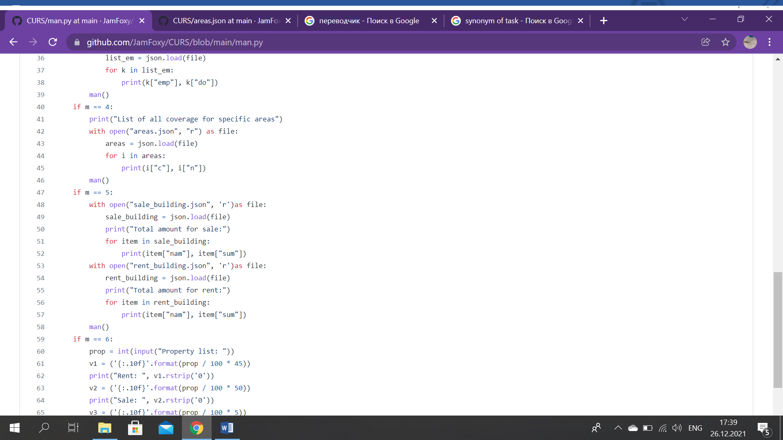

*Sc. 20*

To see the list of all coverage for specific areas, it is needed to load ‘areas’ file, where customer information from certain kyrgyz regions is sorted. We print this data and at the end, return to the main menu of manager’s account. (Sc.20)

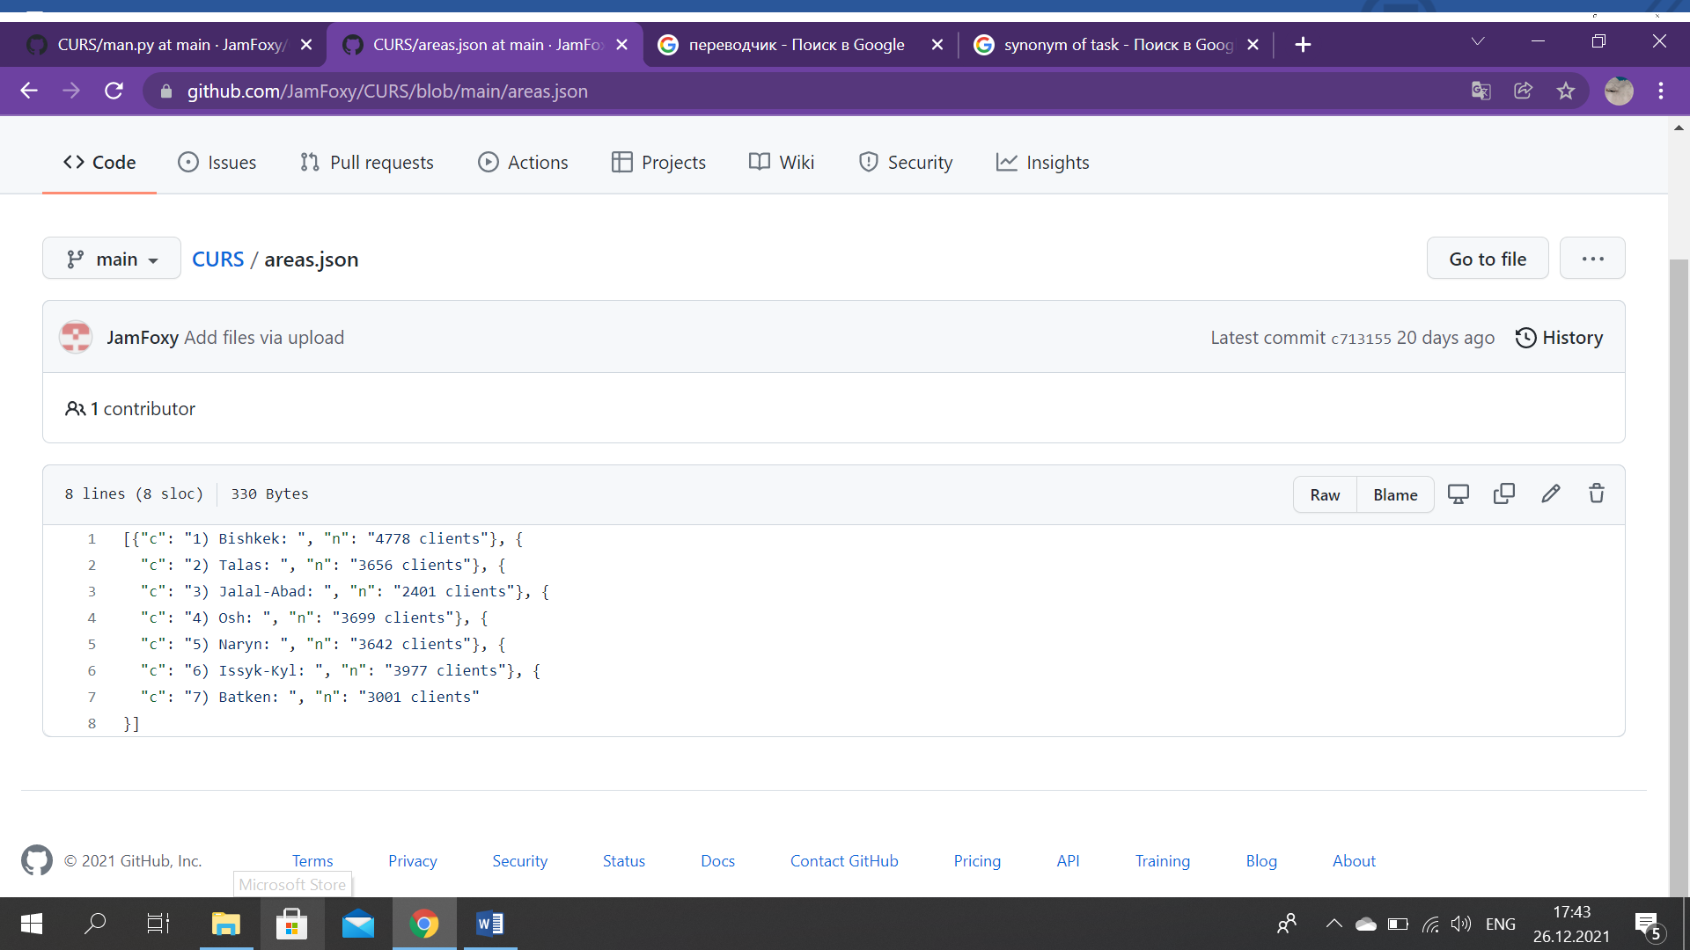

*Sc. 21:* ‘areas.json’

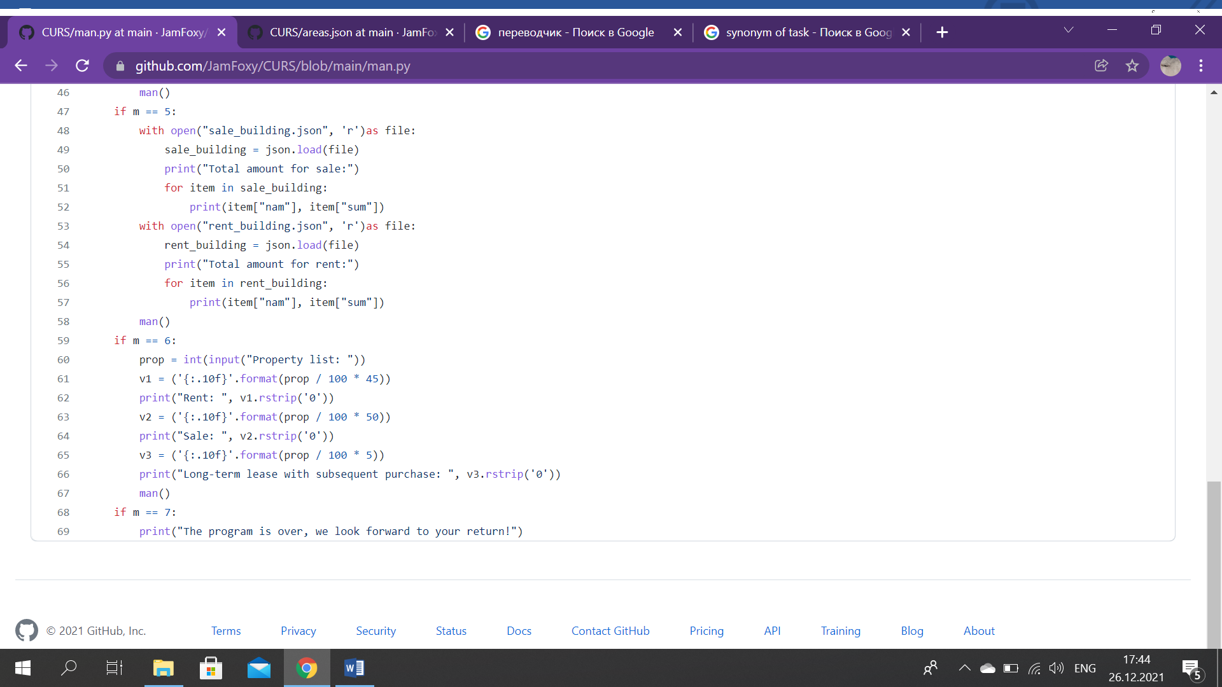

*Sc. 22*

To show the amount for real estate, firstly, it is necessary to open another file, which is called, ‘sale_building’. Therefore, total amount for sale is printed. Secondly, we load a ‘rent_building’ file, where we have stored data about amount for rent. And anologically print all information that is kept there and finally, return to the manager’s main menu. (Sc.22)

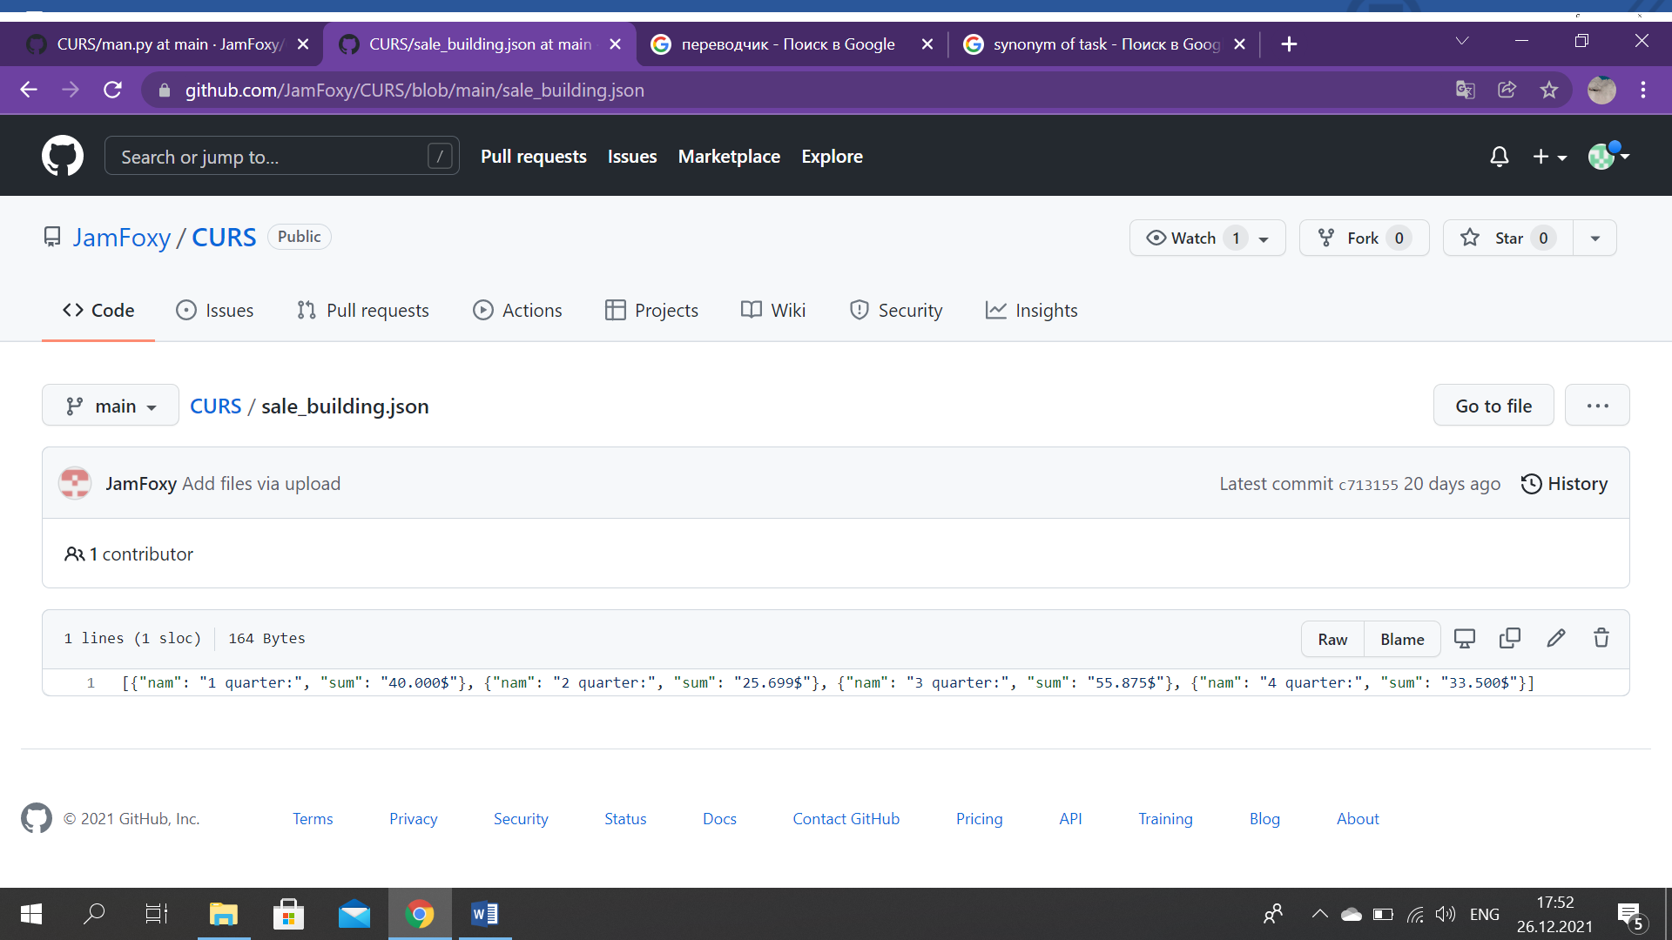

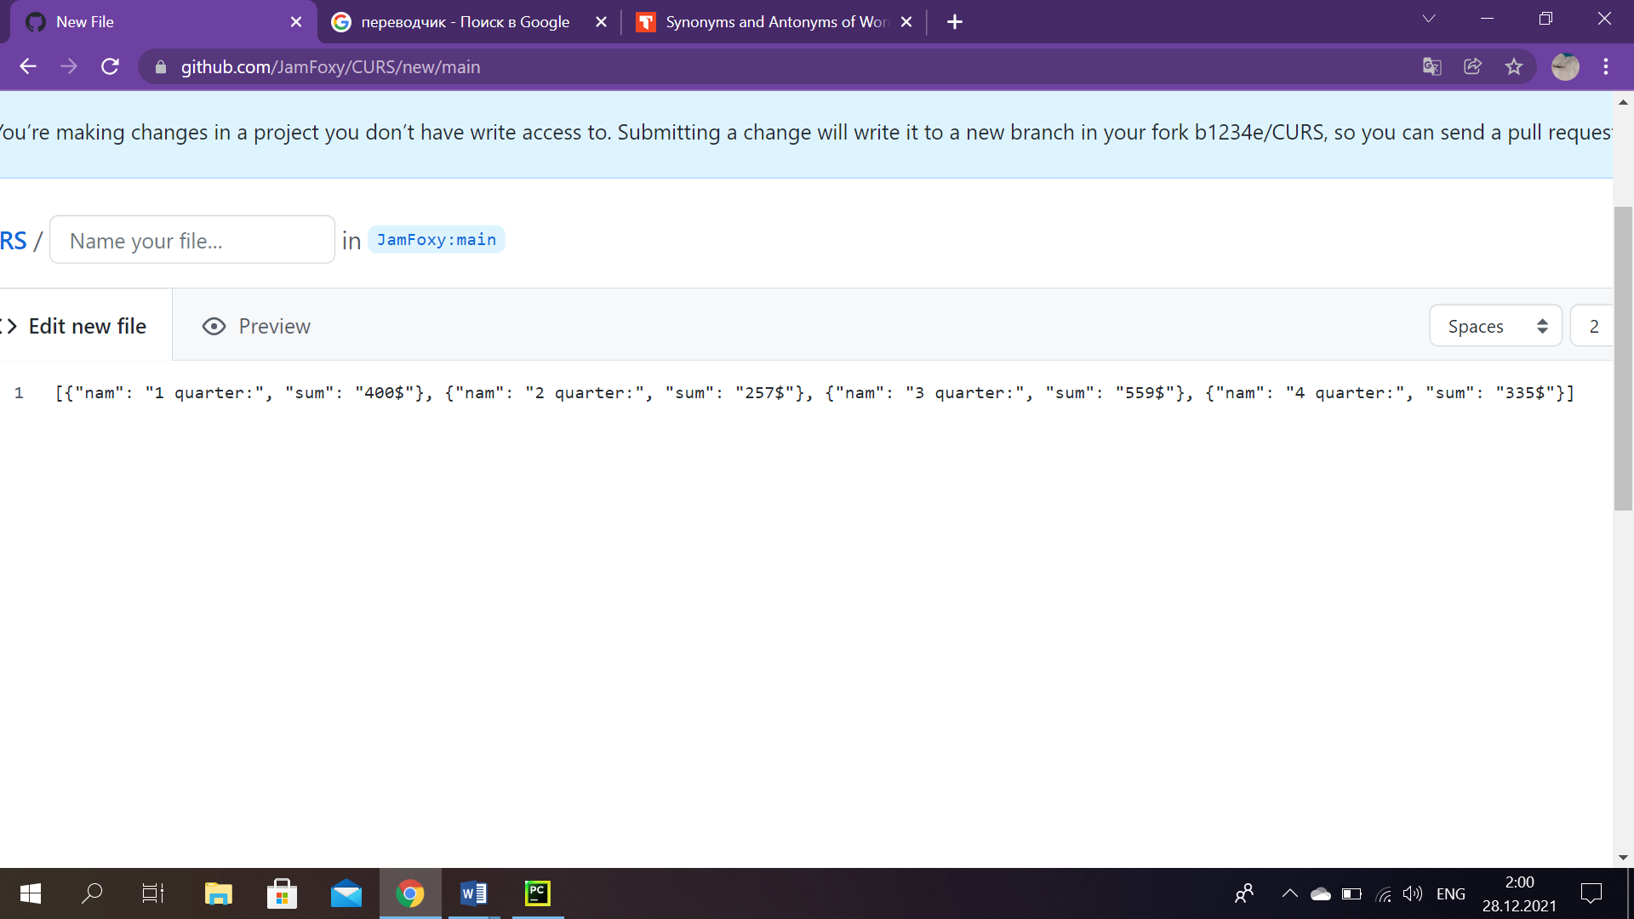

*Sc.23:* ‘sale_building.json’, ‘rent_building.json’ dictionaries.

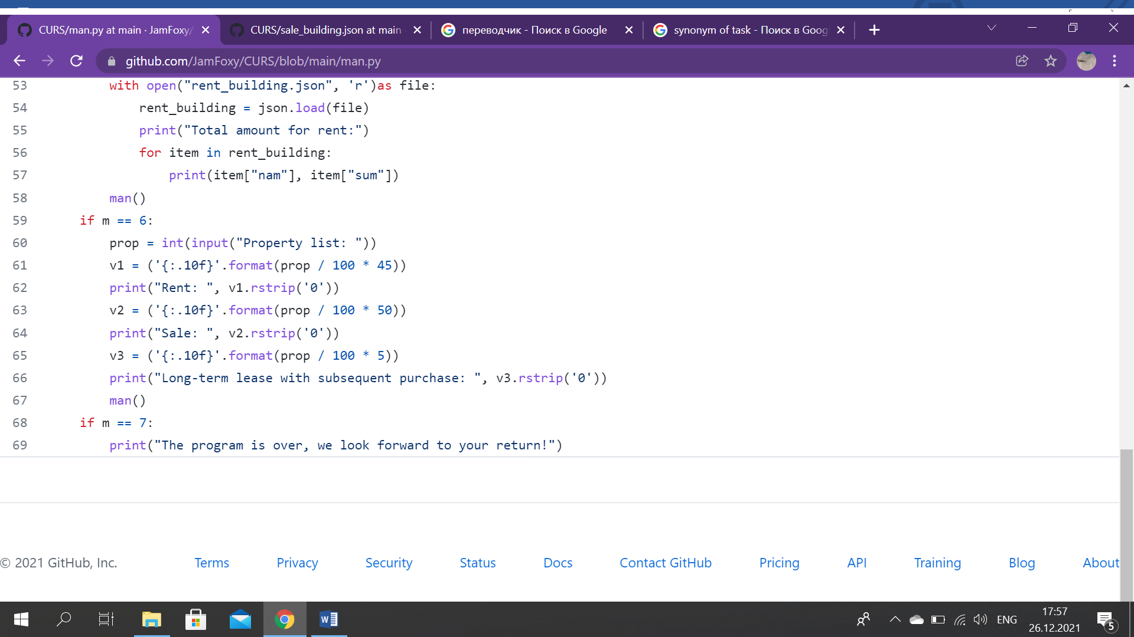

*Sc.24*

This part of code calculates percentage by category of real estate. 100% is the entire list of real estate – 1245 (the manager should type it), with which the real estate agency deals, for example 45% - Rent, 50% - Sale, 5% - long-term leasing with subsequent redemption. By simple mathematic calculations, the program outputs results. (Sc.24)

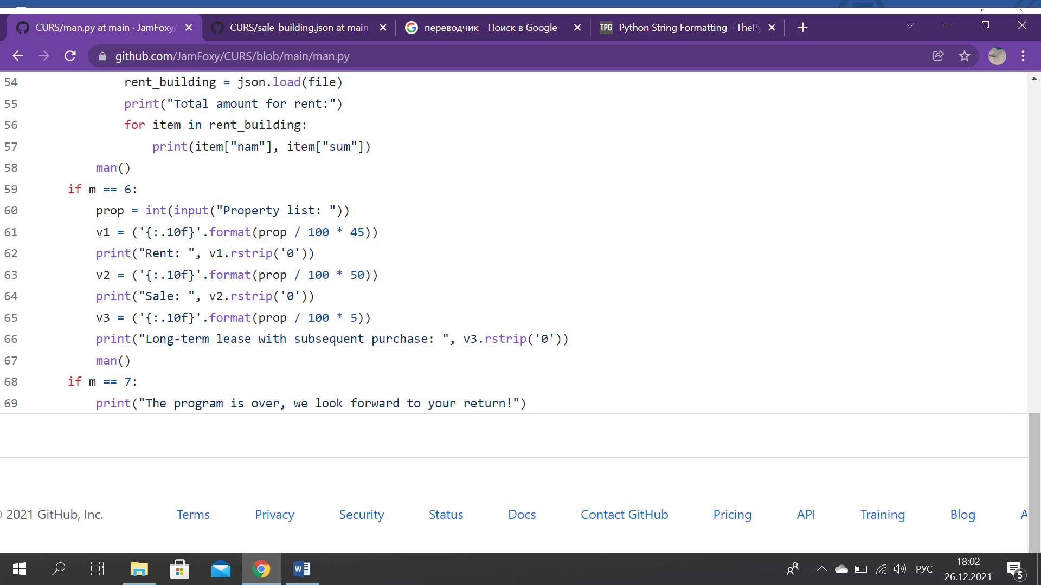

*Sc.25*

After all, if the number ‘7’ is entered, it means that marketer is done and the program is over. (Sc. 25)

# Main Part (Worker)

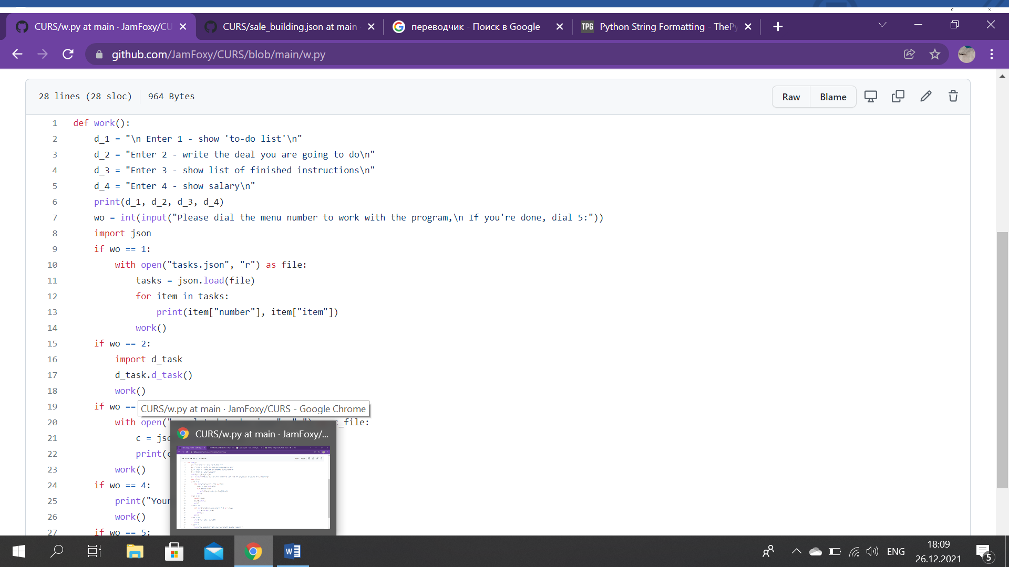

*Sc. 26*

For a worker the program in the beginning recommends to dial the menu number to work with it, then when everything is finished type ‘5’. If an employee enters 1, signifies that he wants the system shows a ‘to-do’ list, 2- wants to write deals he is going to do, 3- to see a list of finished instructions, 4- to see salary. (Sc.26)

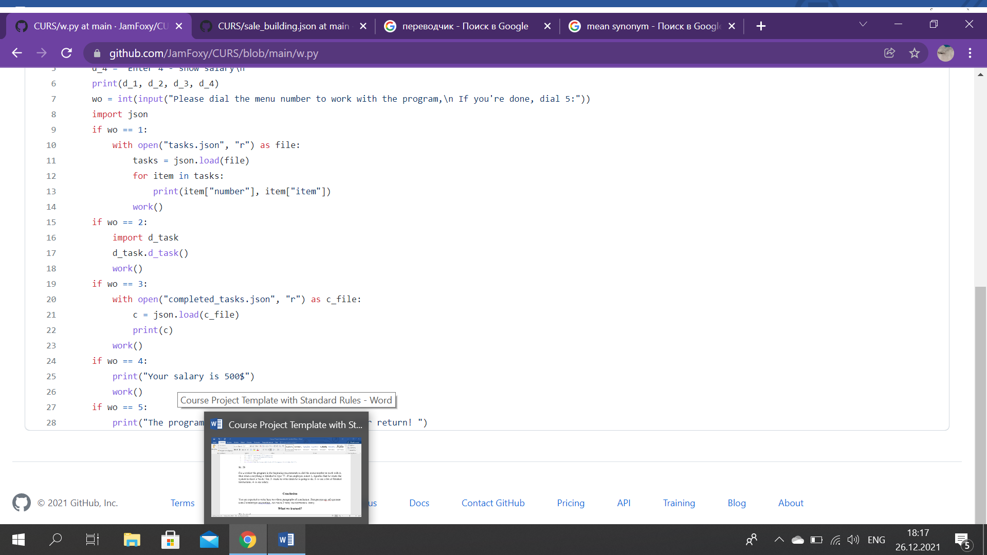

*Sc. 27*

Considering that we use files with JSON extension, it is required to import this database. After that by importing (opening) ‘tasks.json’, program prints all the data in this file. (Sc.27)

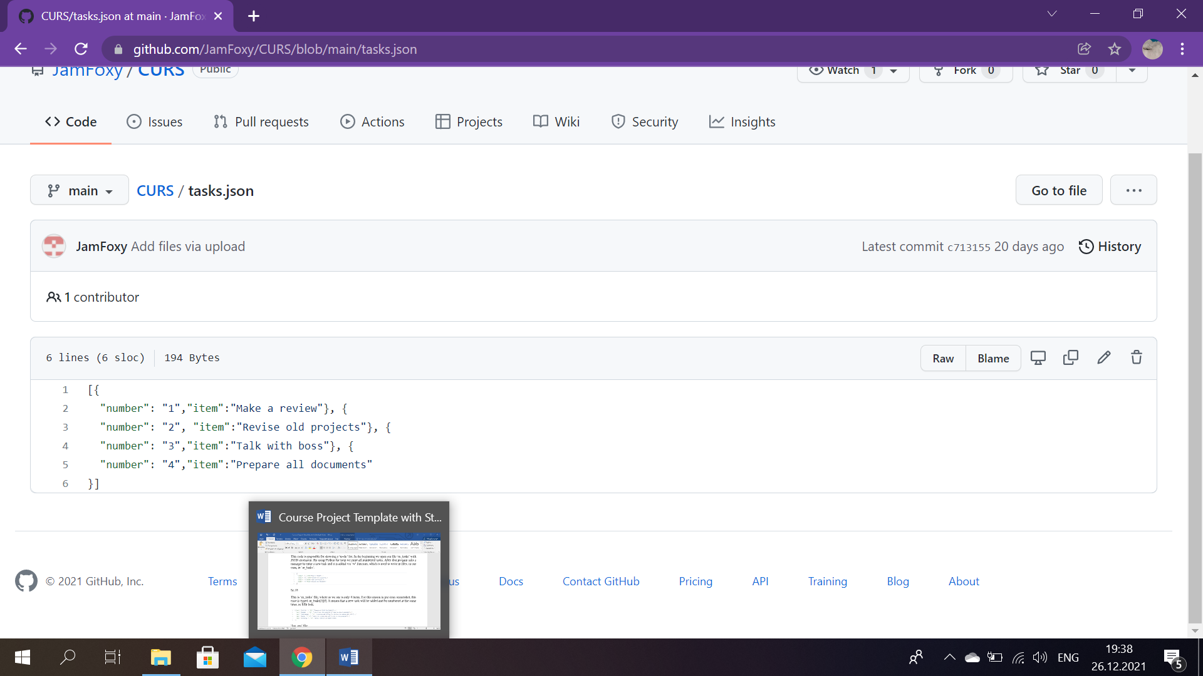

*Sc. 28:* ‘tasks.json’

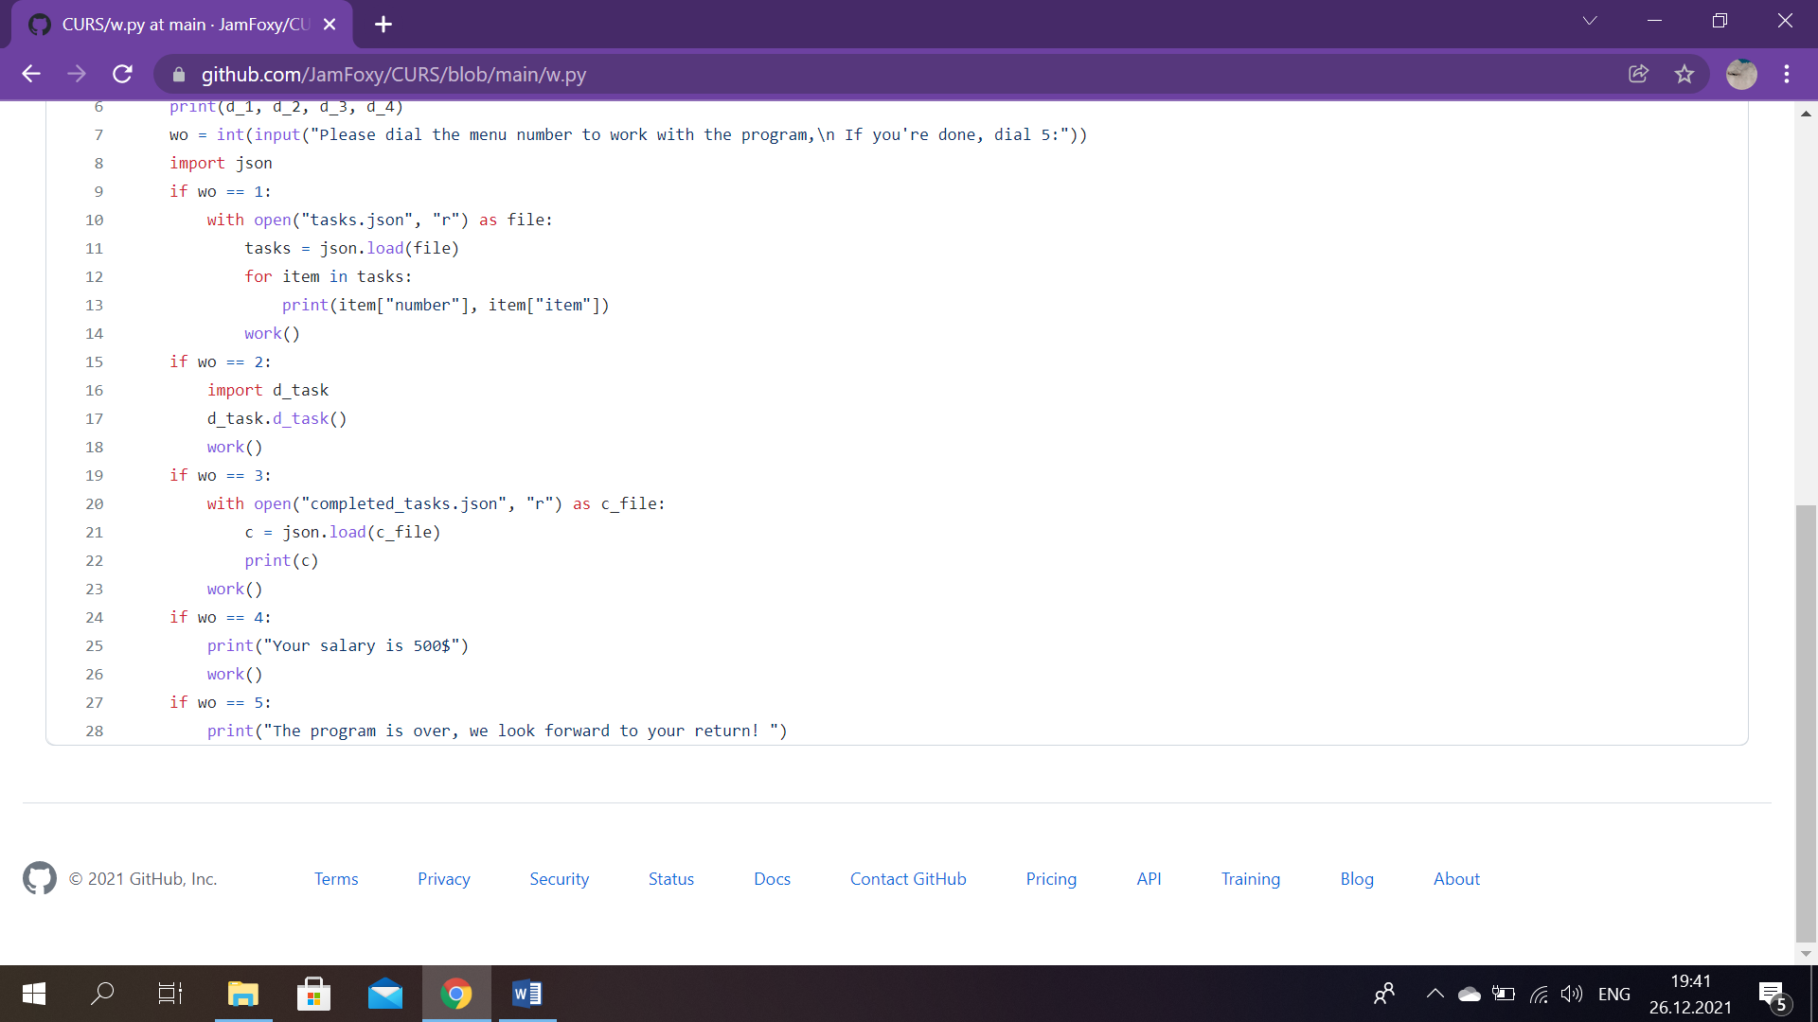

*Sc.29*

To write the deal that worker intends to do, we decided to create new function ‘d_task’. For this reason, we imported it and then when function does its work, we return to the main menu of worker’s account. (Sc.29)

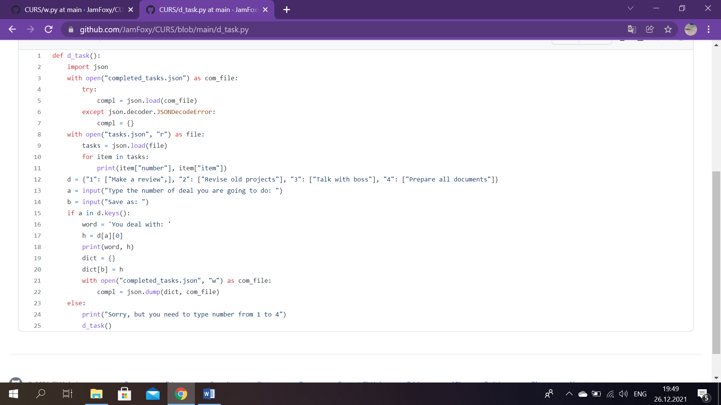

*Sc. 30*

In the very beginning we import JSON database, then open ‘completed_tasks’ file. And use ‘try except’ block, which is basically is needful for catching and handling exceptions. Python executes the code following the try statement as a "normal" part of the program. The code following the except statement is the program's response to any exceptions in the previous try clause. Next step is to import ‘tasks.json’ file and print all the materials in that file. (Sc.30)

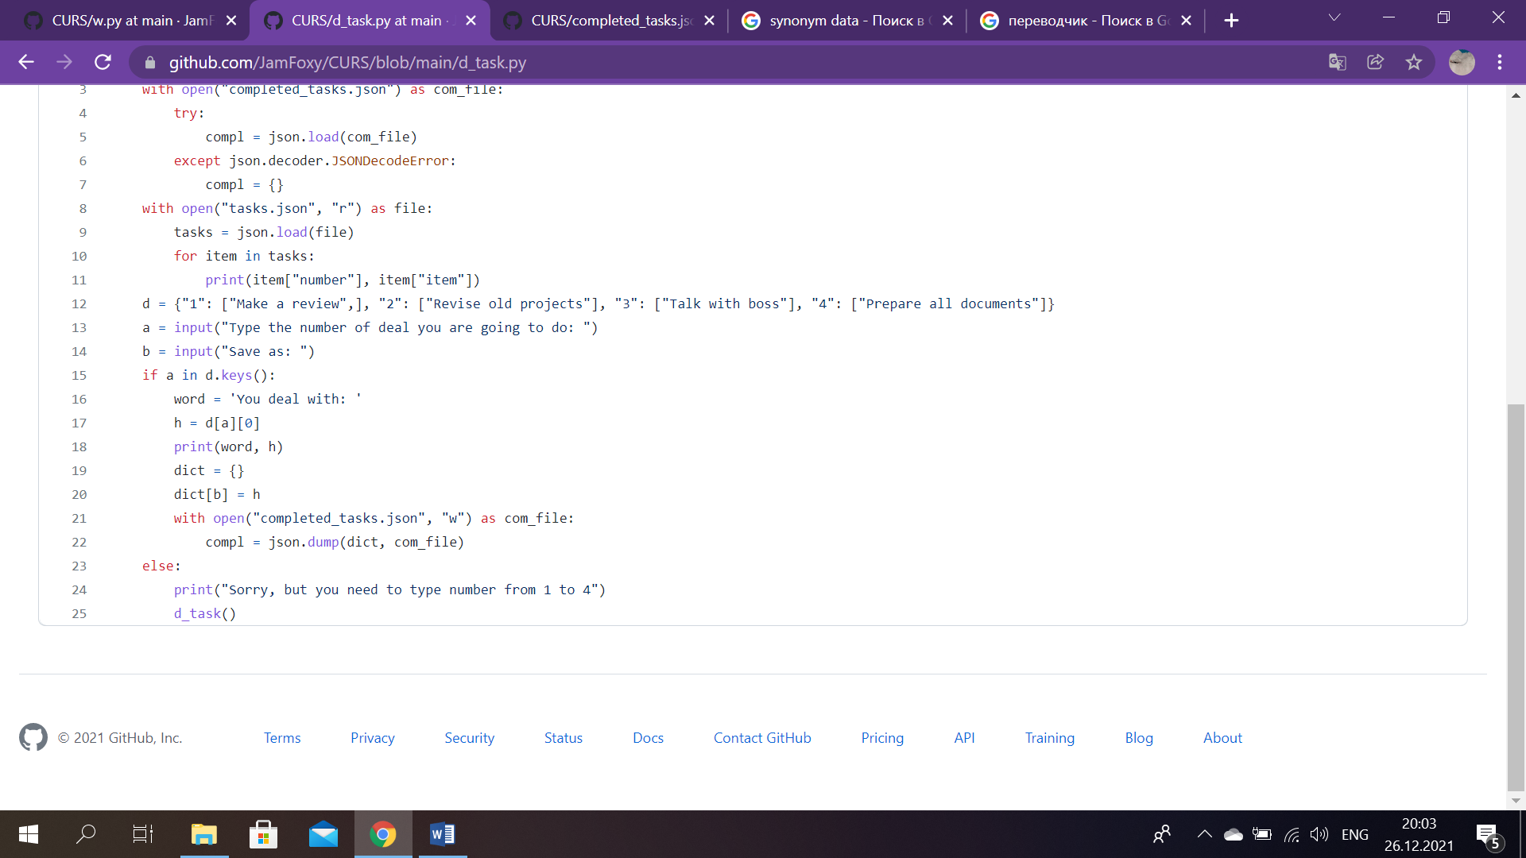

*Sc. 31*

We created new variable ‘d’, which contains information that is in ‘tasks.json’. Later this variable will help us. Then program asks a user to type the number of work he is going to do and to type how he wants ro save it. If a worker enters number from 1 to 4, the system outputs ‘You deal with:’ and the task he chose, for instance, lets say 2, then it looks like this: ‘You deal with: Revise old projects’. After that we created variable ‘dict’ (a new dictionary), with its help we open ‘completed_tasks’ and by using method ‘json.dump’, which converts the Python objects into appropriate JSON objects, we save this new dictionary into that file.

If a user entered another digit, that is not on the sequence of numbers from 1 to 4, then an error message is displayed. And lastly, the program will go back to ‘d_task’ function’s menu. (Sc.31)

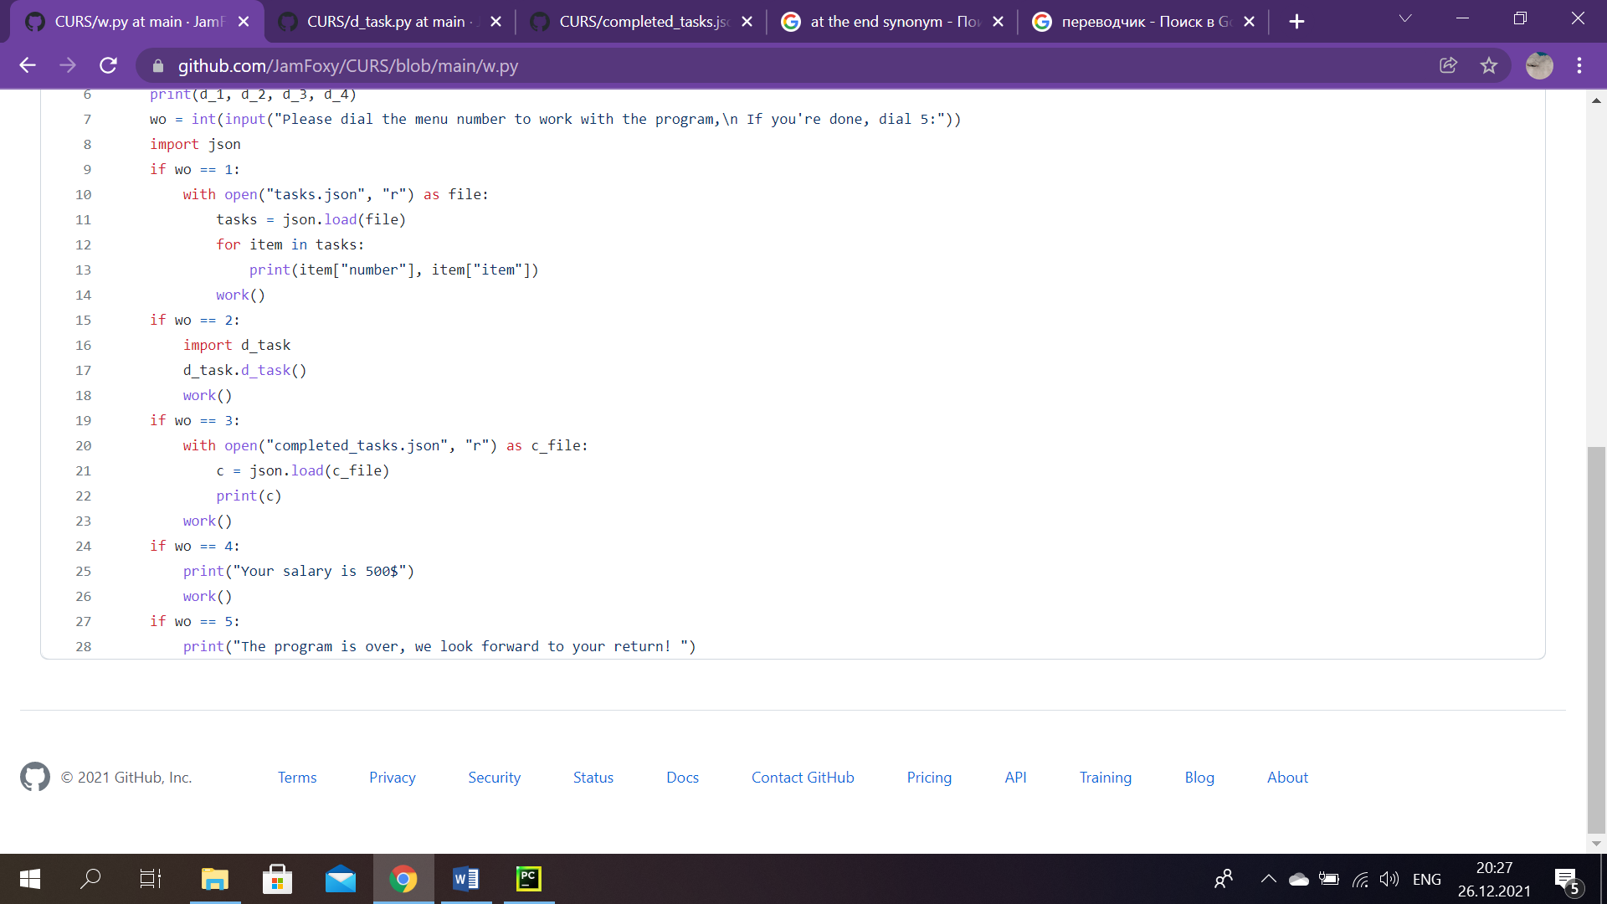

*Sc.32*

By loading idem file and outputing all the information it has, we show the list of finished instructions.

If a worker wants to see his salary, he should type the number 4, than the program prints his salary, in our case worker’s salary is 500 $. And at the end we go back to the main menu. (Sc.32)



*Sc. 33*

If the worker types ‘5’, that means that he has finished, thus, the system goes with the words: ‘The program is over, we look forward for your return’. (Sc.33)

# Main Part (Director’s account)

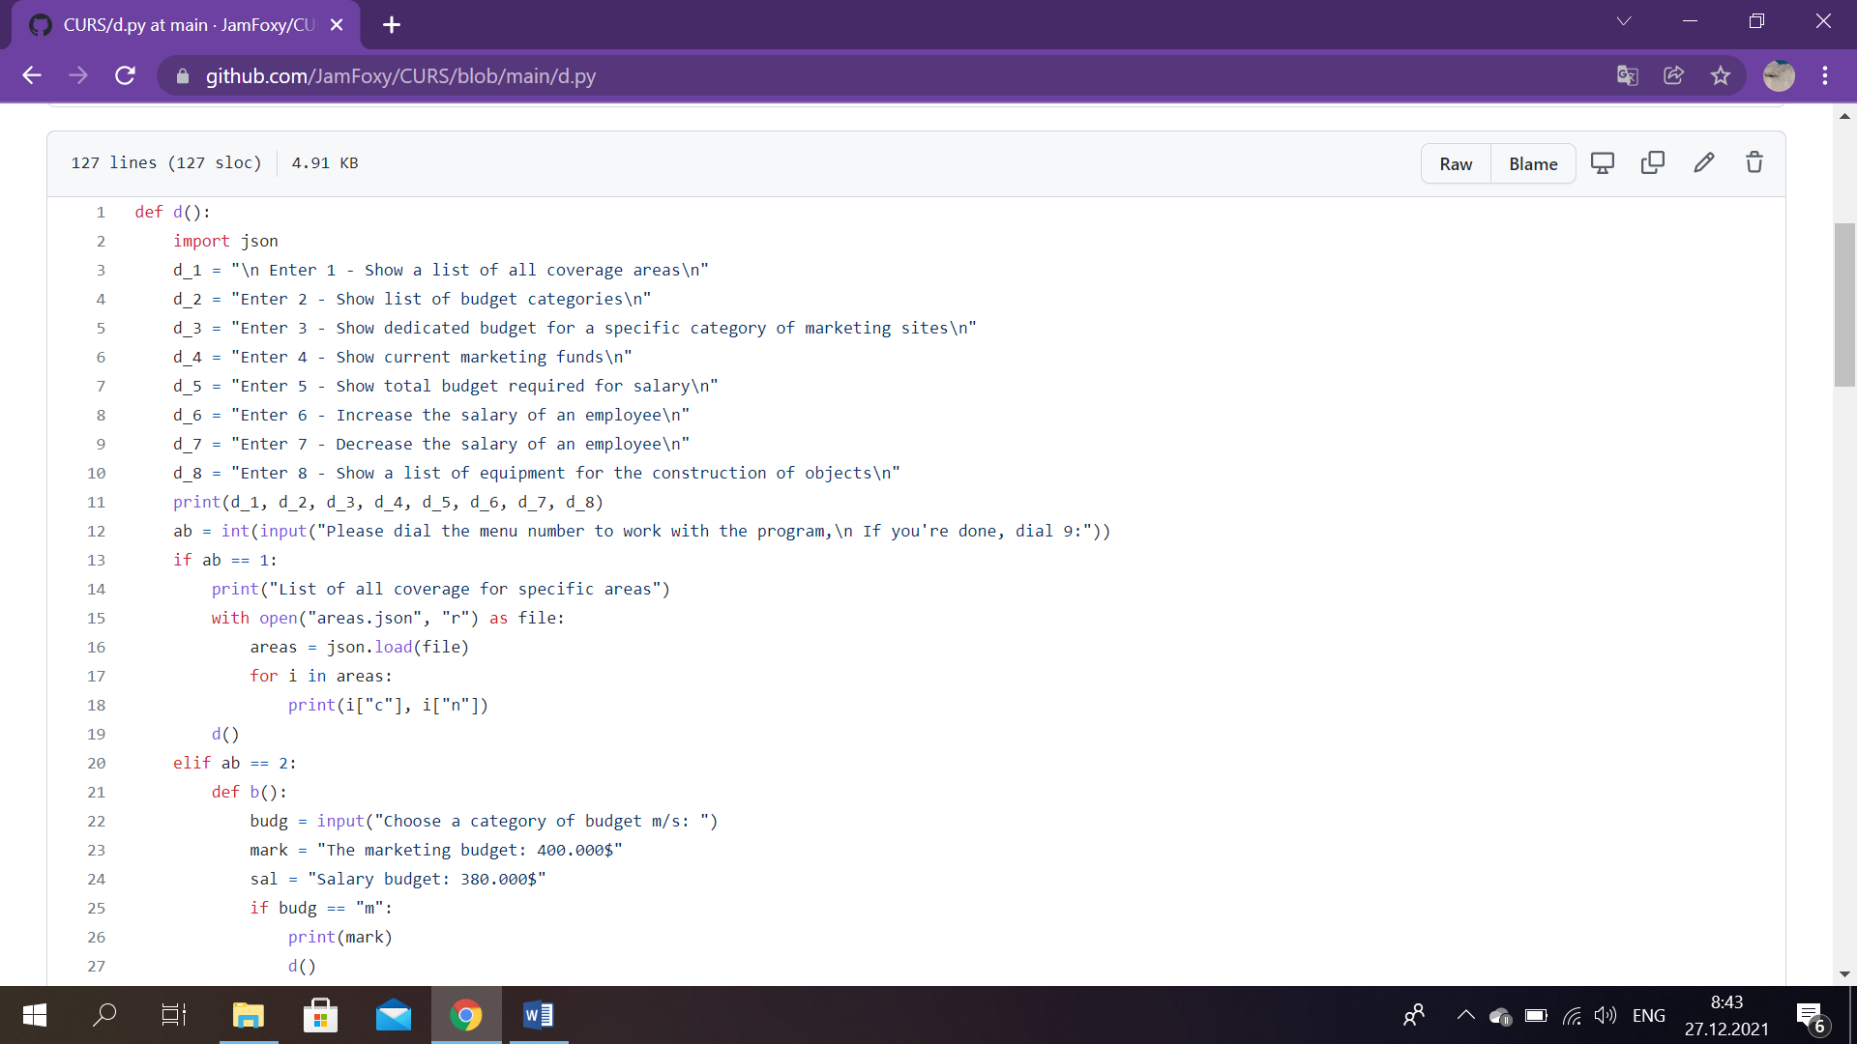

*Sc. 34*

For a director’s account importing JSON also should be performed. After that program suggests eight options to work with. If a user wants to see a list of all coverage areas, he dials 1. System shows list of budget categories, when a director types 2. If you want to see dedicated budget for a specific category of marketing sites, enter 3. Want to see current marketing funds? Then dial 4. Number 5 is responsible for showing total budget required for salary, 6- for increasing the salary of an employee, whereas 7 is in charge of working with decreasing the salary of an employee. And, finally, program shows a list of equipment for the construction of objects, if a user dialed 8. (Sc.34)

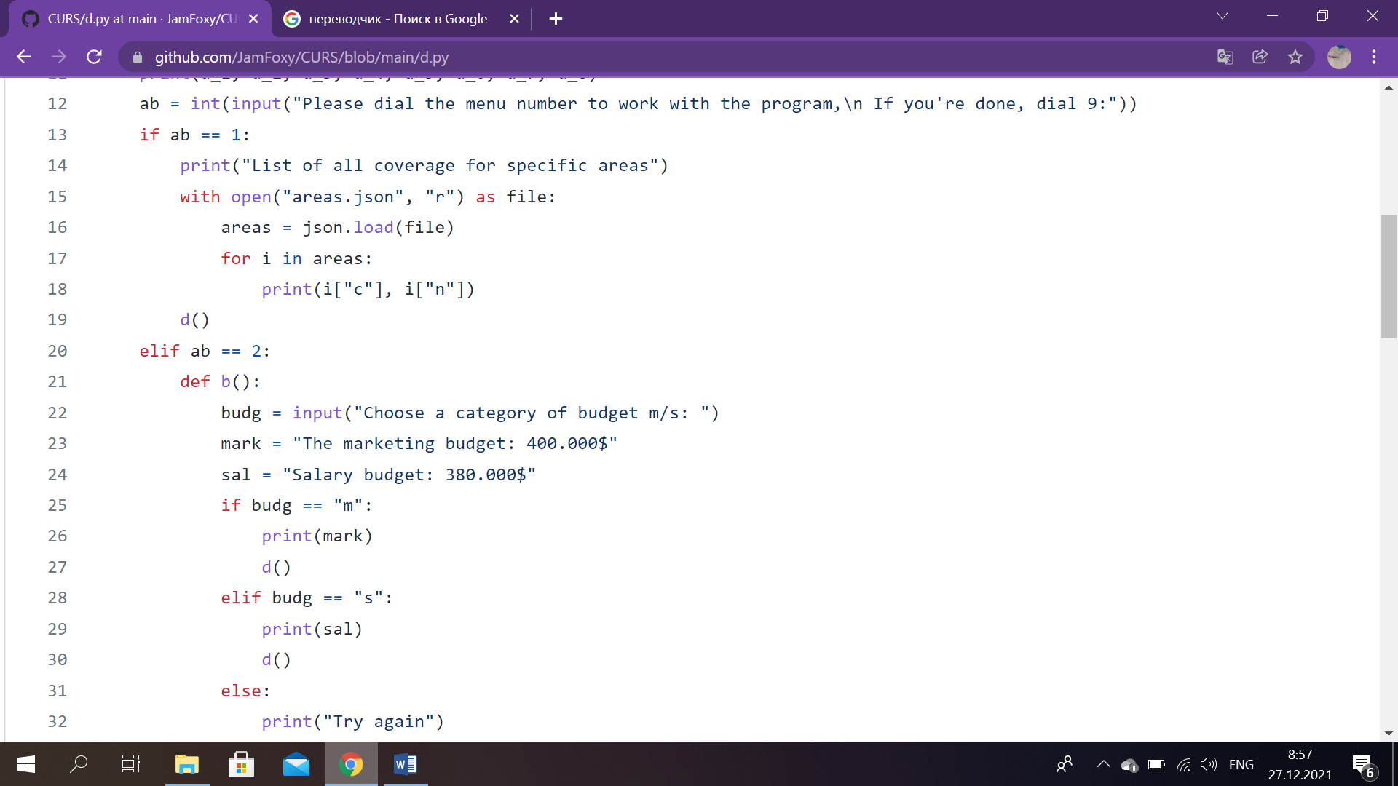

*Sc. 35*

Subsequently, on condition that a director selects number 1, program prints the data consisted in the file ‘areas.json’, as we see with JSON extension. (Sc.35)

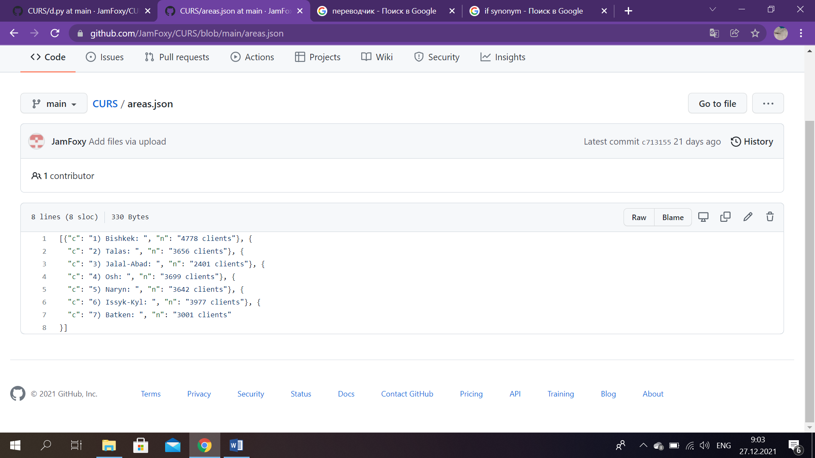

*Sc. 36:* ‘areas.json’

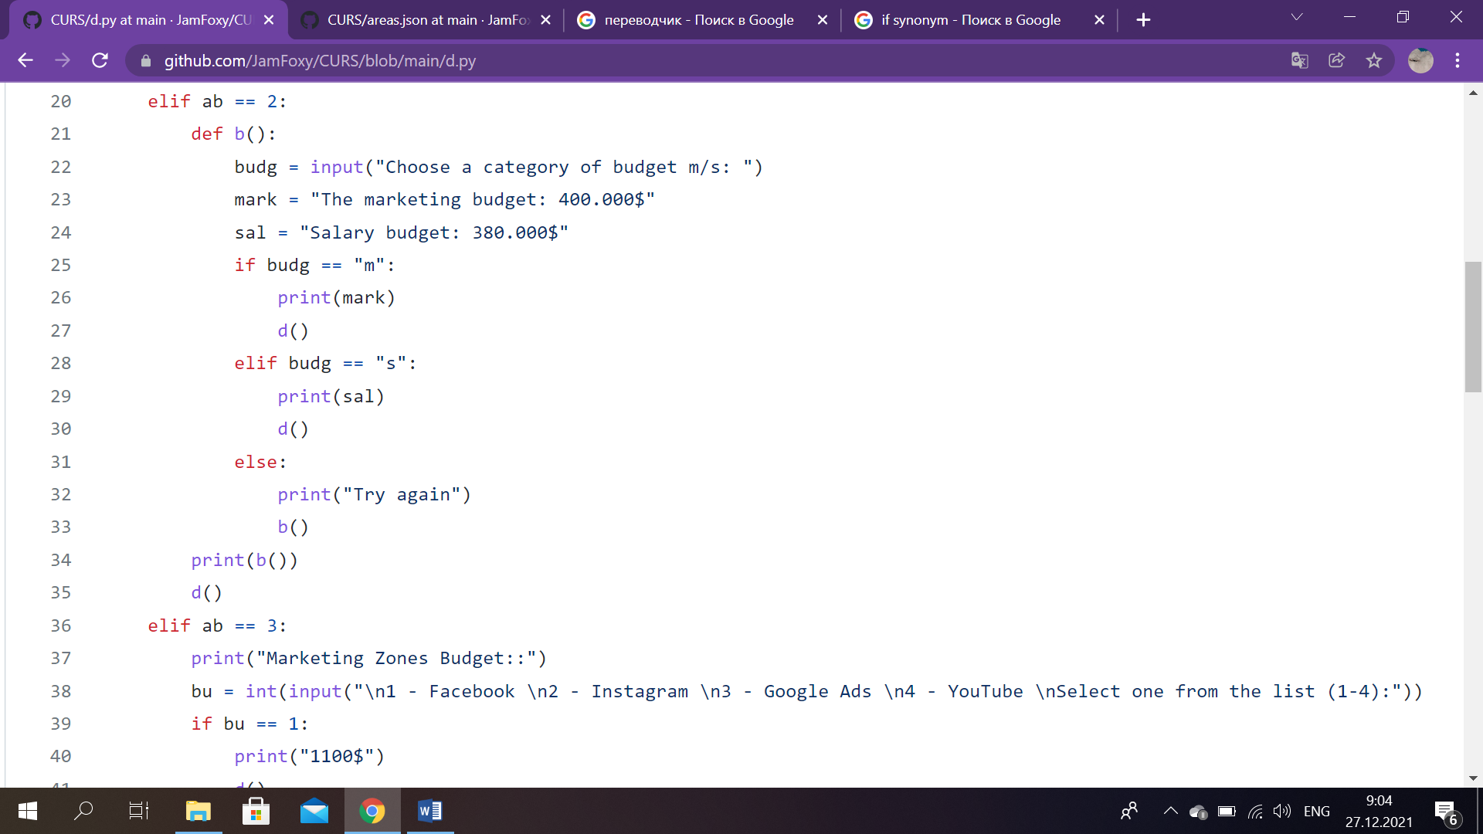

*Sc. 37*

To show information about budget, where at the same time the director can choose a category. In the beginning, we created new function ‘def b()’. After that we created three variables, first variable asks pick a category of budget. Second variable store information about the marketing budget and the third variable is in charge of salary budget. So, program prints data in the second variable, if the user types ‘m’ and anologically as long as you want to see salary budget, it is necessary to enter ‘s’, then data in the third variable is outputed. After printting the corresponding information, system returns to the main menu of director’s account.

In case when another symbols besides ‘s’ or ‘m’ are entered, message to try again is displayed then we go back to this ‘def b()’ function. (Sc.37)

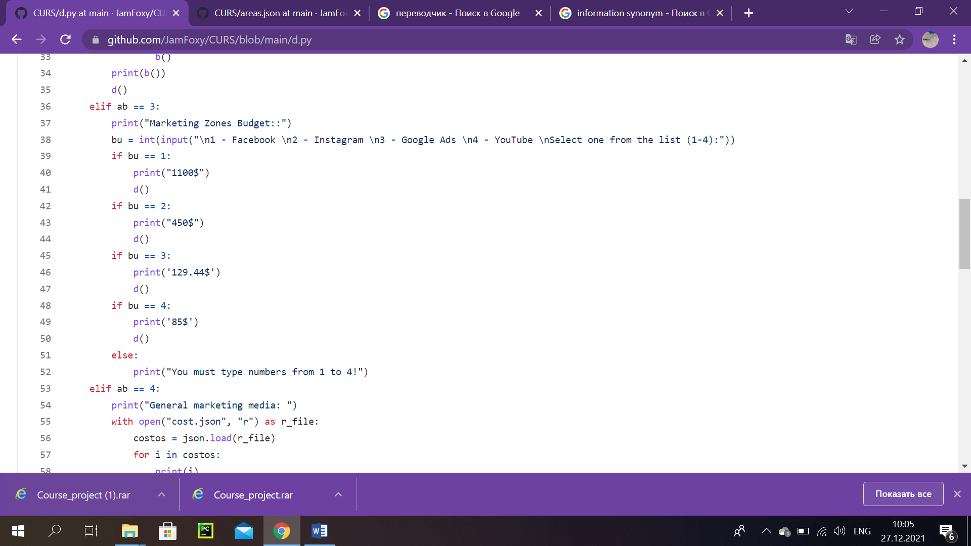

*Sc. 38*

Number 3 is responsible for dedicating budget for a specific category of marketing sites. Afterwards, it is needed to choose a platform, which is already numbered. If you select Facebook, that goes as the first platform on the list, relevant details are showed, after printing this information, program goes back to the director’s menu. Same goes to another platforms: Instagram (2), Google ads (3), YouTube (4).

It is required to select only from this list, numbered from 1 to 4. In other words, if you type incorrectly, this problem will show off. (Sc.38)

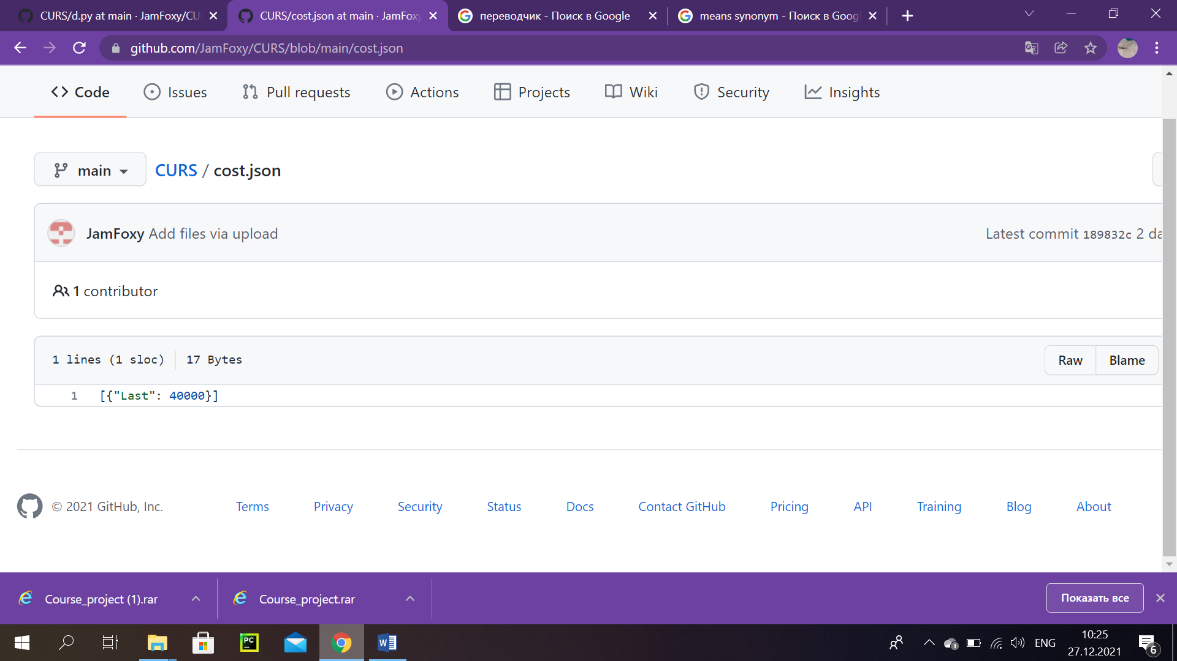

‘cost.json’

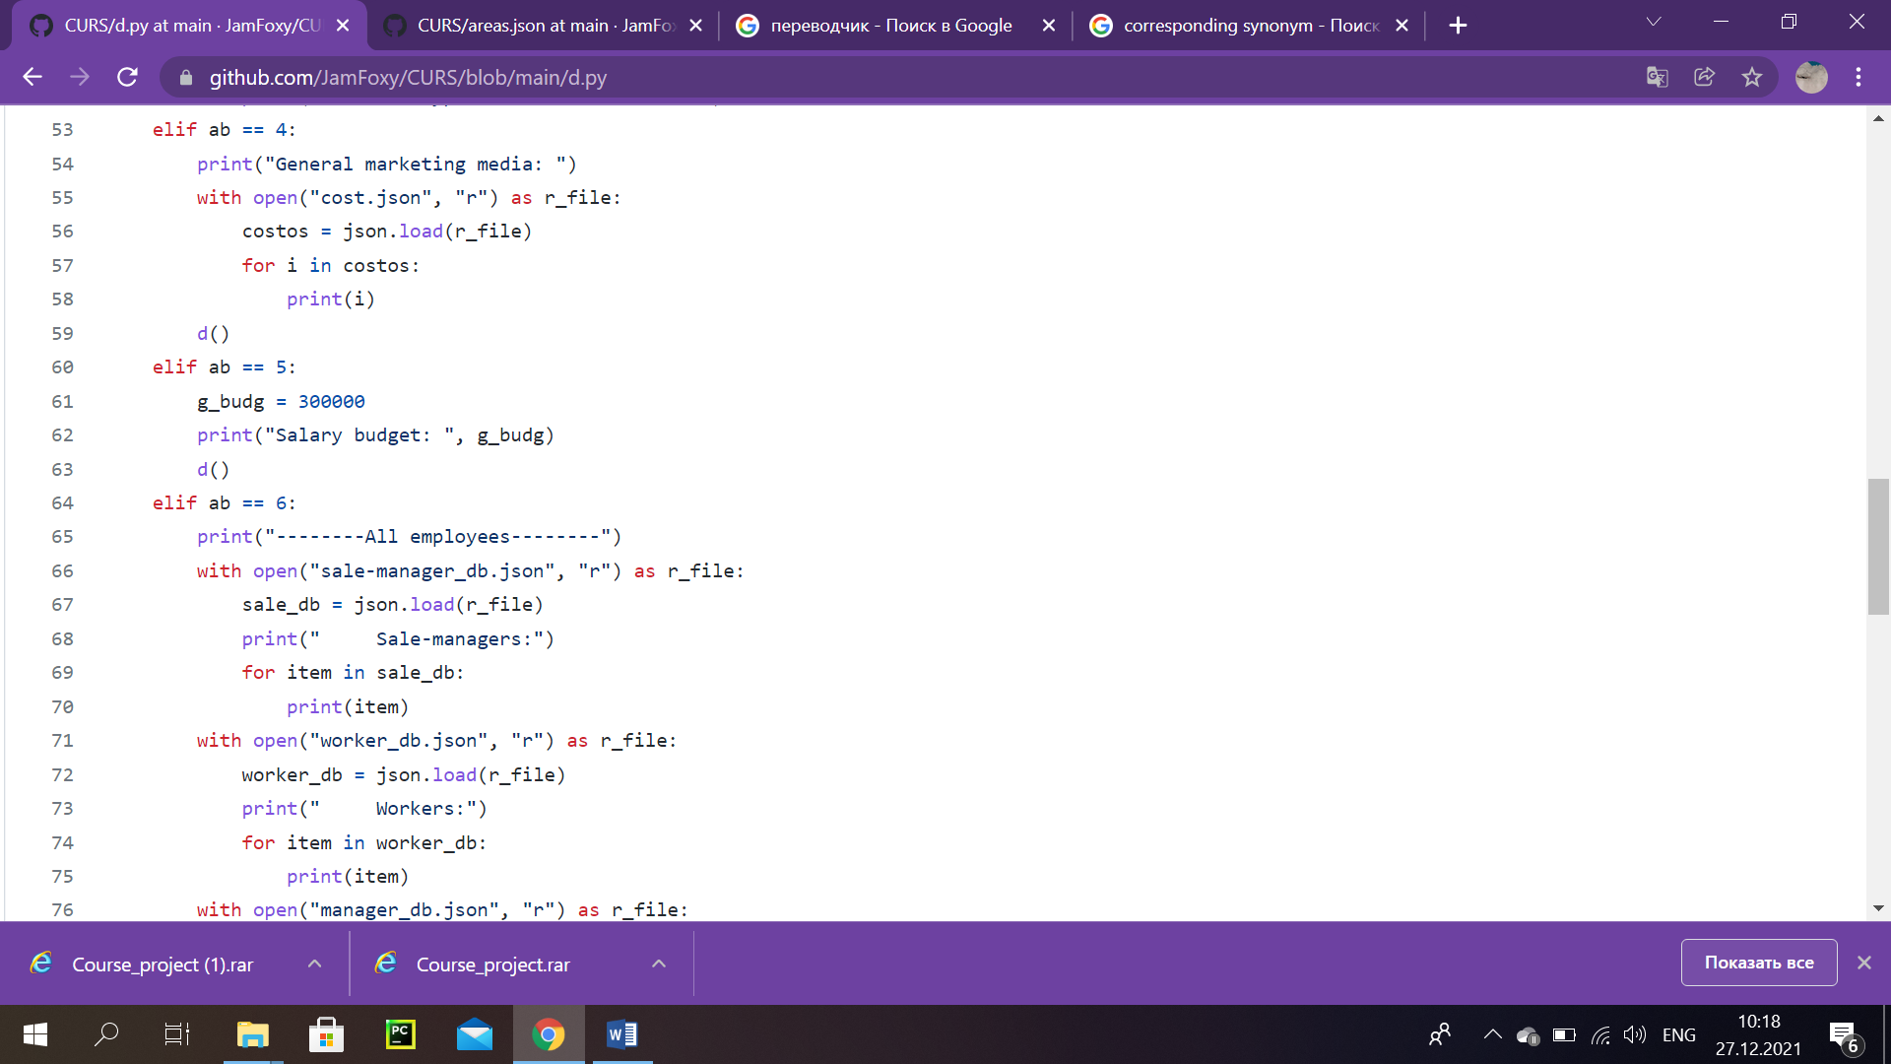

*Sc. 39*

As we know, if the user chooses 4, that stands for showing current marketing funds. To make it work, we upload new JSON file, called ‘cost.json’ and print all the information, consisted there. (Sc.39)

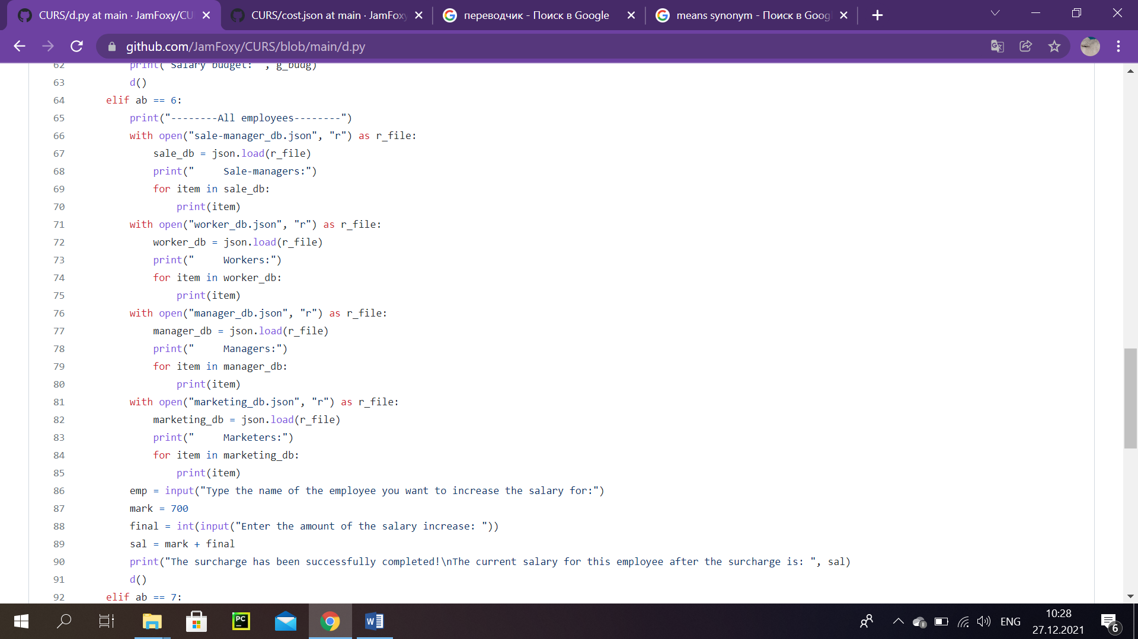

*Sc. 40*

To increase salary of a worker, following steps should be performed:

1) program outputs all employees, by importing four different files, which consist of data about various position workers. As we see on the screenshot 40: first goes, sale-managers info, then- workers list. After that managers and finally, marketer’s lists.

2) The director should enter the name of the worker he wants to increase salary for.

3) The amount of the salary increase should be entered afterwards.

4) There is a buil-in amount of money (salary) for an employee. In the end, program sums up entered amount by the director and inbuilt quantity.

5) The result of calculation is printed. (Sc.40)

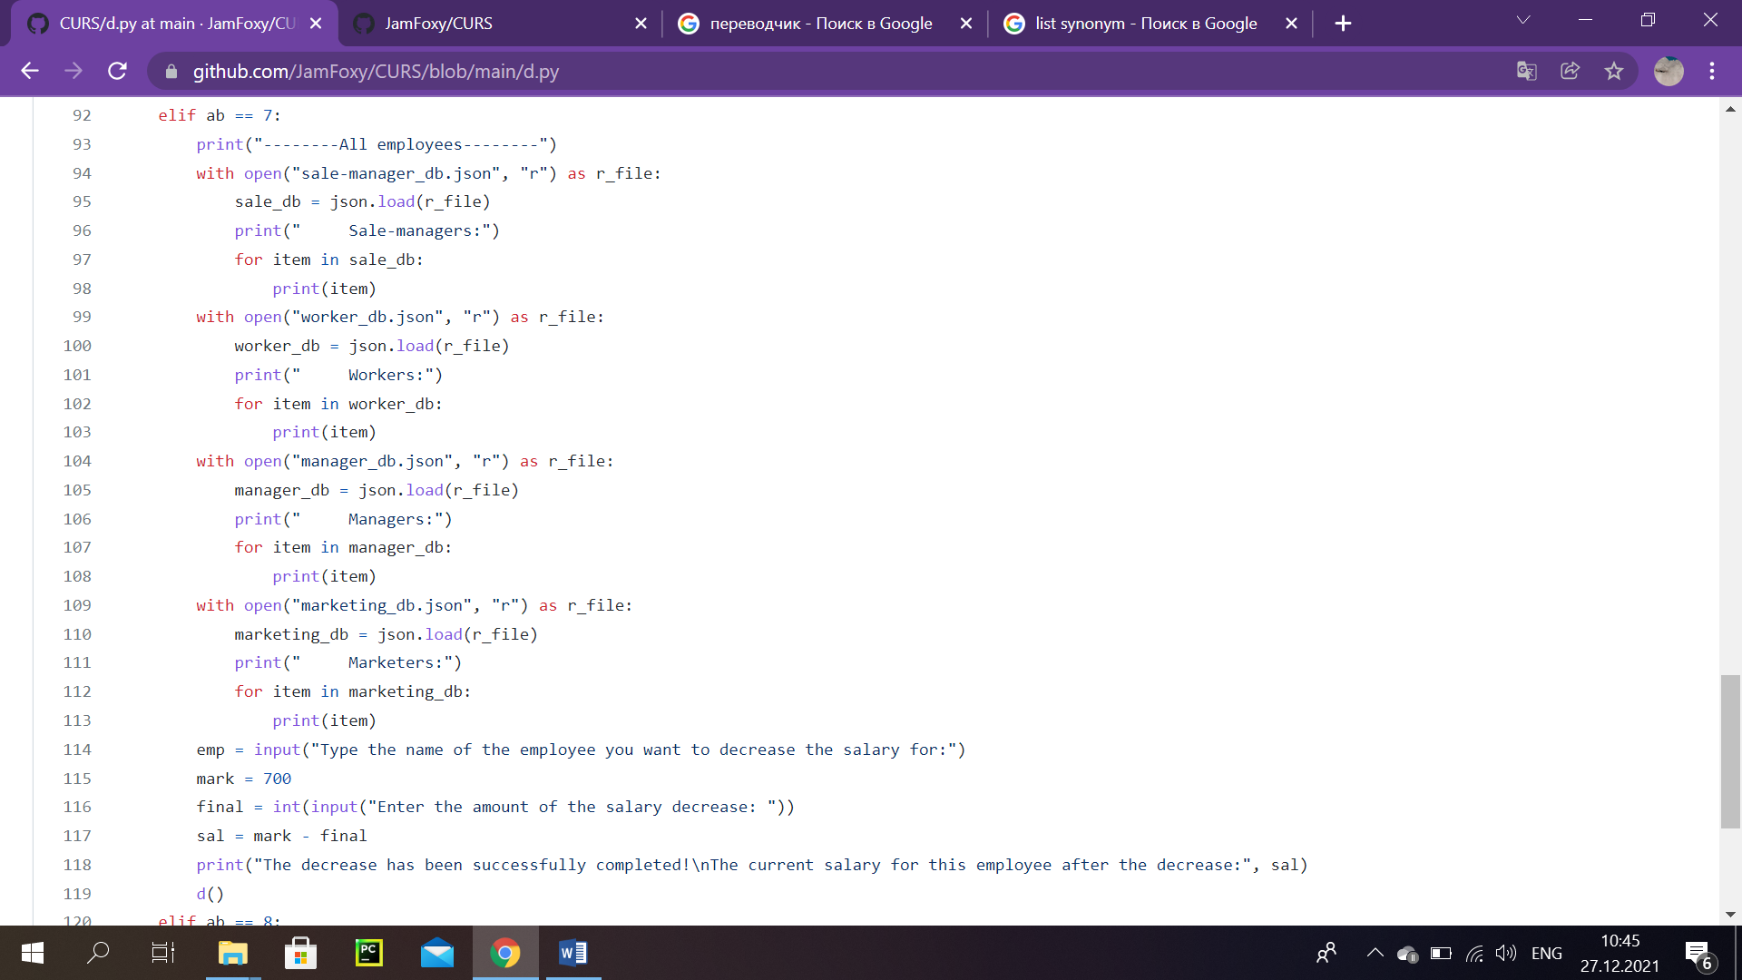

*Sc. 41*

For decreasing salary of a worker, we did almost everything identically. The first step in previous menu option is completely alike. There are some insignifical differences: the director should enter the name of an employee, he wants to decrease salary for. And then this typed amount is subtracted from built-in quantity. At the end, the result is printed. After we go back to the main menu f the director’s account. (Sc.41)

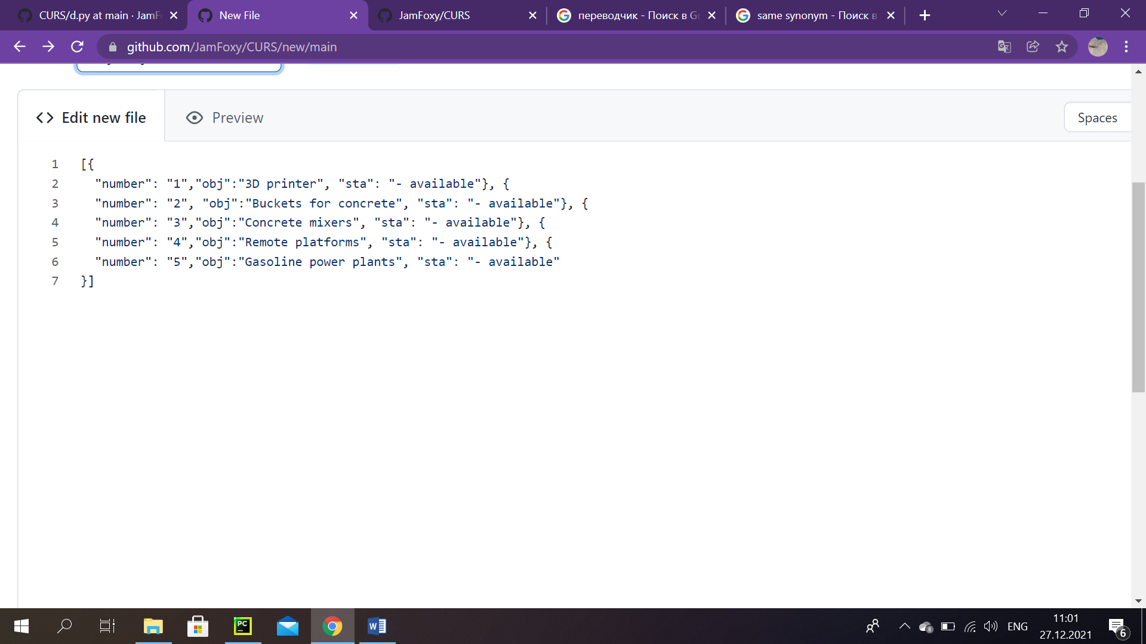

‘objects.json’

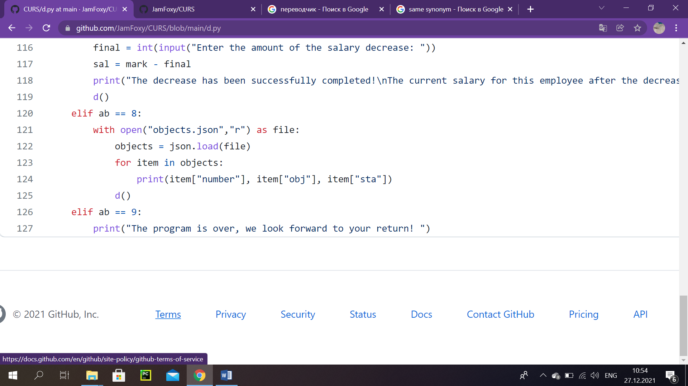

*Sc.42*

To see a list of equipment for the construction of objects, these actions were made: first of all, we opened a file, called ‘objects.json’ with, obviously, JSON extension, then loaded it and printed data, consisted there. And ofcourse, in the end we return to the main menu. (Sc.42)

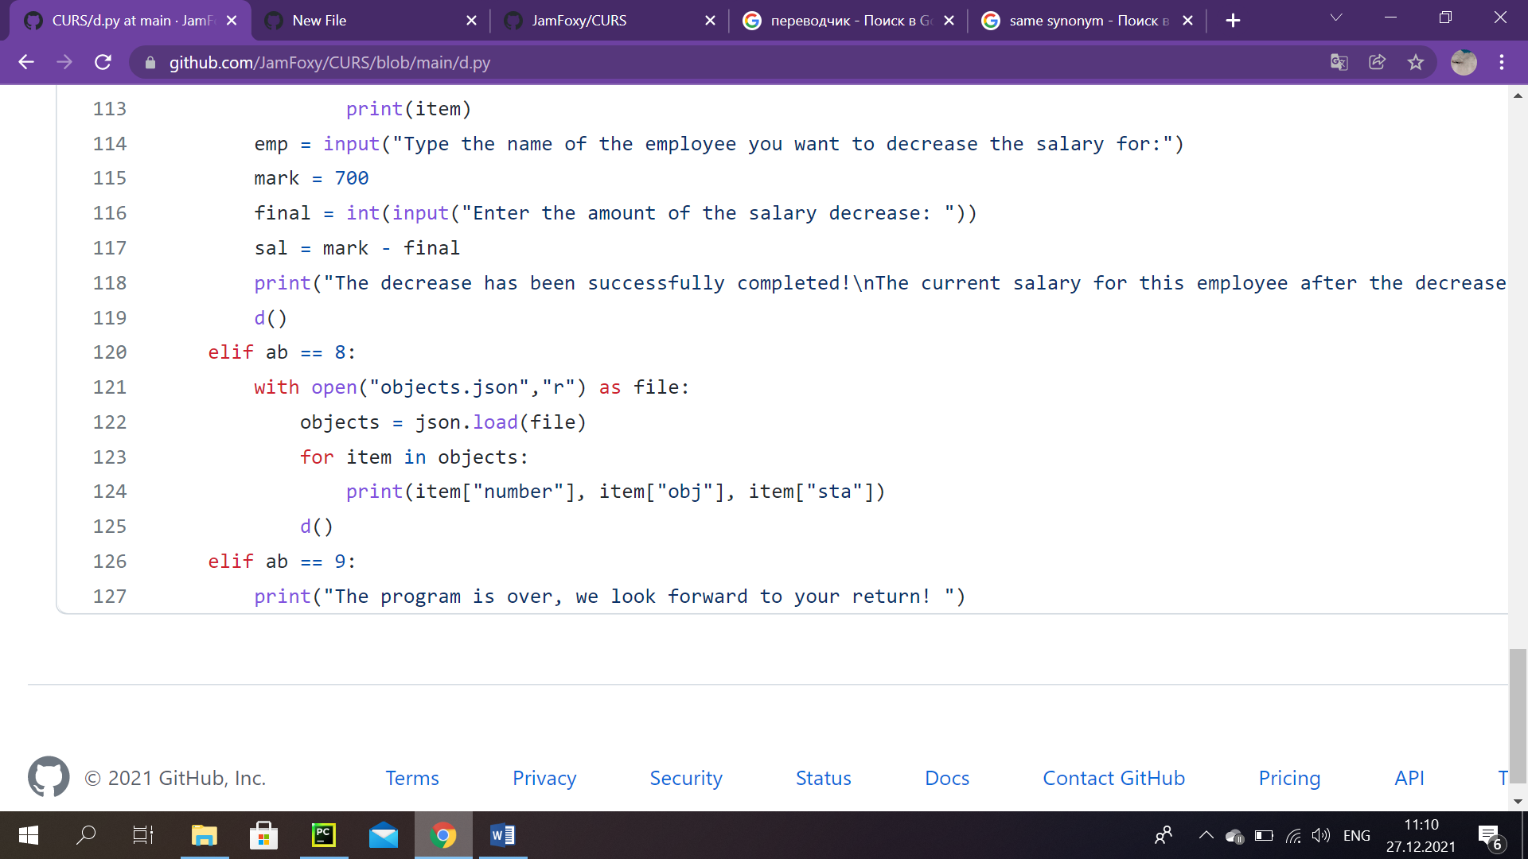

*Sc. 43*

In that case, when the director selects number 9, that automatically means that he wants to finish working. The system goes to the end, with following words: ‘The program is over, we look forward to your return’. (Sc.43)

# Main Part (Sales agent)

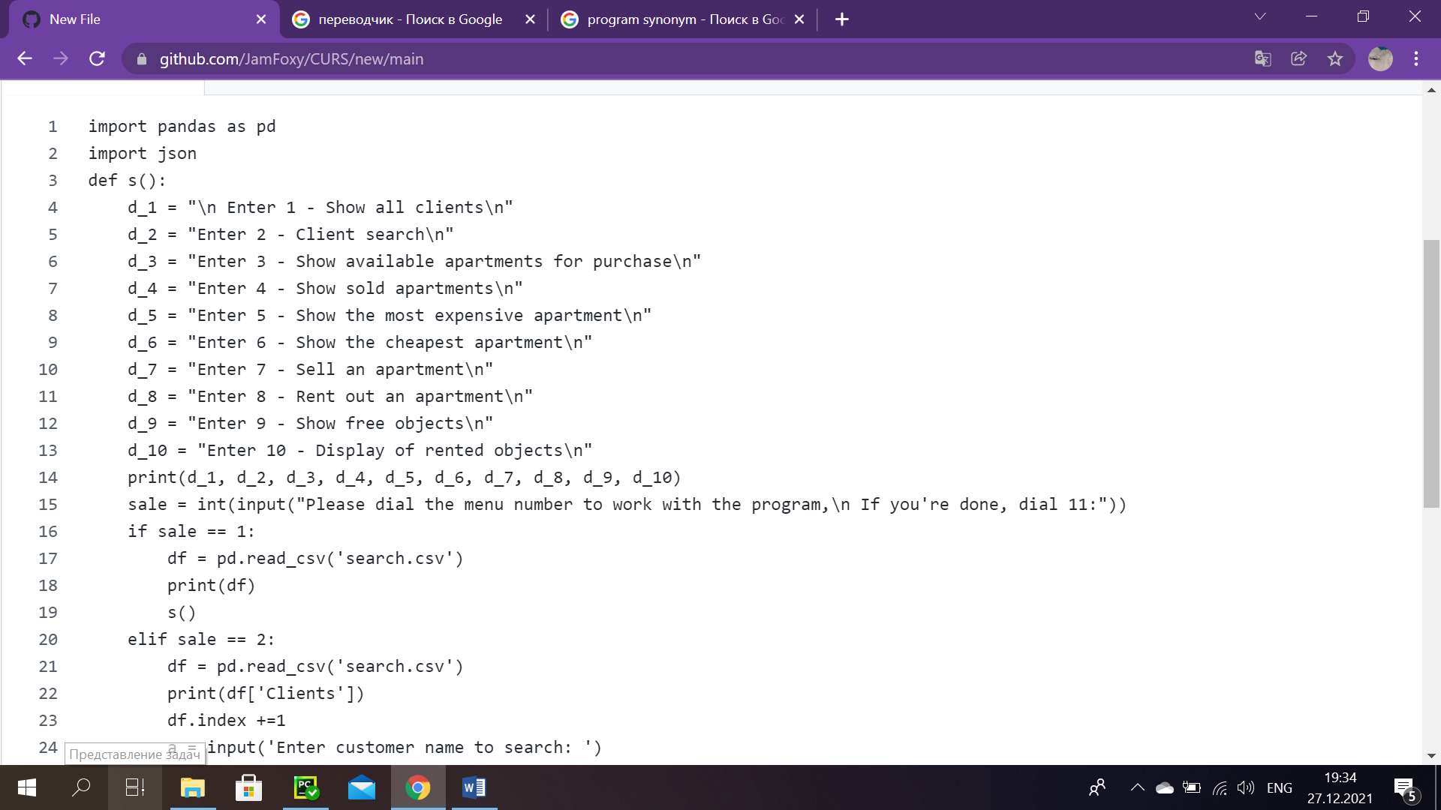

*Sc. 44*

First of all, we import Python data analysis library- pandas and database JSON, by virtue of the fact that we will need them later to upload data from certain files.

The program prints a main sales manager account menu. And then asks the attendant, what he intends to do. In short, sales agent is able to work with 10 various options. Thus, entering number 1, means that you want to see a list of all clients. If 9 was dialed, then it is possible to look for certain clients. Number 3 is responsible for making the user able to see available apartments for purchase, 4 is in charge of showing sold apartments, 5- showing the most expensive apartment, and 6 in its turn displays the cheapest apartment. If the sales agent wants to sell an apartment, it is required to dial 7, whereas if renting out an apartment is the desired option, it is needed to type 8. Number 9 is for showing free objects and number 10- for displaying of rented objects.

After printing this course of action, system asks to enter a number to work with the program. Also suggets to type the number 11. (Sc.44)

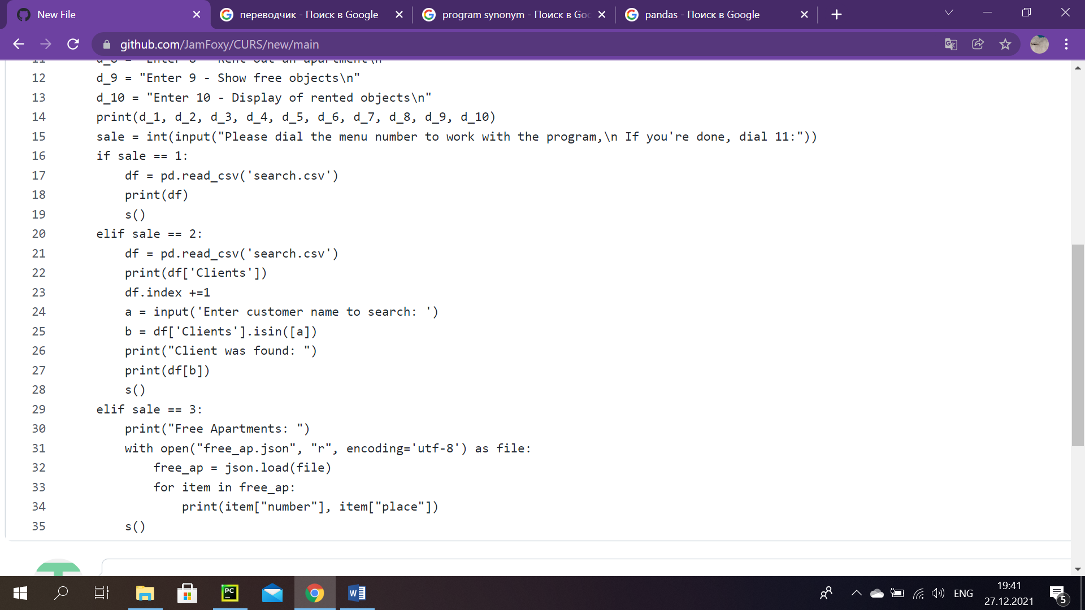

*Sc. 45*

So, if the sales manager wants to see list of all clients, we simply import csv file, which is called: ‘search.csv’and afterwards output all the information there. Ultimately, system returns to the main menu part.

And to search for certain clients, using that same file, program asks a worker to type one’s name. If it is a match, it is printed out that the customer was found. To perform it, we decided to use some built-in functions as ‘.isin()’, also we used slices and worked with indexes to find a person in ‘search.csv’. In the end same as in the first option is done here. (Sc.45)

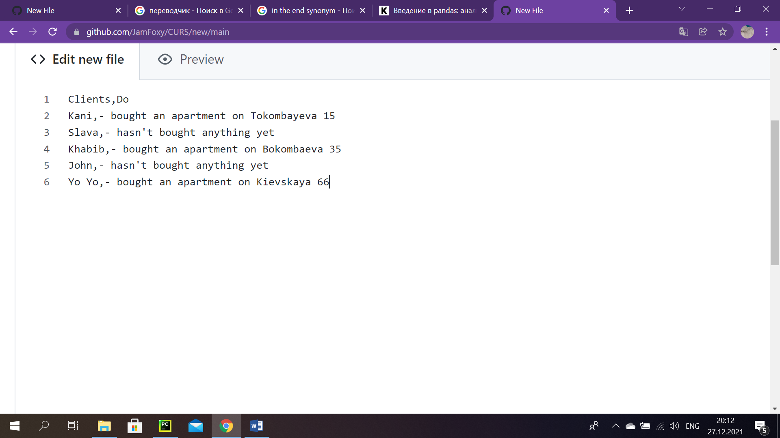

*Sc. 46 :* ‘search.scv’

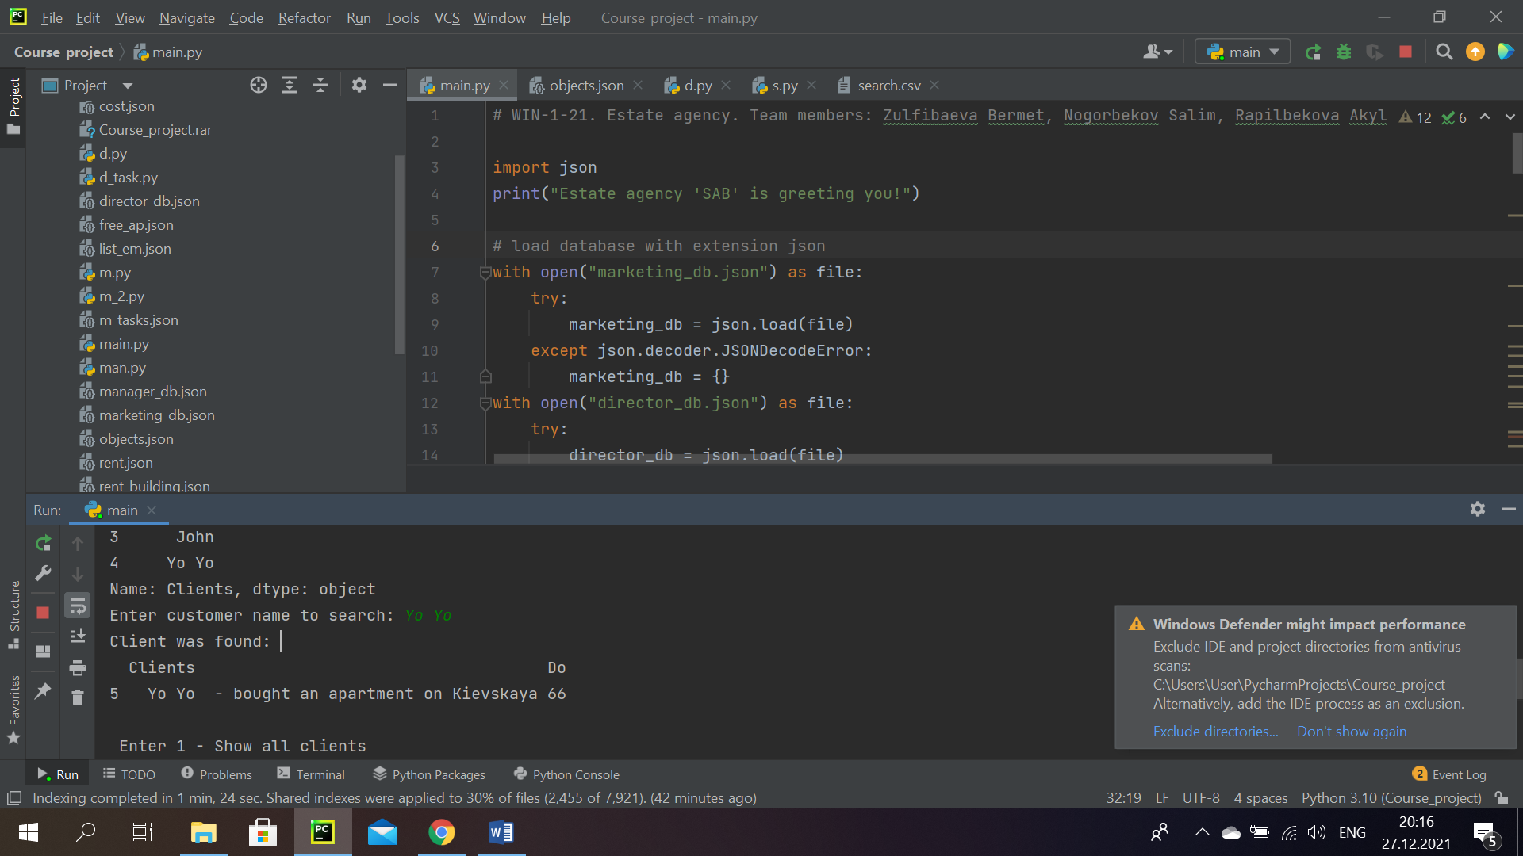

*Sc. 47*

It is an pictorial representation of how it works on program. So, I typed ‘Yo Yo’ (a name of the client), after which system outputted the message that he has been found and then it printed the data only about him, about his type of activities. In our case, Yo Yo has bought an apartment on Kievskaya 66, and we were shown this information. (Sc.47)

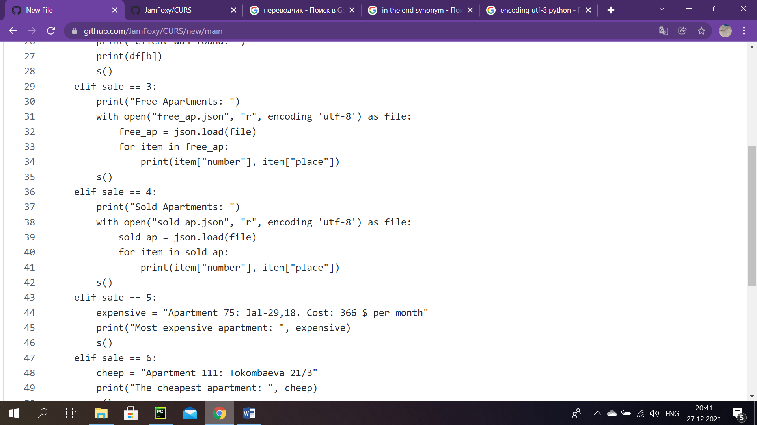

*Sc. 48*

To show the list of free apartments, we have loaded our ‘free_ap.json’ file and simply printed all the data, consisted there. The “encoding= ‘utf-8’” is the standart procedure, that saves from unwanted mistakes. (Sc.48)

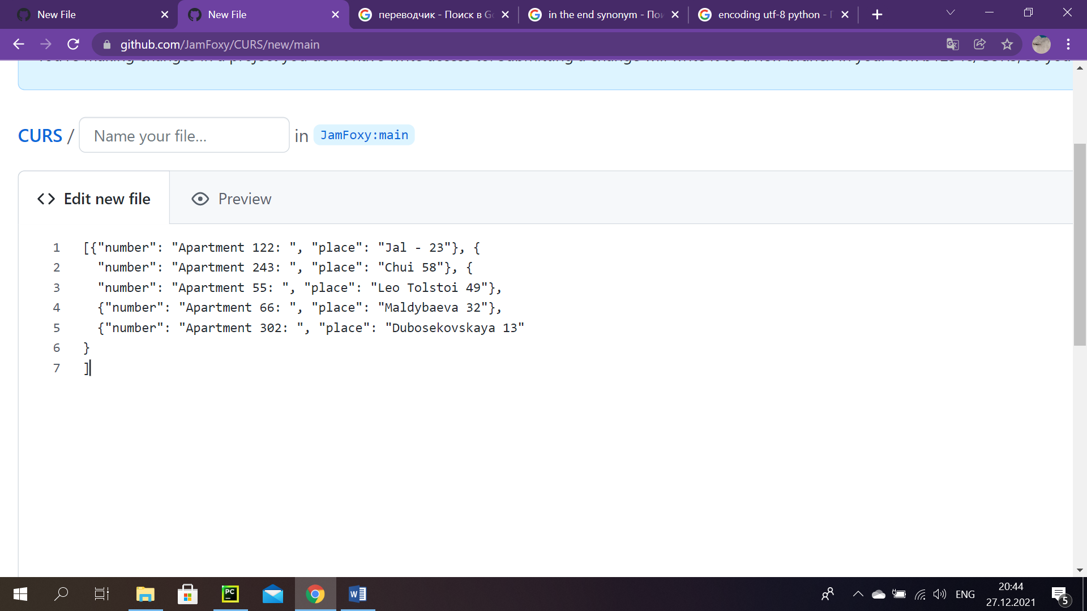

*Sc. 49: ‘*free_ap.json’

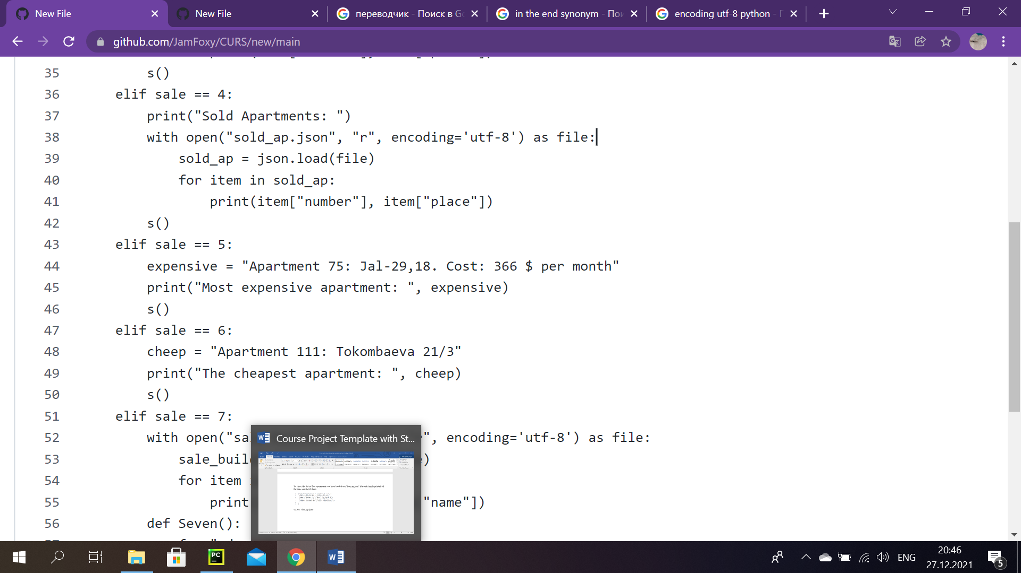

*Sc. 50*

The same thing was done in the fourth option, except we load another file called ‘sold_ap.json’. And identically as there, using for loop, program outputs all the details of this option. (Sc.50)

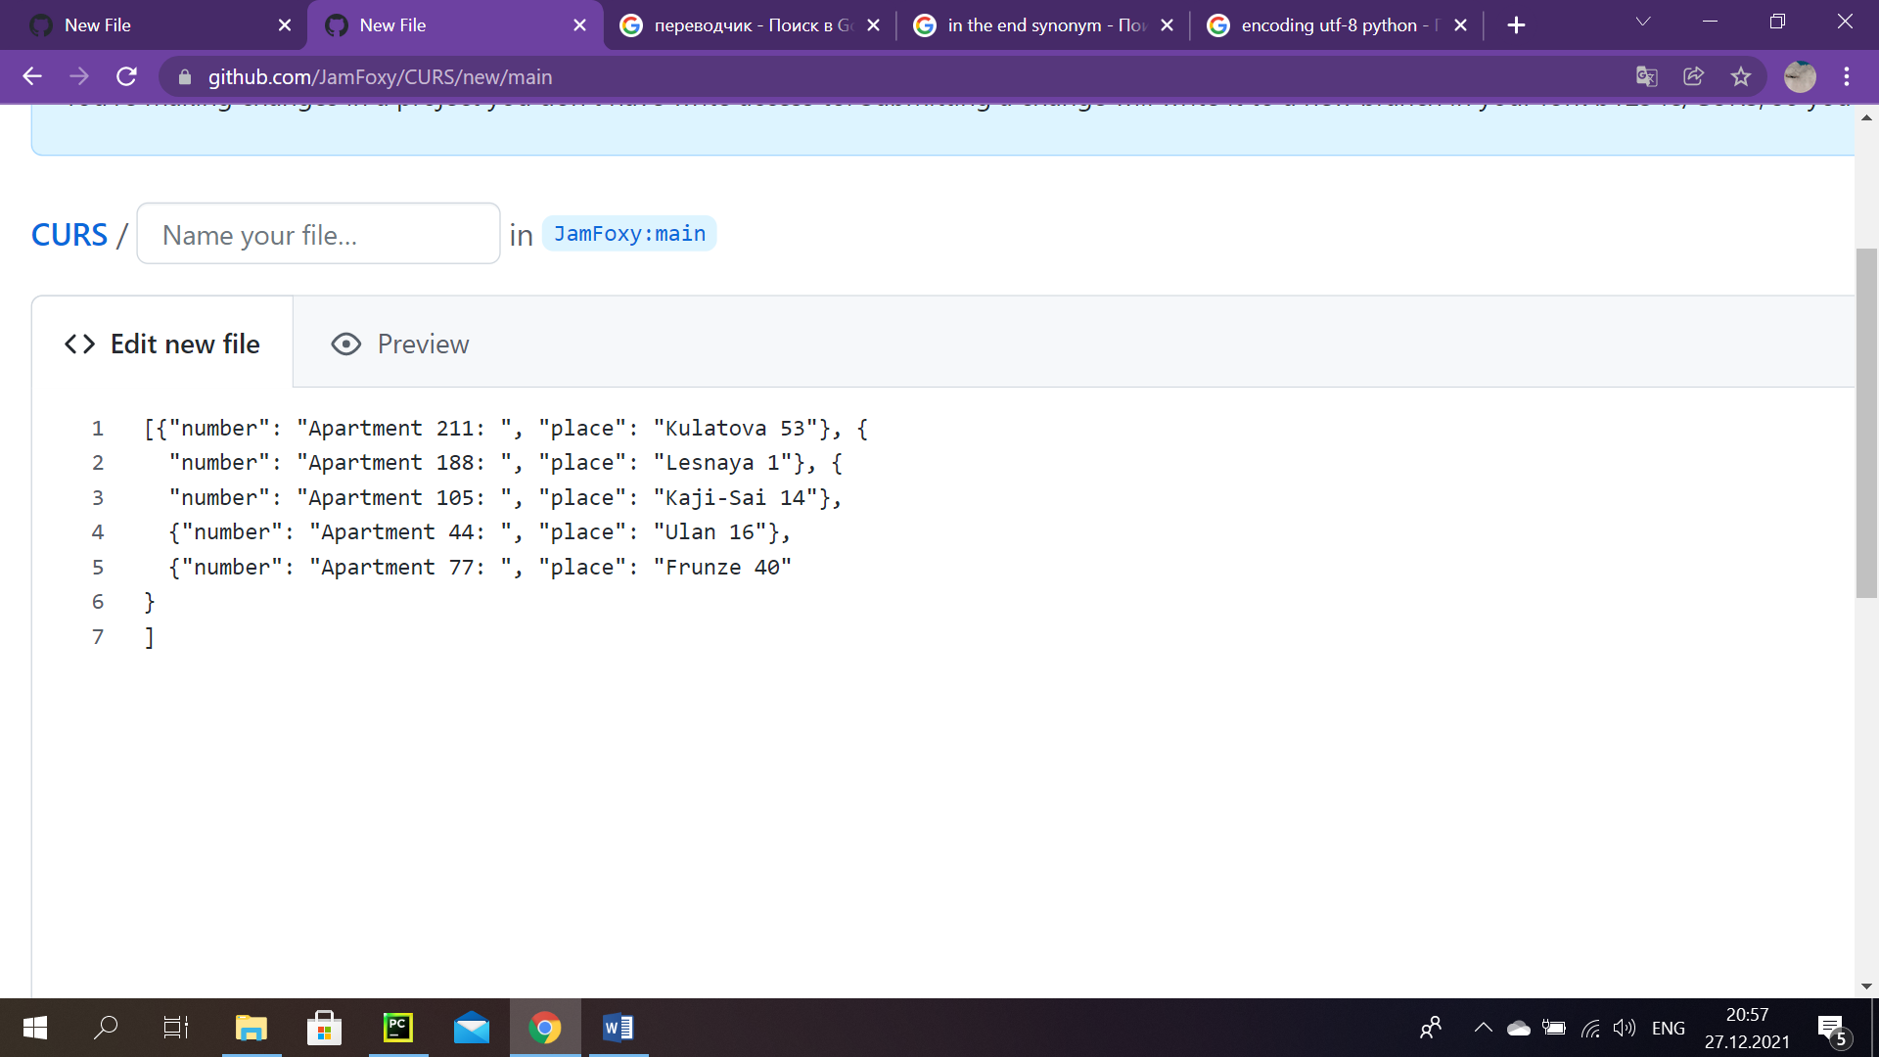

*Sc. 51:* ‘sold_ap.json’

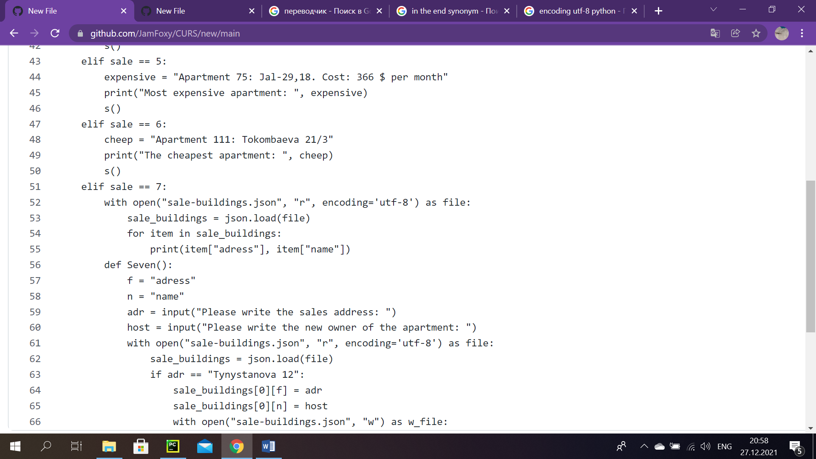

*Sc. 52*

If a user chooses 5 or 6, corresponding material is outputted. In the fifth variant we used a variable ‘expensive’, so then we could use it to print the data, which was there. Anologically, in the sixth a variable ‘cheap’ was used to output the information consisted there by using this variable. (Sc.52)

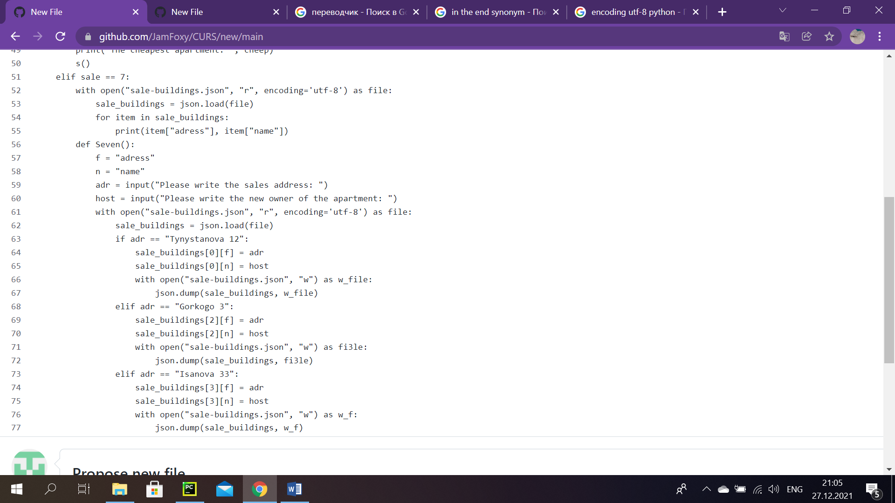

*Sc. 53*

In this part, we open and afterwards print file ‘sale-buildings.json’, where all property data is stored. (Sc.53)

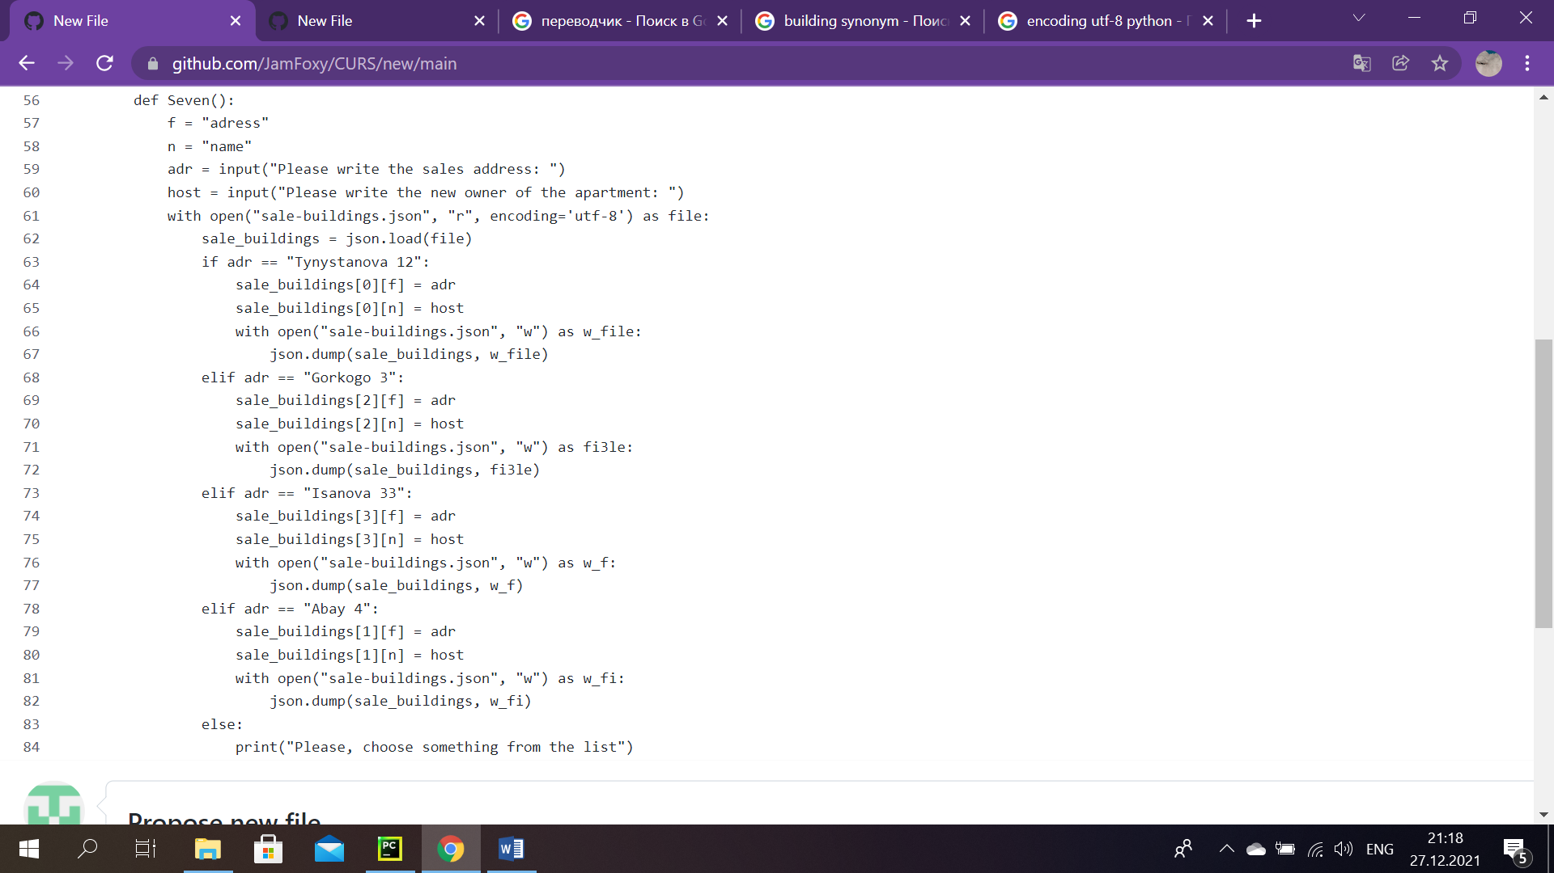

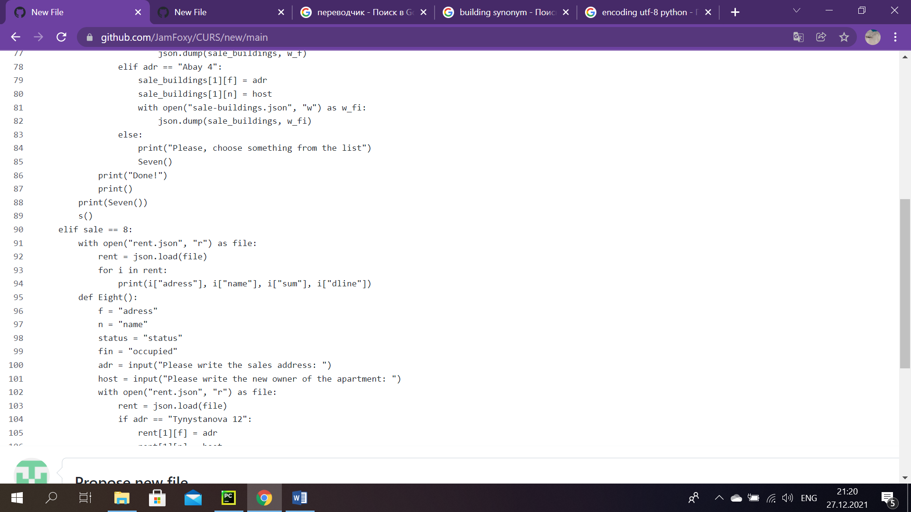

*Sc. 54*

It is necessary to create new function, which we decided to call ‘def Seven()’. First two variables are responsible for key names in our JSON dictionary: ‘sale-buildings.json’. And the other two ones essentially ask a worker to write an address of a house they want to buy and to type in their name, so that the program could save new householder in previous file (dictionary). In our case we have four buildings for sale, obviously, a sales agent should enter necessary address and host name to save new data to the dictionary. By using slices, all the information, that was typed in, goes to the correct place. What I mean by that is, if a worker chose let’s say the address: Gorkogo 3 and entered some name, then this name goes as a value of corresponding key. Gorkogo 3 has index- 2, so that is why in the code there is ‘[2][f]’ (f-variable for the key, ‘address’) . By doing it new details find and be stored in their own place. Same was performed for other addresses.

In the case when an address out of suggested list was selected, program asks a user to choose something from the built-in list. And goes back to this ‘Seven()’ function.

If everything was performed correctly, then the message: ‘Done!’ is displayed on the screen and main sales manager account menu is showed. (Sc.54)

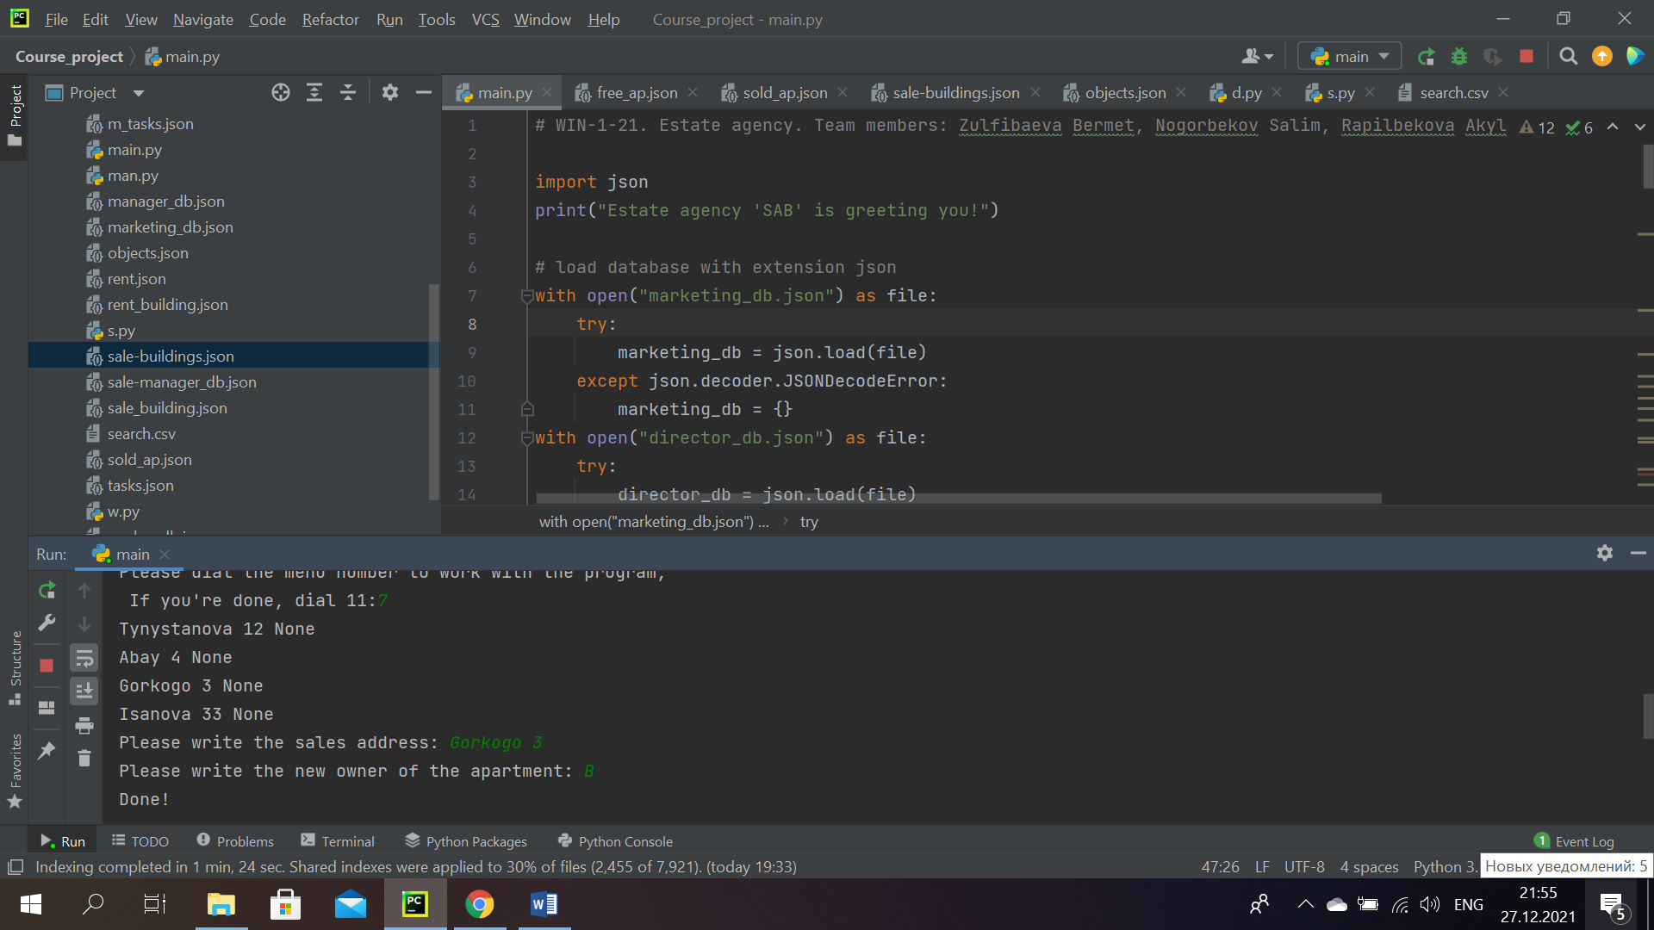

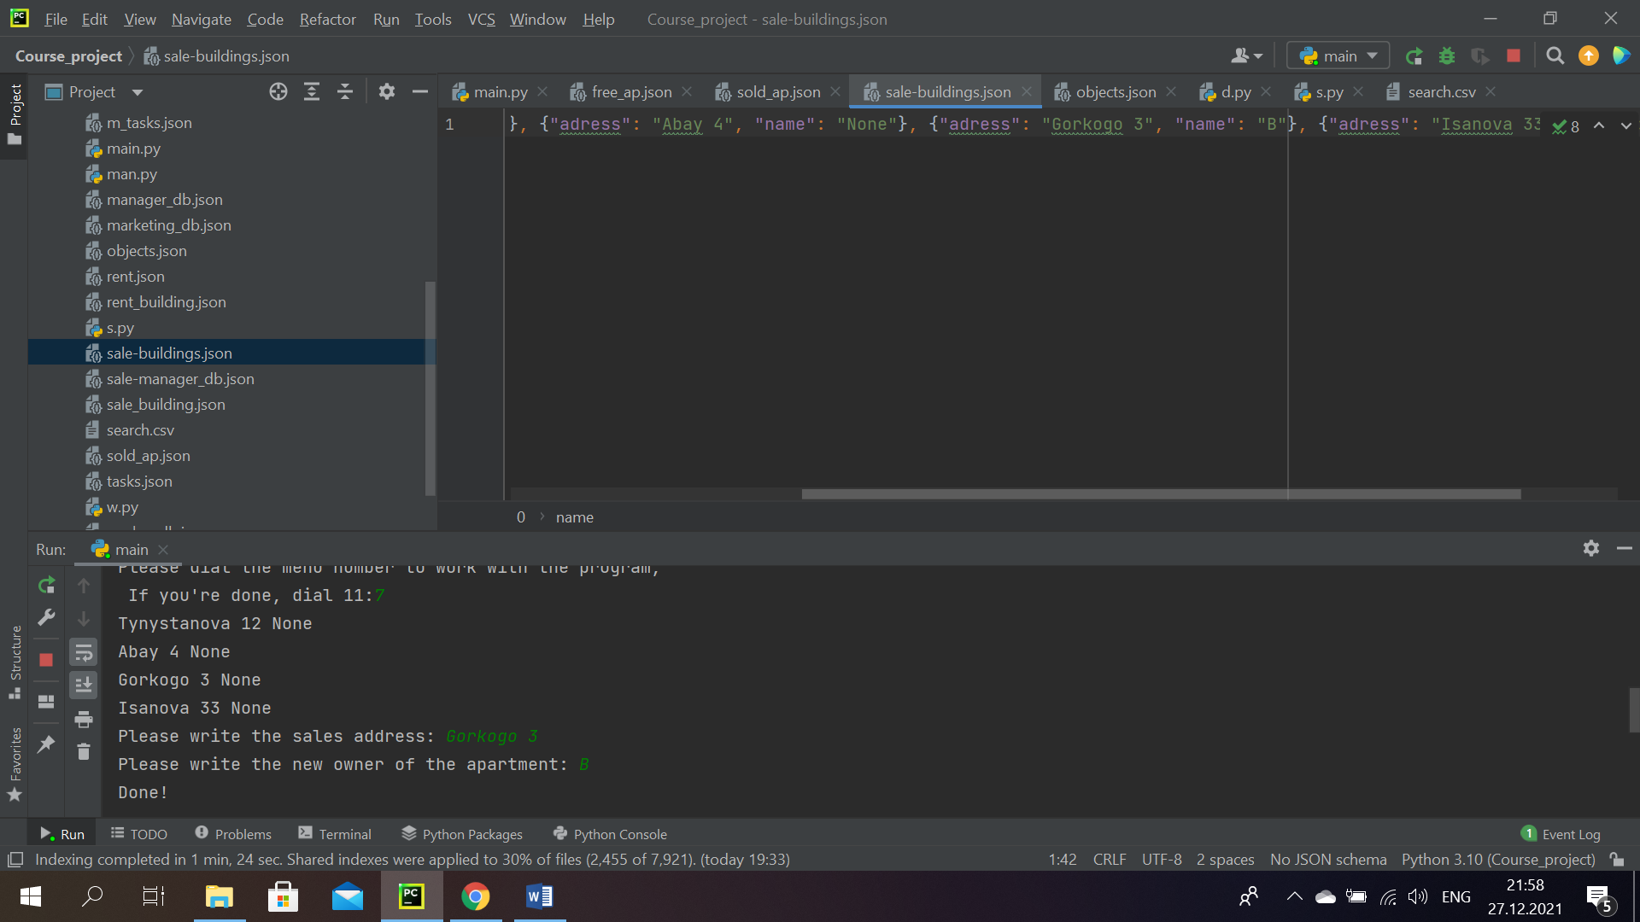

*Sc. 55.* Represantation of how the program works in the seventh part.

As we see, the system saved new material in the right place. (Sc.55)

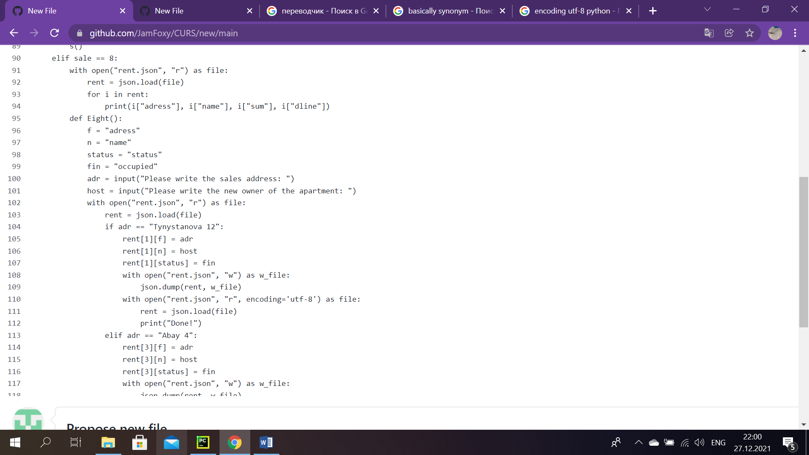

*Sc. 56*

This part is used, if a client wants to rent out an apartment. Then from the file ‘rent.json’ by using for loop, we load the information, consisted there. (Sc.56)

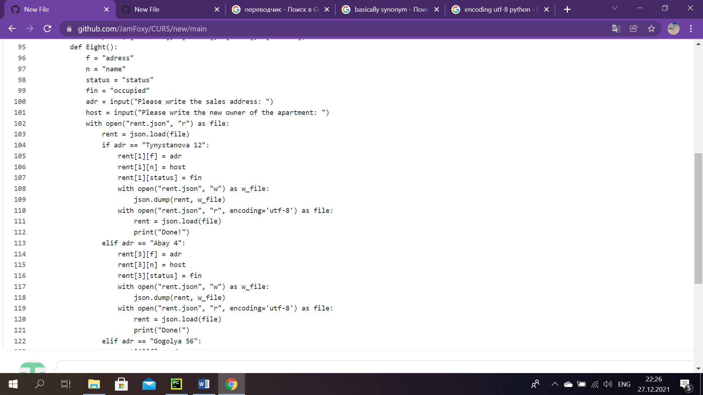

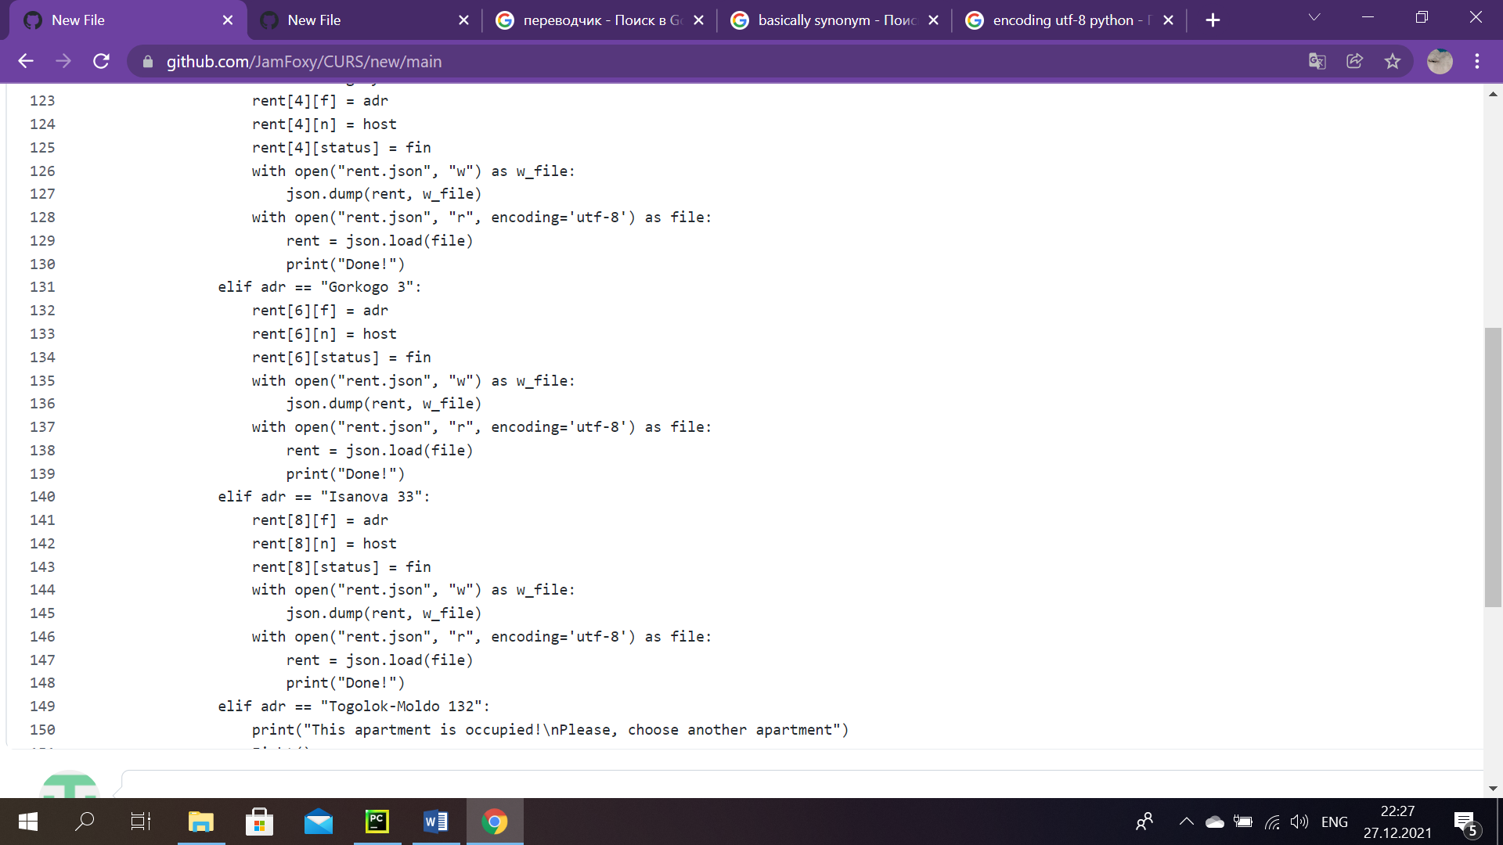

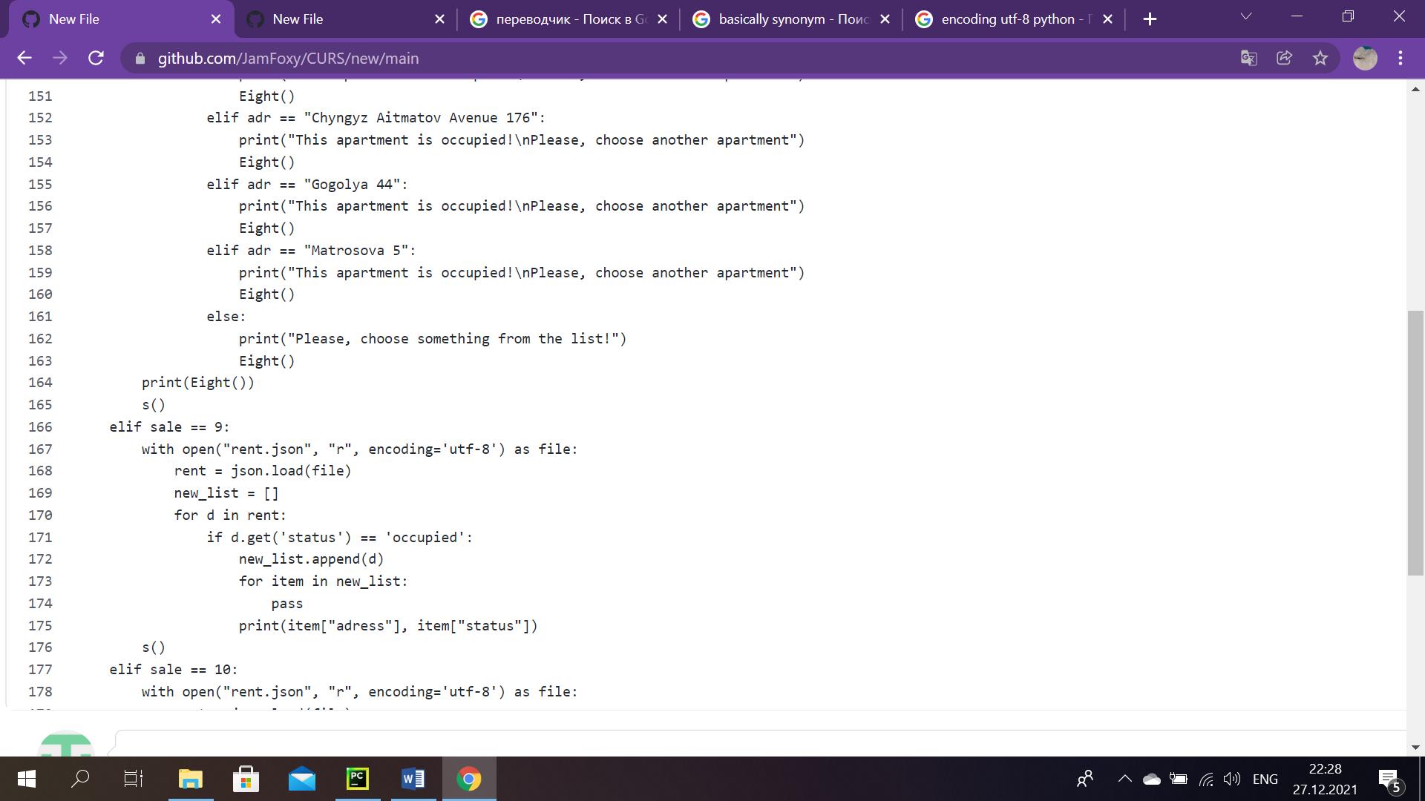

*Sc. 57*

To make it possible to read and write new details in the file, that is in charge of showing information about buildings for rent, following steps were performed:

1) In the beginning we created new function ‘def Eight()’. There are six variables. First two and the last two variables do same things as in previous screen description, these are variables ‘f’, ‘n’, ‘adr’, ‘host’. However, since in this case there is more materials, two more variables appeared: ‘status’ and ‘fin’ (fin= ‘occupied’), which displays, obviously, its status.

2) We have nine apartments, four of which are occupied. Therefore, if one of the booked addresses will be selected, then the message about it will show off on the screen and the program will ask choose the worker another apartment by returning to our function ‘Eight()’.

3) In case of correct selection, program finishes with the words ‘Done!’. Afterwards, we go back to the main sales manager account menu. (Sc.57)

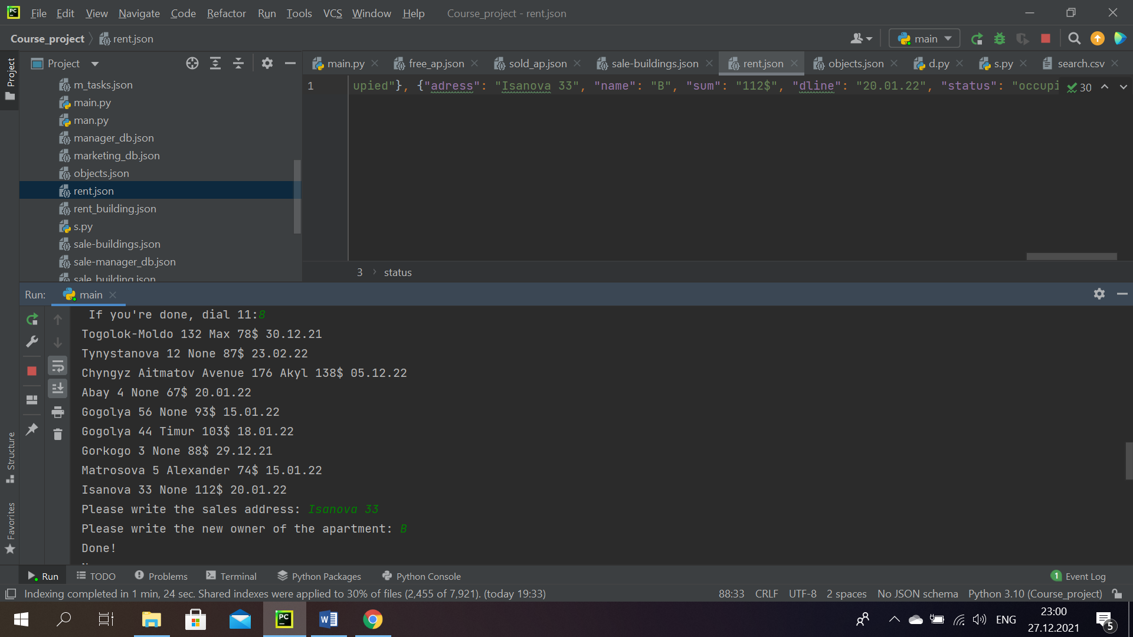

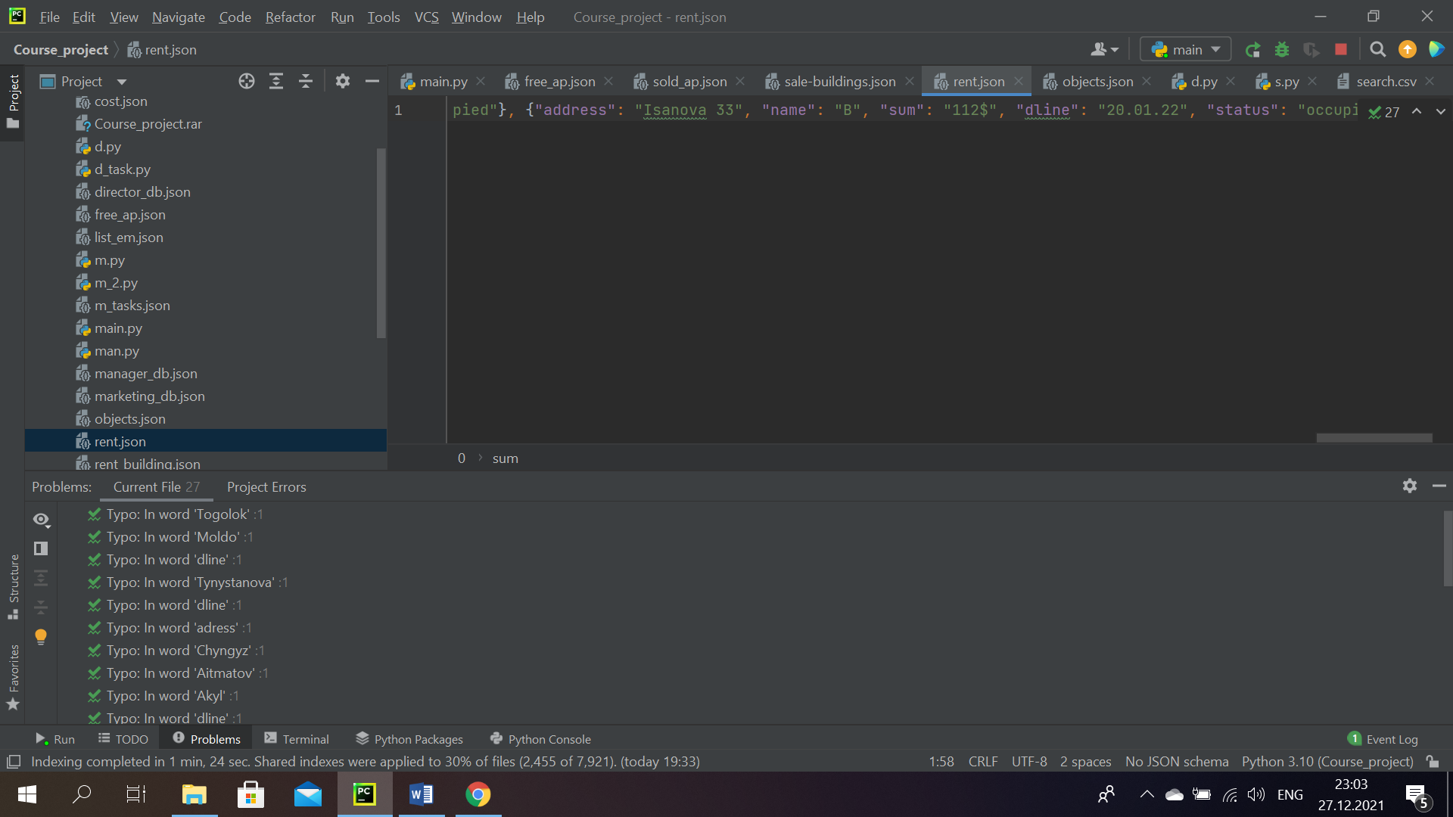

*Sc. 58* Represantation of how the program works (saves data) in case of successful rent.

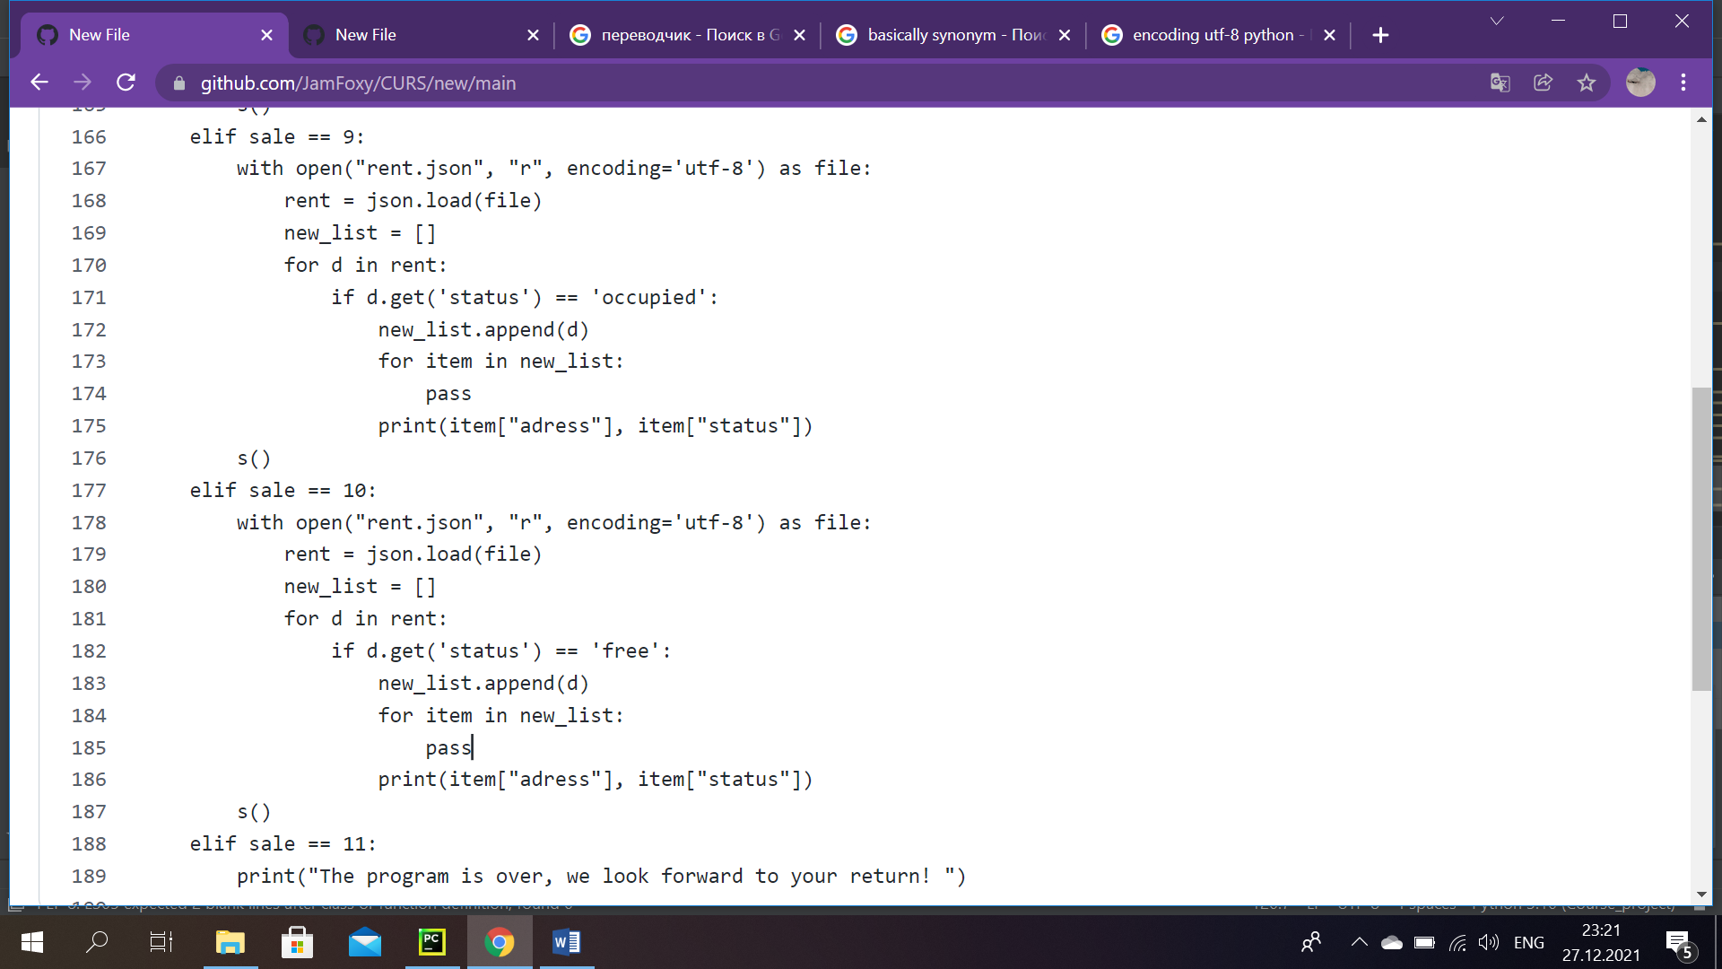

*Sc. 59*

This part of code shows busy objects for rent: (all objects with the "occupied" status are read from ‘rent.json’ file). Here we created new list, where we appended all apartments with busy status. And finally, printed the adress itself with its ‘occupied’ status. (Sc.59)

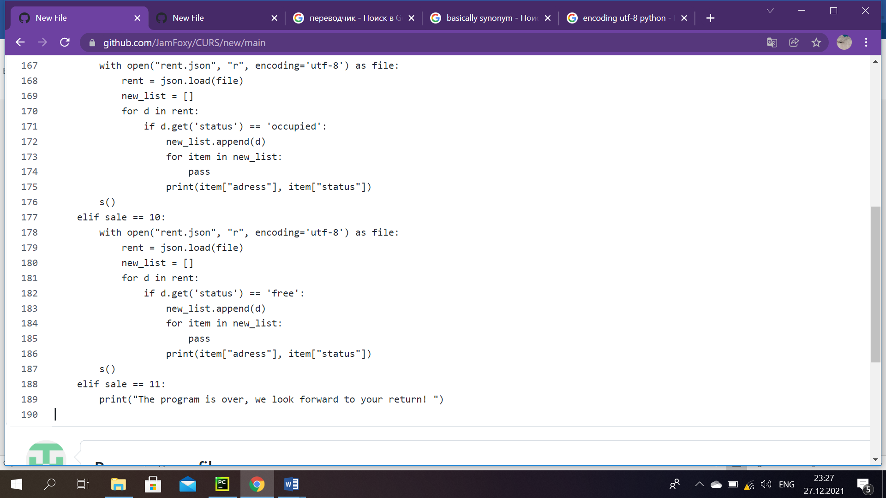

*Sc. 60*

To see apartments’ list with free status, it is required, as we know, to type number 10. The code part is the same as previous one, except: here the program looks for ‘free’ status addresses. (Sc.60)

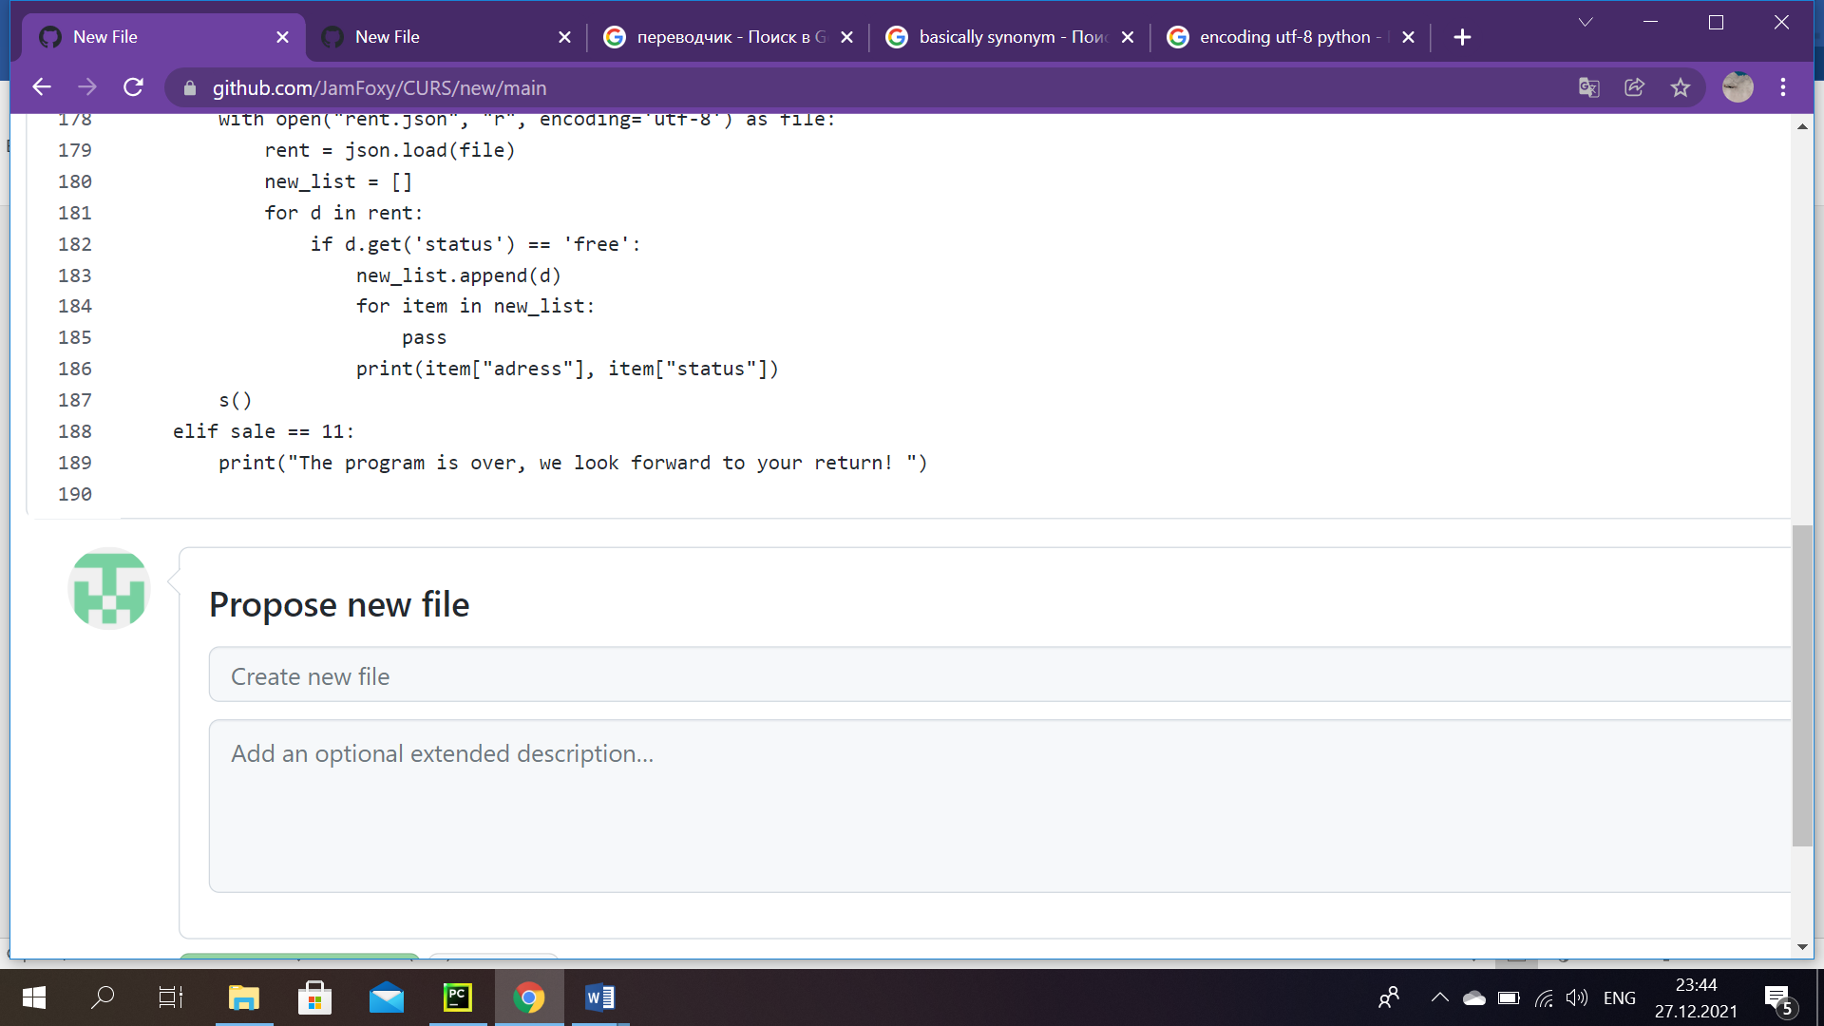

Sc. 61

If sales manager is done with working, he dials 11. At this point program finishes with the words: ‘The program is over, we look forward to your return!’ (Sc.61)

# Conclusion

As we have researched whether there is something similar as our project, we have found an enormous quantity of platforms, that actually have not that much in common with our work. Some of this projects were described in introduction part. Shall we elaborate on saying ‘not much in common’ a little deeply. Subsequently, the problem of all that programs/sites was in that they were being more client-oriented, by that we mean, they mainly provided their service to people, who either wants to get a property or who would like to sell it or lease by using their platform. Whereas, in our case we developed a program mainly for workers in different companies related to real estate, where they can do their daily assignments quicker with the help of automated system ‘SAB’. Also, we created a platform which works for five diverse employee positions with their own peculiarity.

Now, workers who use our system have an incredible opportunity to automatically search, read and without any efforts supplement or make entries in the files. It is also possible to quickly look for the data needed, since without our system all these documents, records make it difficult to work, when it takes much time to find them. Additionally, some users have duties, which incline calculating different processes, our team took this into account and made it possible for employees to receive information in finished form. Everything listed here is the smallest part of our project. To sum up, making a program for workers in the sphere of real estate was not an easy thing. In coding there were various problems met, from the silliest to, at that time, hard solving problems. For instance, there were some complications with logic, as a consequence, it is the most important thing in coding rightly. It doesn’t matter how brilliantly a person knows syntax of any language, if he cannot put the logic that will determine the order of items so that a computer can perform specific tasks. There were some improper actions made, as incorrect using of built-in functions, erroneous practice with Python loops. Moreover, owing to the fact that we decided to work with a completely new for us database-JSON by ourselves, a lot of obstacles were in our way. It was complicated to quickly master working with this database. We had some issues with opening, writing and deserialization. Also some problems were met, when we wanted to develop a code part, that would write to one library, using another. Anyways, in the end we learned our mistakes and made the program work correctly. There is a different category of workers, because of it, those various works differ from each other with their complexity, by that we mean, employees have dissimilar positions, which incline different tasks and duties. In other words, creating login to one’s account, developing an ability to choose from the menu based on the type of worker’s account, developing an ability to search, to delete or change some data and to see some types of reports were achieved. In spite of everything, it was fascinating for each member of our team to create this kind of program, because at the end, all of us learned something new, which surely will be useful to us in the future.

**What we learned?**

We learned: in programming: data structures (floats, integers, strings and Booleans), loops (for and while), conditions, if/elif/else conditional statements, indexing (slices), try except blocks, functions, writing to a file, reading from a file and doing operations on them, we have learned to work with various built-in functions. Plus, we improved our soft skills: learned how to work with a team, how to present own project. Also, now we know how to correctly manage time.

We also did: additionally, learned to work with database, called JSON and the Python CSV files.

# References

Here the used books, links, terminological dictionaries were included.

1. <https://study.com/academy/lesson/types-of-real-estate-agencies.html>
2. <https://www.g2.com/categories/brokerage-management>
3. <https://dictionary.cambridge.org/ru/>
4. <https://python-intro.readthedocs.io/en/latest/conclusions.html>
5. <https://www.house.kg/>
6. <http://an.kg/>
7. <https://thepythonguru.com/python-string-formatting/>
8. <https://context.reverso.net/%D0%BF%D0%B5%D1%80%D0%B5%D0%B2%D0%BE%D0%B4/%D0%B0%D0%BD%D0%B3%D0%BB%D0%B8%D0%B9%D1%81%D0%BA%D0%B8%D0%B9-%D1%80%D1%83%D1%81%D1%81%D0%BA%D0%B8%D0%B9/>
9. <https://techvidvan.com/tutorials/terminologies-in-python/>
10. <https://www.thesaurus.com/>
11. <https://avg.kg/>